The Transactions and Projects System’s (TaPS) Central Data Exchange (CDX) Start-Up Guide



Updated 7/28/2025

Table of Contents

Revision Log 3

TaPS Overview 4

CDX Overview 4

Role Sponsorship Process Overview 4

1) OGGRF Administrator Role 5

2) Authorized Official Representative Role 6

Role Sponsorship/Invitation 6

Pending Sponsorship Requests 8

Access Management 15

3) Grantee Submitter, Reviewer, and Approver Roles 17

Accepting Sponsorship Invitations 17

Completing Account Registration 21

Grantee Reviewer/Approver Identity Verification 23

Conclusion 25

List of Images

Image 1: Flowchart detailing the pre-registering and sponsorship process. 5

Image 2: Role Sponsorship page in CDX for AoRs. 6

Image 3: Role Sponsorship/Invitation page in CDX. 7

Image 4: Role Sponsorship/Invitation Review page in CDX. 7

Image 5: Example of the email confirmation pop-up modal. 8

Image 6: Example of a CDX generated email for Role Sponsorship/Invitation. 8

Image 7: Example of a CDX generated email for rejected sponsorship requests. 9

Image 8: Example of a CDX generated email for the Role Sponsorship/Invitation. 9

Image 9: Log In page for the Role Sponsorship Process page in CDX. 10

Image 10: CDX redirect page to Login.gov for authentication. 10

Image 11: Role Sponsorship Review page in CDX. 11

Image 12: Account Registration page to sponsor users representing my organization. 12

Image 13: Account Registration page to sponsor users representing their own organization. 13

Image 14: The CDX Role Sponsorship Signature Page. 14

Image 15: Example of a certification pop-up modal for Electronic Signatures. 14

Image 16: Example of a CDX generated email for a successful signature submission. 15

Image 17: Role Sponsorship page in CDX for AoRs. 15

Image 18: Example of the CDX Role Sponsorship "Access Management" tool. 16

Image 19: Example of a CDX generated email when a role has been revoked. 16

Image 20: Example of a CDX generated email for a role sponsorship request. 17

Image 21: Example of a CDX generated email for a rejected sponsorship request. 17

Image 22: Log In page for the Role Sponsorship Process. 18

Image 23: CDX Account Registration page for the Role Sponsorship Process. 18

Image 24: CDX redirect page to Login.gov for authentication. 19

Image 25: Role Sponsorship Review page in CDX. 19

Image 26: Account Registration page in the Role Sponsorship Process in CDX. 20

Image 27: Example of the MyCDX Page with a "pending" Grantee Submitter Role. 20

Image 28: Example of a CDX generated email when a sponsor letter is received. 21

Image 29: Log In page for the Role Sponsorship Process in CDX. 21

Image 30: CDX redirect page to Login.gov for authentication. 22

Image 31: Complete Account page in the Role Sponsorship Process. 22

Image 32: Example of a CDX generated email for role activation. 23

Image 33: Identity Verification page in CDX for Lexis Nexis. 23

Image 34: Paper CDX Electronic Signature Agreement (ESA) page. 24

Image 35: Example of a certification pop-up modal for Electronic Signatures. 24

Image 36: Example of the MyCDX Page with a Grantee Reviewer role "Awaiting Approval". 25

Image 37: Example of a CDX generated email when a role has been activated. 25

# Revision Log

|  |  |  |  |  |  |
| --- | --- | --- | --- | --- | --- |
| **Date** | **Version No.** | **Description** | **Author** | **Reviewer** | **Review Date** |
| 11/25/24 | 1.0 | Initial Draft and Delivery | A. Claiborne | K. Hoke | 11/26/24 |
| 07/01/25 | 2.0 | Updates following TaPS v1.2.0 release | S. Bihm | A.Claiborne | 7/7/25 7/25/25 |

# TaPS Overview

Grantees who have received funds through the Environmental Protection Agency's (EPA's) Office of Greenhouse Gas Reduction Fund (OGGRF) will use the Transactions and Projects System (TaPS) to report on grant expenditures and project activities under the National Clean Investment Fund (NCIF), Solar for All (SFA) and Clean Communities Investment Accelerator (CCIA) grant programs. TaPS is a web-based reporting system and is accessed via EPA's Central Data Exchange (CDX).

# CDX Overview

CDX is EPA's electronic reporting site. It serves as EPA's central point that allows regulated entities, grantees, or other non-EPA users the ability to electronically report data to EPA. TaPS is one of many reporting systems hosted in CDX.

CDX has test and production environments, accessible at the following links:

Test: [https://test.epacdx.net](https://test.epacdx.net/)

Production: [https://cdx.epa.gov](https://cdx.epa.gov/)

# Role Sponsorship Process Overview

TaPS is a role-based application; users are assigned to roles based on actions that they are required to perform in the application. In accordance with the Terms and Conditions of the CCIA, SFA, and NCIF programs, TaPS has the following roles:

* **OGGRF Administrator (OGGRF Admin)**
* **Authorized Official Representative (AoR)**
* Grantee Submitter
* Grantee Reviewer
* Grantee Approver

A CDX account is required to access the TaPS application. However, TaPS utilizes a “closed” registration, meaning users must wait until an authorized role sends them an invitation to setup their CDX account. The following stepwise process must be followed before access is granted:

1. The OGGRF Admin identifies and pre-registers AoRs in CDX. (See Section 1 for details)
2. The AoR logs into their CDX account and uses the Role Sponsorship tools to invite/sponsor other users for the Grantee Submitter, Grantee Reviewer, or Grantee Approver roles. (See Section 2 for details)
3. Grantee Submitters, Reviewers, and Approvers must create a CDX account or use an existing account to accept the invitation/sponsorship and complete setup for their role. (See Section 3 for details)

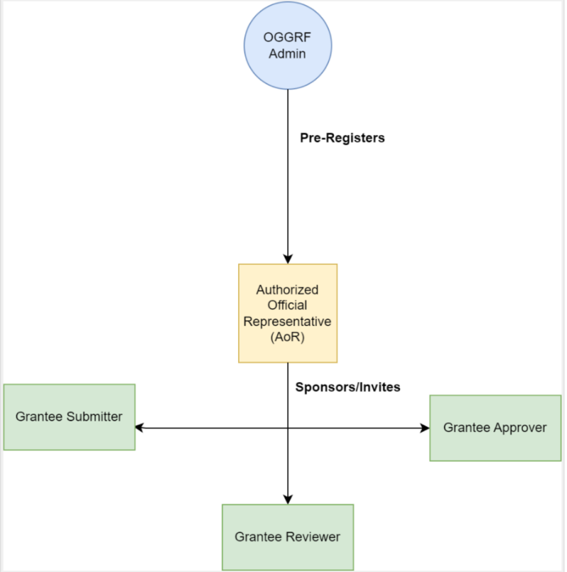

Image 1: Flowchart detailing the pre-registering and sponsorship process.

# 1) OGGRF Administrator Role

EPA's Office of Greenhouse Gas Reduction Fund have Administrators who work closely with grantees to identify the appropriate personnel to fill the Authorized Official Representative (AoR) role for each grant.

Under the CDX role-based and sponsorship model, EPA users in the OGGRF Admin role grant access to the AoR role for the appropriate grantee representatives.

# 2) Authorized Official Representative Role

An Authorized Official Representative (AoR) is a sponsorship role, meaning that, in addition to other permissions in TaPS, users with this role can grant access to other users for other roles in the system. This ensures only authorized individuals can provide grant reporting data.

Upon creating a CDX account for the first time, the new user must be pre-registered for the AoR role by an Office of Greenhouse Gases and Reduction Fund (OGGRF) Admin. After the registration is complete, the AoR is granted access to the "Role Sponsorship" tab in the CDX environment which contains the following tools:

* **Role Sponsorship/Invitation**: Where AoRs can initiate and inform users of requests to authorize service access.
* **Pending Sponsorship Requests**: Displays a list where AoRs can approve or deny requests for service access.
* **Access Management**: Where AoRs can view and/or modify existing privileges.

## Role Sponsorship/Invitation

To provide access to the TaPs application, the AoR must sponsor the Grantee Submitter, Reviewer, or Approver. When sponsoring/inviting a new or existing user to the CDX environment, an email notification will be sent to the recipient. The recipient will then follow the instructions to complete the account and/or permissions setup.

To sponsor a Grantee Submitter, Reviewer, and/or Approver:

1. Navigate to the "Role Sponsorship" tab.
2. Click "Role Sponsorship/Invitation".

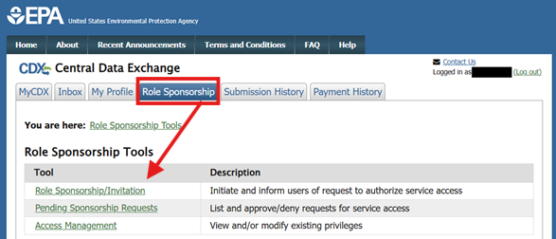

Image 2: Role Sponsorship page in CDX for AoRs.

1. Enter the users email in the "Recipient Information" section and select the appropriate role from the "Sponsorship Information" section dropdown fields then click "Submit".

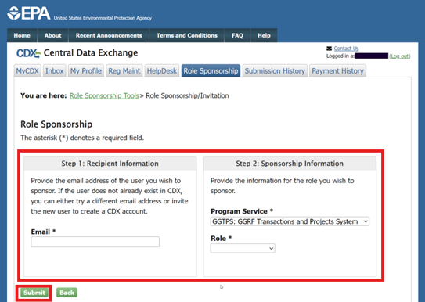

Image 3: Role Sponsorship/Invitation page in CDX.

1. Confirm the details of the Sponsorship on the "Role Sponsorship/Invitation Review" page and click “Submit”.

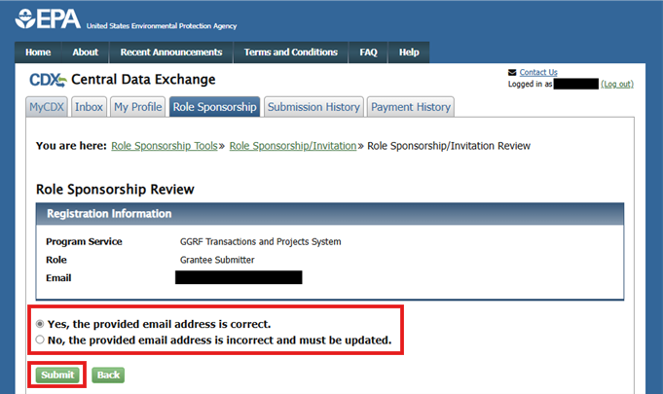

Image 4: Role Sponsorship/Invitation Review page in CDX.

1. Re-enter the email provided and click “Confirm” to send the invitation.

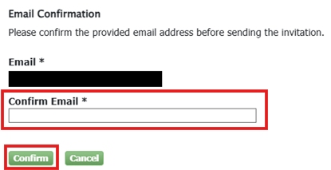

Image 5: Example of the email confirmation pop-up modal.

1. The AoR will receive a confirmation email that their request was submitted with a copy of the information sent to the invited user.

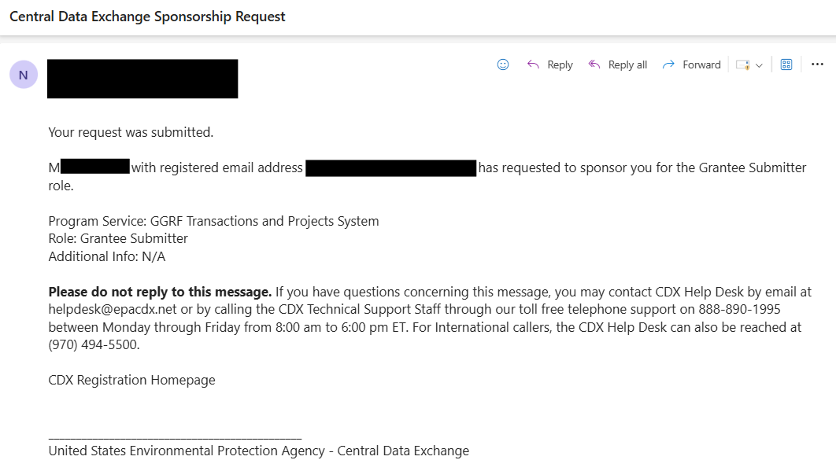

Image 6: Example of a CDX generated email for Role Sponsorship/Invitation.

It is important to note that additional input is needed to complete the sponsorship. More information related to this setup is explained in the later sections.

## Pending Sponsorship Requests

After all steps for the account setup and verification are completed by the invited user, the AoR is responsible for approving or denying the pending sponsorships.

* If the sponsorship is approved, the OGGRF Admin is responsible for the final approval that grants access to the TaPs application.
* If the sponsorship is "denied" or "rejected" at any point, the sponsorship request is canceled and does not advance to the next step in the approval process. The affected user will receive an email notification with details.

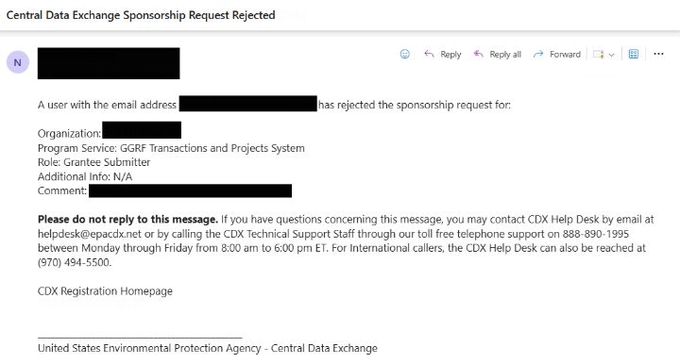

Image 7: Example of a CDX generated email for rejected sponsorship requests.

Once the invited user completes their account registration, the AoR receives a sponsorship request email with two options; to review or cancel the sponsorship request:

1. Click the link to "review this sponsorship request”.

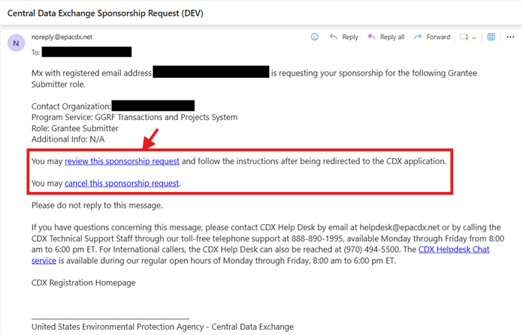

Image 8: Example of a CDX generated email for the Role Sponsorship/Invitation.

1. Review the sponsorship information and click “Log In”.

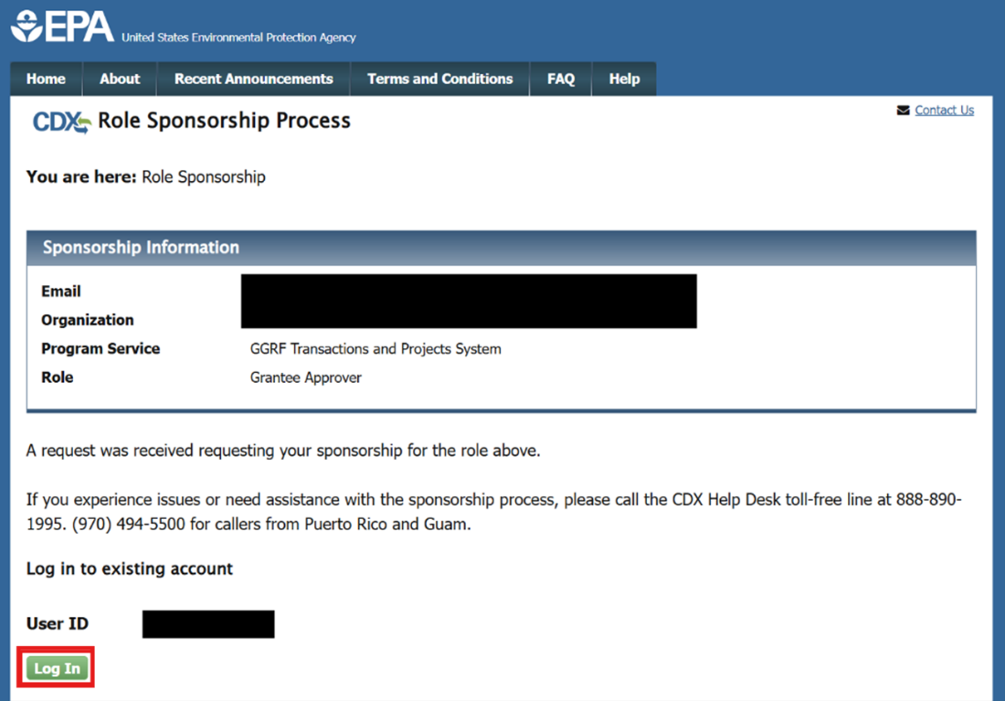

Image 9: Log In page for the Role Sponsorship Process page in CDX.

1. Click “Proceed to Login.gov”.
   1. For additional information about getting started with login.gov or issues signing in, please visit: <https://www.login.gov/help/>

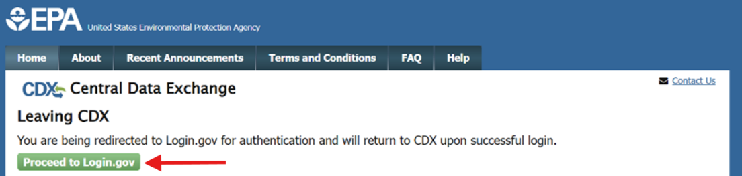

Image 10: CDX redirect page to Login.gov for authentication.

1. On the “Role Sponsorship Review” page, select the appropriate option to approve the request and click “Continue”.

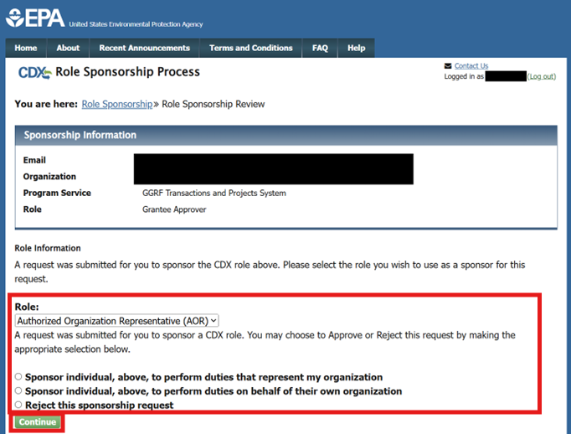

Image 11: Role Sponsorship Review page in CDX.

* 1. If you selected “Sponsor individual, above, to perform duties that represent my organization” you will need to "Select a Current Organization" or "Request to Add an organization” then click "Submit Request for Access".

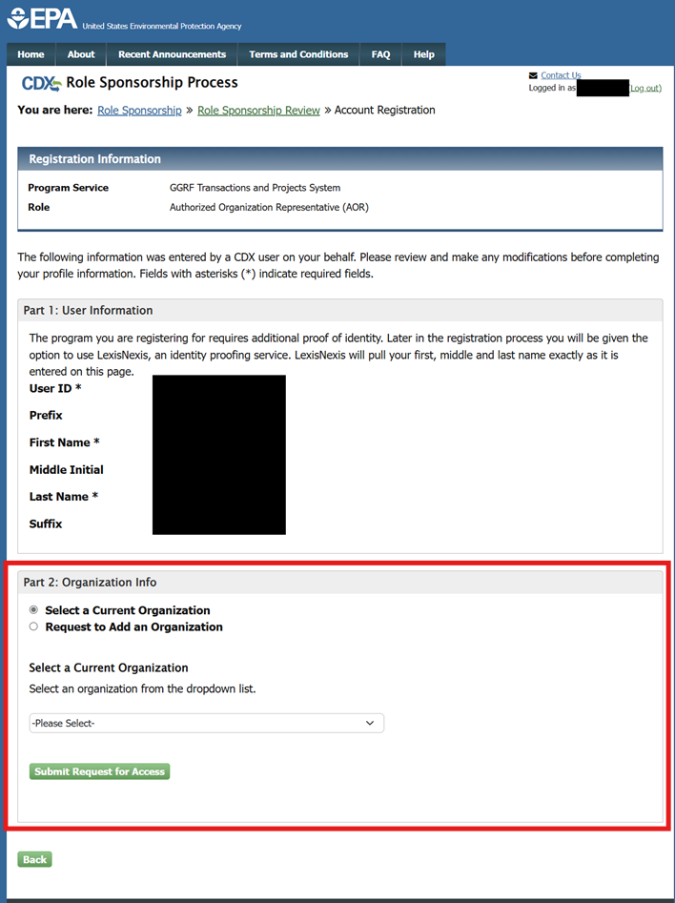

Image 12: Account Registration page to sponsor users representing my organization.

* 1. If you selected, “Sponsor individual, above, to perform duties that represent their own organization” you will need to input the required Organization Info then click then click "Submit Request for Access".

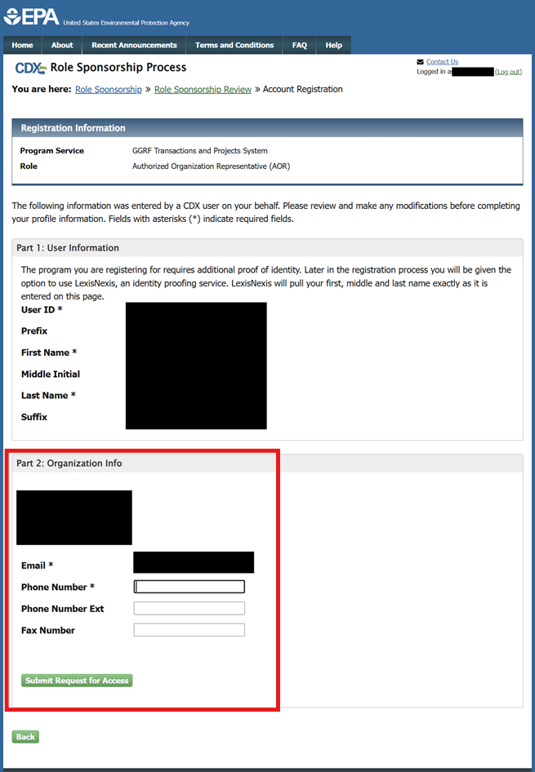

Image 13: Account Registration page to sponsor users representing their own organization.

1. Review the Electronic Role Sponsor Agreement, click “Sign Electronically”.

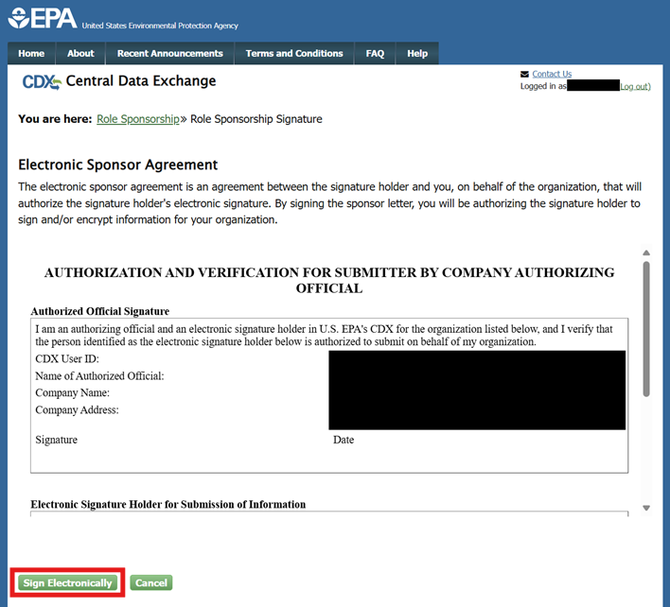

Image 14: The CDX Role Sponsorship Signature Page.

1. Finally, click “Accept”.

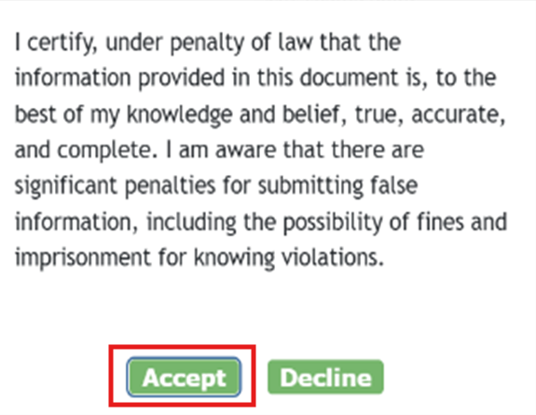

Image 15: Example of a certification pop-up modal for Electronic Signatures.

1. When the signature has been accepted, the AoR and the sponsored user will each receive an email notification.

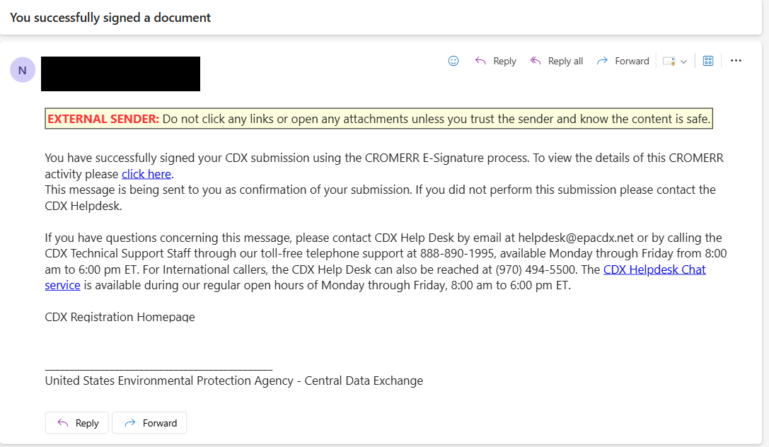

Image 16: Example of a CDX generated email for a successful signature submission.

* 1. Please note that final approval will be needed by the OGGRF Admin before the sponsored user can access the TaPS Application.

## Access Management

After roles have completed the sponsorship process, they are listed in the “Access Management” tool which can be accessed from the “Role Sponsorship” page.

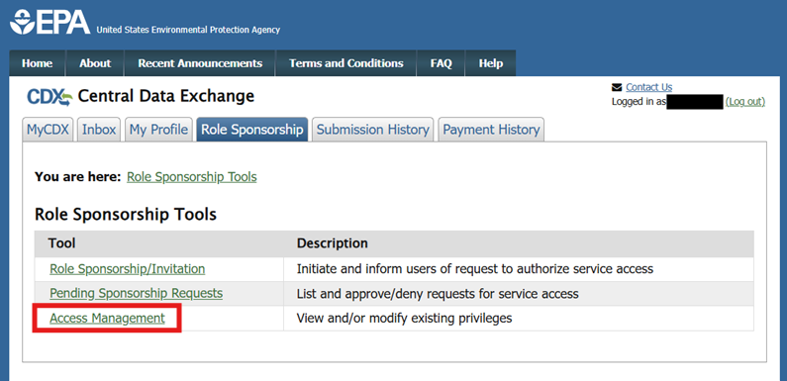

Image 17: Role Sponsorship page in CDX for AoRs.

As necessary, the AoR can revoke CDX TaPS privileges of the Grantee Submitter, Reviewer, and/or Approver.

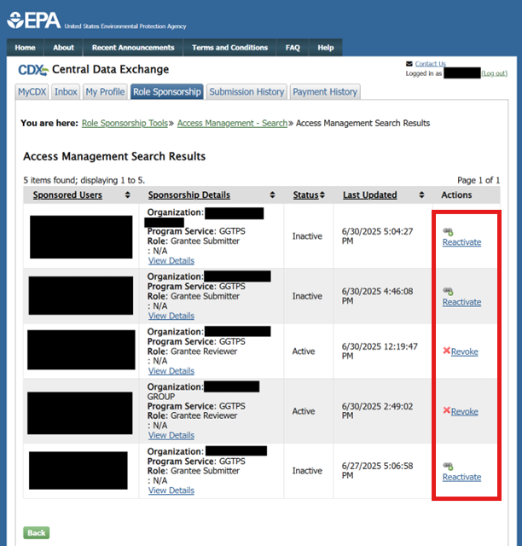

Image 18: Example of the CDX Role Sponsorship "Access Management" tool.

The affected user will receive an email notification with details.

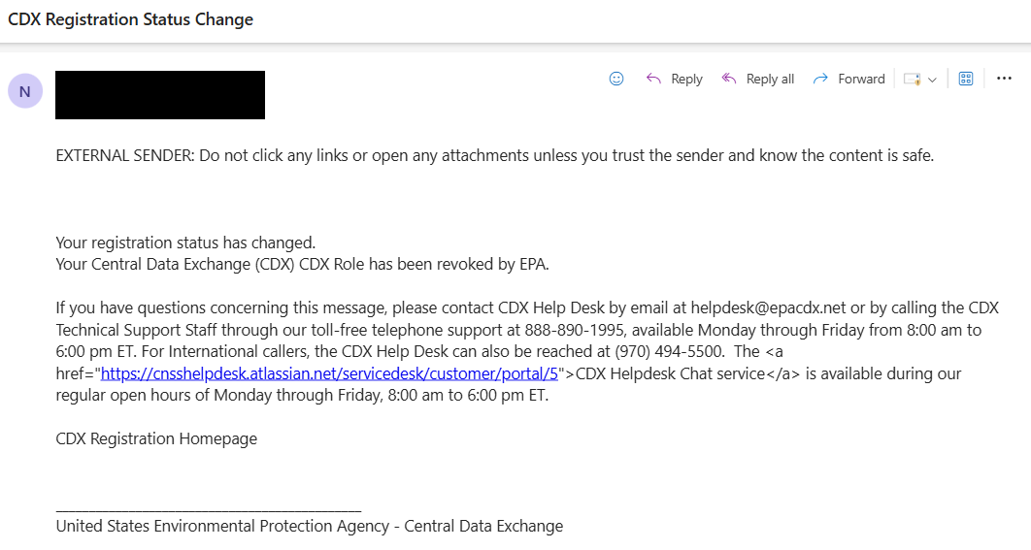

Image 19: Example of a CDX generated email when a role has been revoked.

# 3) Grantee Submitter, Reviewer, and Approver Roles

The Grantee Submitter, sometimes referred to as the prime recipient or Grantee, is responsible for uploading information related to the transactions and project reporting.

The Grantee Reviewer and/or the Grantee Approver are the roles responsible for reviewing and signing submissions uploaded by a Grantee Submitter.

*The Grantee Submitter, Grantee Reviewer, and Grantee Approver should be individuals that work at the prime recipient*.

## Accepting Sponsorship Invitations

To access the TaPS application these roles must be sponsored by an AoR. The AoR initiates the workflow by inviting the Grantee Submitter, Reviewer, and/or Approver, who will receive an email notification from the CDX environment to complete their account setup.

The email provides the user with two options; to review or cancel the sponsorship request:

1. Click the link to "review this sponsorship”.

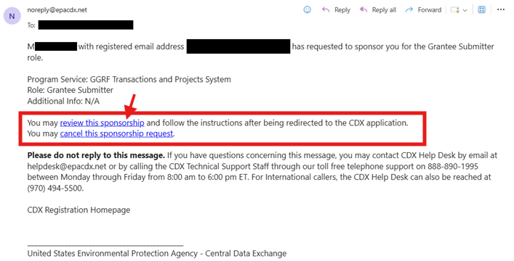

Image 20: Example of a CDX generated email for a role sponsorship request.

* 1. Note: If the user chooses to cancel the sponsorship, accessing the link immediately cancels the sponsorship and they will receive an email notification.

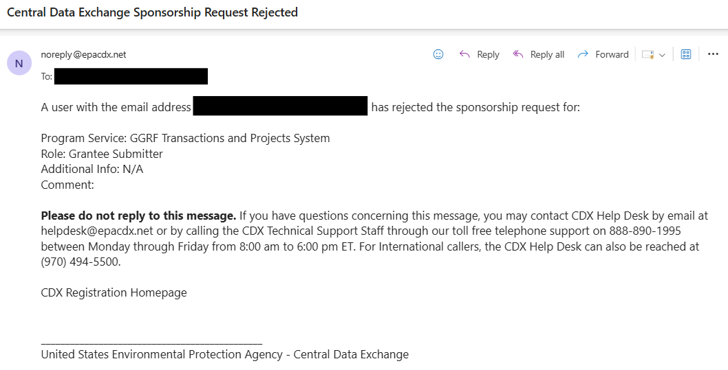

Image 21: Example of a CDX generated email for a rejected sponsorship request.

1. On the "Role Sponsorship Process" screen, select the user ID from the drop-down.

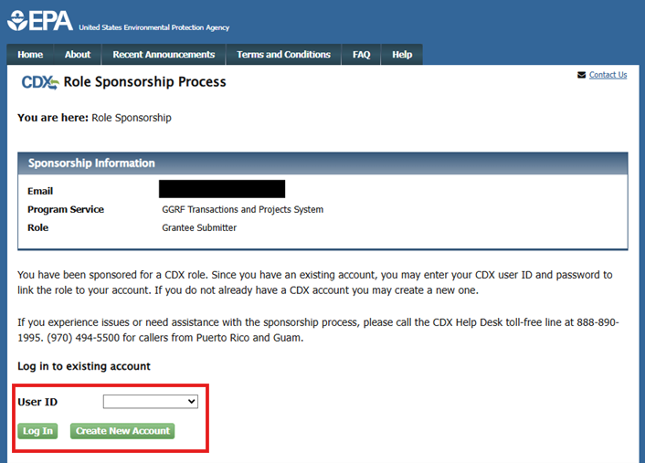

Image 22: Log In page for the Role Sponsorship Process.

* 1. Note: If a user does not have an existing CDX Account, they will be prompted to enter a new User ID and complete Account Registration before access is granted.

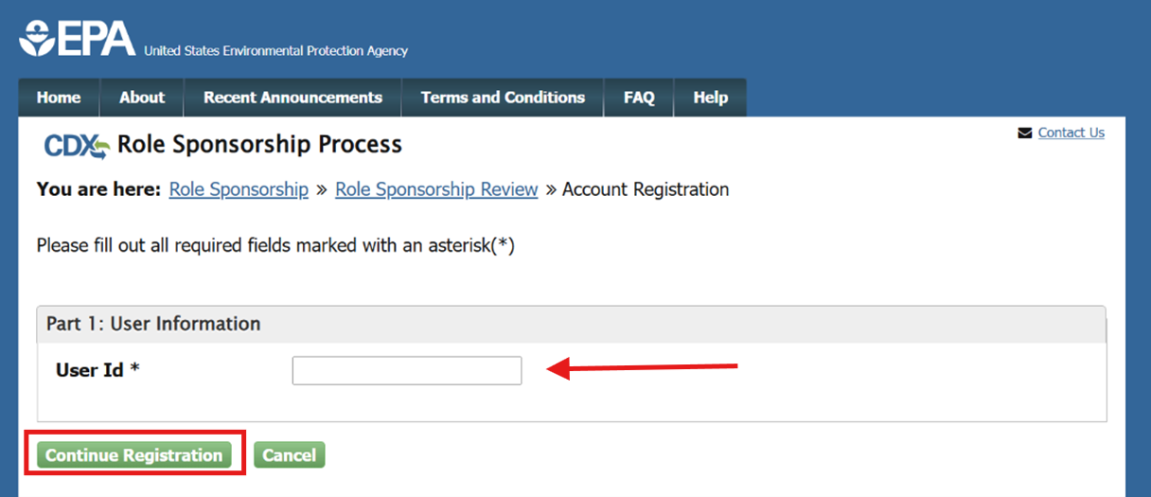

Image 23: CDX Account Registration page for the Role Sponsorship Process.

1. Click “Proceed to Login.gov”.
   1. For additional information about getting started with login.gov or issues signing in, please visit: <https://www.login.gov/help/>

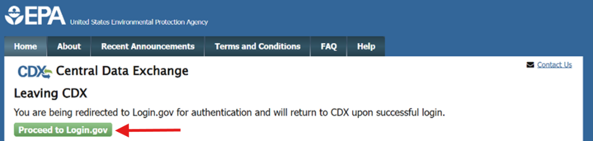

Image 24: CDX redirect page to Login.gov for authentication.

1. "Approve" the sponsorship.

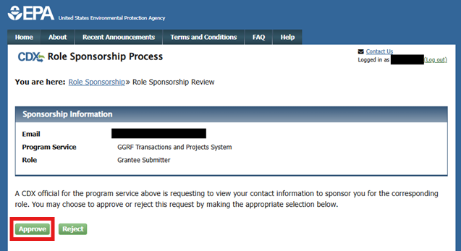

Image 25: Role Sponsorship Review page in CDX.

1. If applicable, "Select a Current Organization" or "Request to Add an organization". Then click "Submit Request for Access".

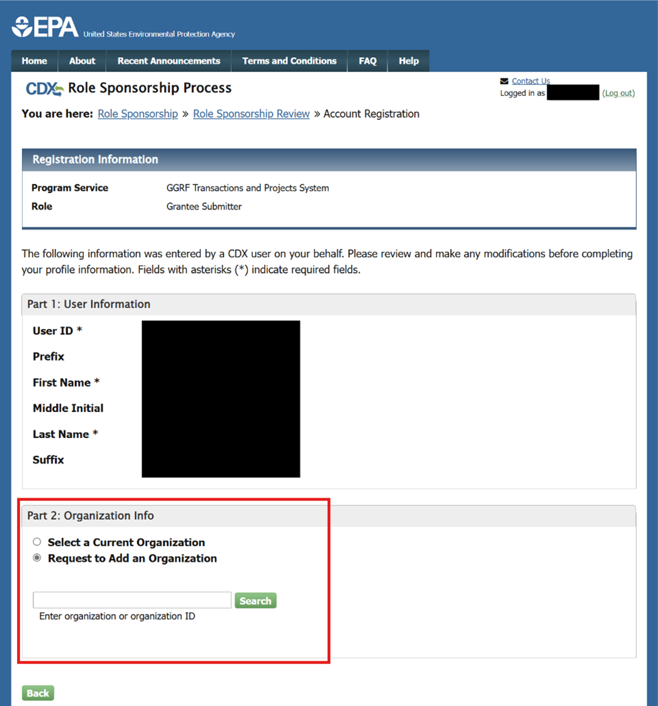

Image 26: Account Registration page in the Role Sponsorship Process in CDX.

1. The user will be redirected to the MyCDX Page. Please note that the setup is not yet completed and the status will say “Awaiting Sponsorship”. Now, the action is on AoR to "Approve" or "Reject" the sponsorship.

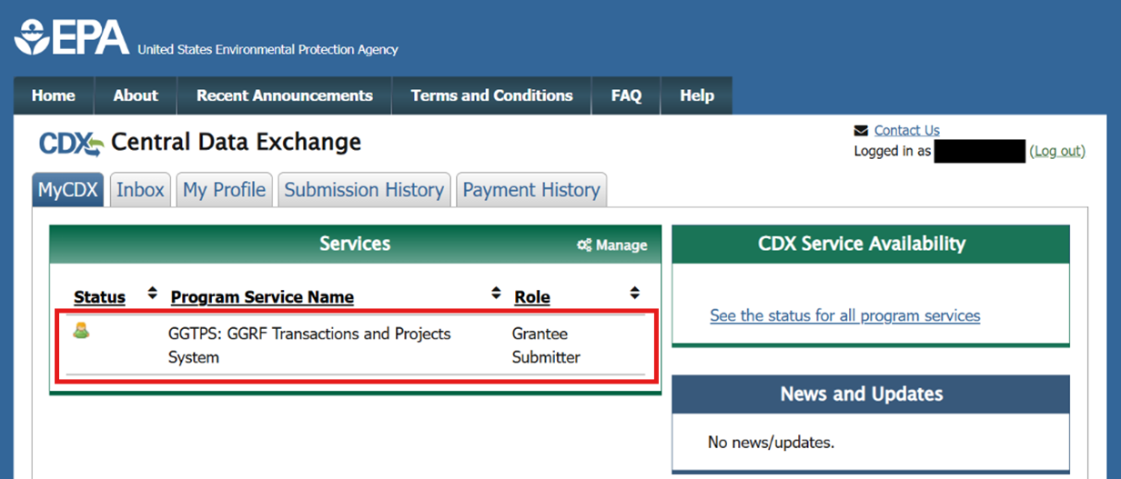

Image 27: Example of the MyCDX Page with a "pending" Grantee Submitter Role.

## Completing Account Registration

1. Once the AoR has approved the sponsorship, you will receive an email to “log in to complete your account registration”, click the link to continue.

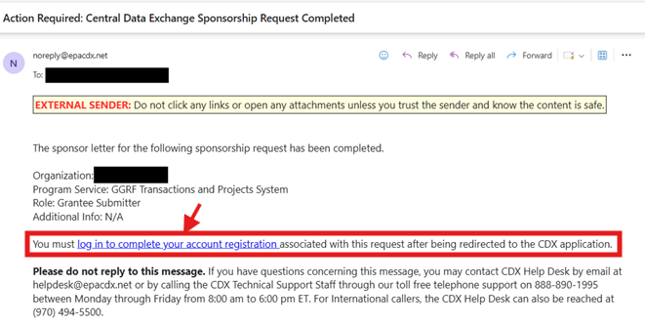

Image 28: Example of a CDX generated email when a sponsor letter is received.

1. Review the information on the screen for accuracy and click “Log In”.

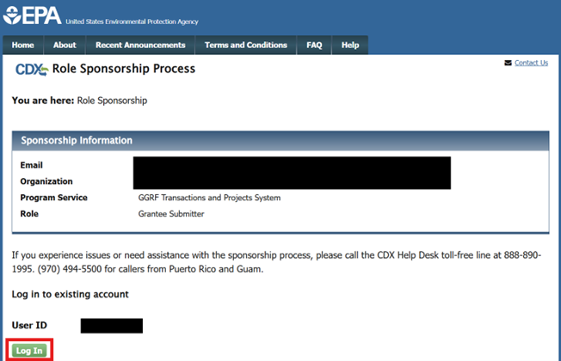

Image 29: Log In page for the Role Sponsorship Process in CDX.

1. Click “Proceed to Login.gov”.
   1. For additional information about getting started with login.gov or issues signing in, please visit: <https://www.login.gov/help/>

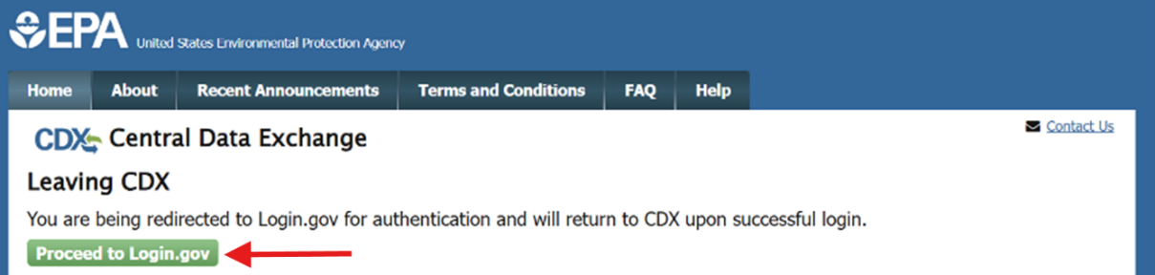

Image 30: CDX redirect page to Login.gov for authentication.

1. Provide your Contact Information and then click “Submit.”.

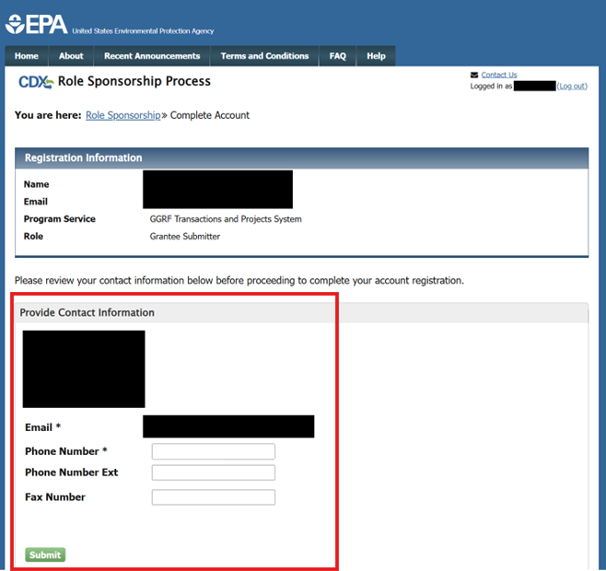

Image 31: Complete Account page in the Role Sponsorship Process.

1. At this point Grantee Submitters will be redirected to the MyCDX Page. Please note that their setup is complete, however final approval will be needed by the OGGRF Admin before the Grantee Submitter can access the TaPS Application. The Grantee Submitter will receive an email notification once this is completed and their role is activated.

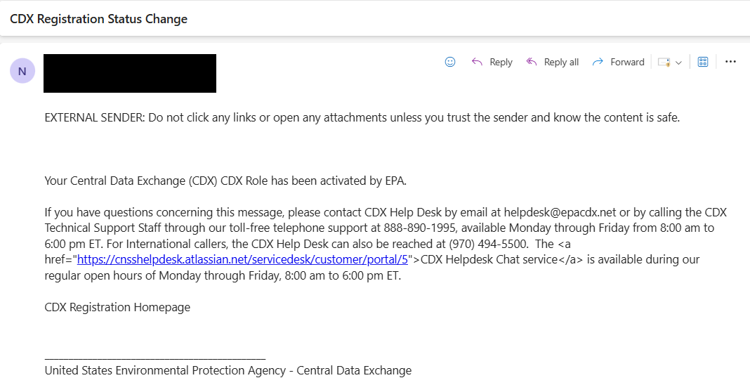

Image 32: Example of a CDX generated email for role activation.

* 1. Note: Grantee Reviewers and Approvers will be required to complete additional identity verification steps that are detailed in the next section.

## Grantee Reviewer/Approver Identity Verification

1. After completing account setup, the Grantee Reviewer/Approver will automatically begin the Lexis Nexis identity verification process. Fill out the required fields and click “Proceed with Verification”.

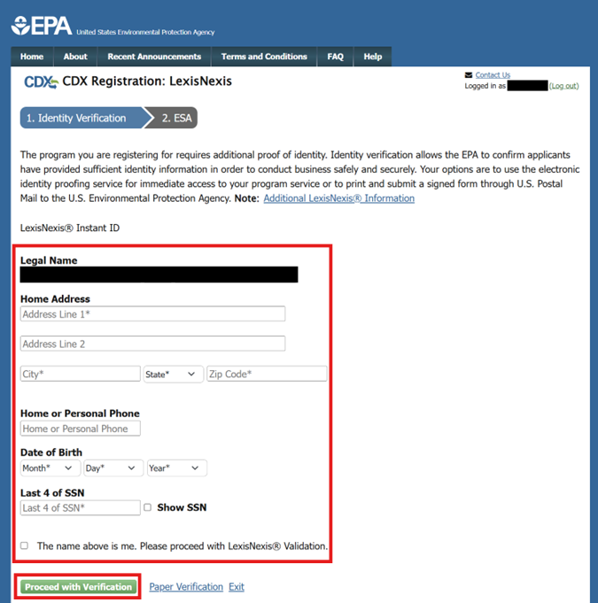

Image 33: Identity Verification page in CDX for Lexis Nexis.

* 1. Note: If the user does not pass the identity verification required (or if they chose “Paper Verification”), they must click “Sign Paper Form” to print and mail the paper form to the office listed in the pop-up modal. After the form has been received and processed, the CDX helpdesk with continue with activating the desired role.

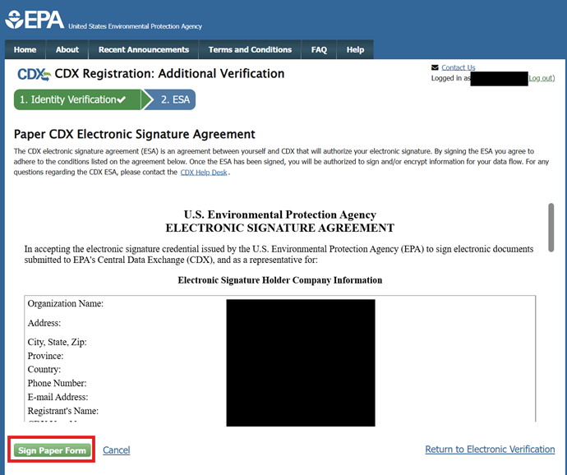

Image 34: Paper CDX Electronic Signature Agreement (ESA) page.

1. Once the user passes identity verification, they should review the agreement and click “Sign Electronically” then “Accept”.

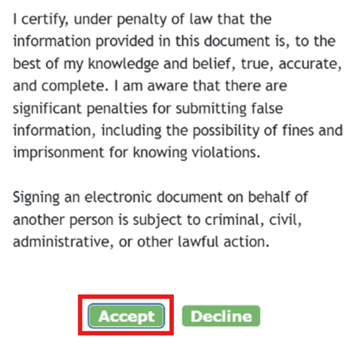

Image 35: Example of a certification pop-up modal for Electronic Signatures.

1. Please note that the setup is now complete for the Grantee Reviewer/Approver, however final approval will be needed by the OGGRF Admin before the sponsored user can access the TaPS Application.

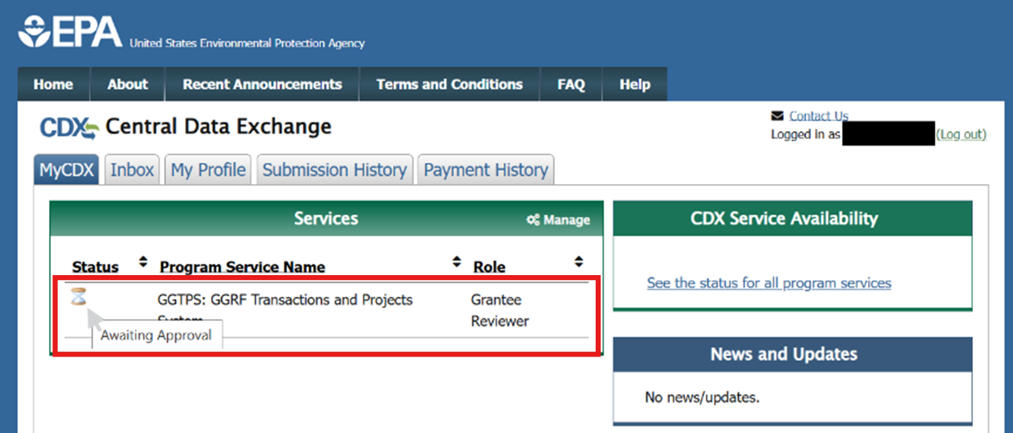

Image 36: Example of the MyCDX Page with a Grantee Reviewer role "Awaiting Approval".

1. The sponsored user will receive an email notification once the role is activated.



Image 37: Example of a CDX generated email when a role has been activated.

# Conclusion

Aside from the AoR role, all roles must be sponsored/invited before access can be granted to the CDX environment.

For any questions related to accessing the CDX environment, contact your Project Officer.

If issues persist, please contact CDX Helpdesk by email at [helpdesk@epacdx.net](mailto:helpdesk@epacdx.net) or by calling the CDX Technical Support Staff through the toll-free telephone support at 888-890-1995, available Monday through Friday from 8:00 am to 6:00 pm ET.