# **Registering as a Preparer**

This job aide includes information on the following steps related to registering as a Preparer for the Electronic Permit System (EPS) program service.

The Preparer is the person within a given permitting authority that is responsible for preparing and submitting permit actions to the Environmental Protection Agency (EPA).

* Accessing the CDX Homepage
* Adding the Electronic Permit System Program Service to an Existing CDX Account
* Creating a New CDX Account
* Organization Information
* Confirming your Account Registration
* Registration Notifications
* Support

Accessing the CDX Homepage

1. Access the Central Data Exchange (CDX) home page directly by selecting this URL (or entering it into your browser): <https://cdx.epa.gov/>. The homepage provides you with the following features:
   1. **Log in:** If you already have an existing CDX account, you may log into the system by entering your User ID and Password, and clicking the ‘Log In’ button (see Figure 1). Then proceed to the next section to add the Electronic Permit System program service to your account.
   2. **Registration:** If you do not have an account with CDX, click the ‘Register with CDX’ button (see Figure 1) and proceed to Creating a New CDX Account to begin the CDX registration process.

Figure : CDX Web Home Page

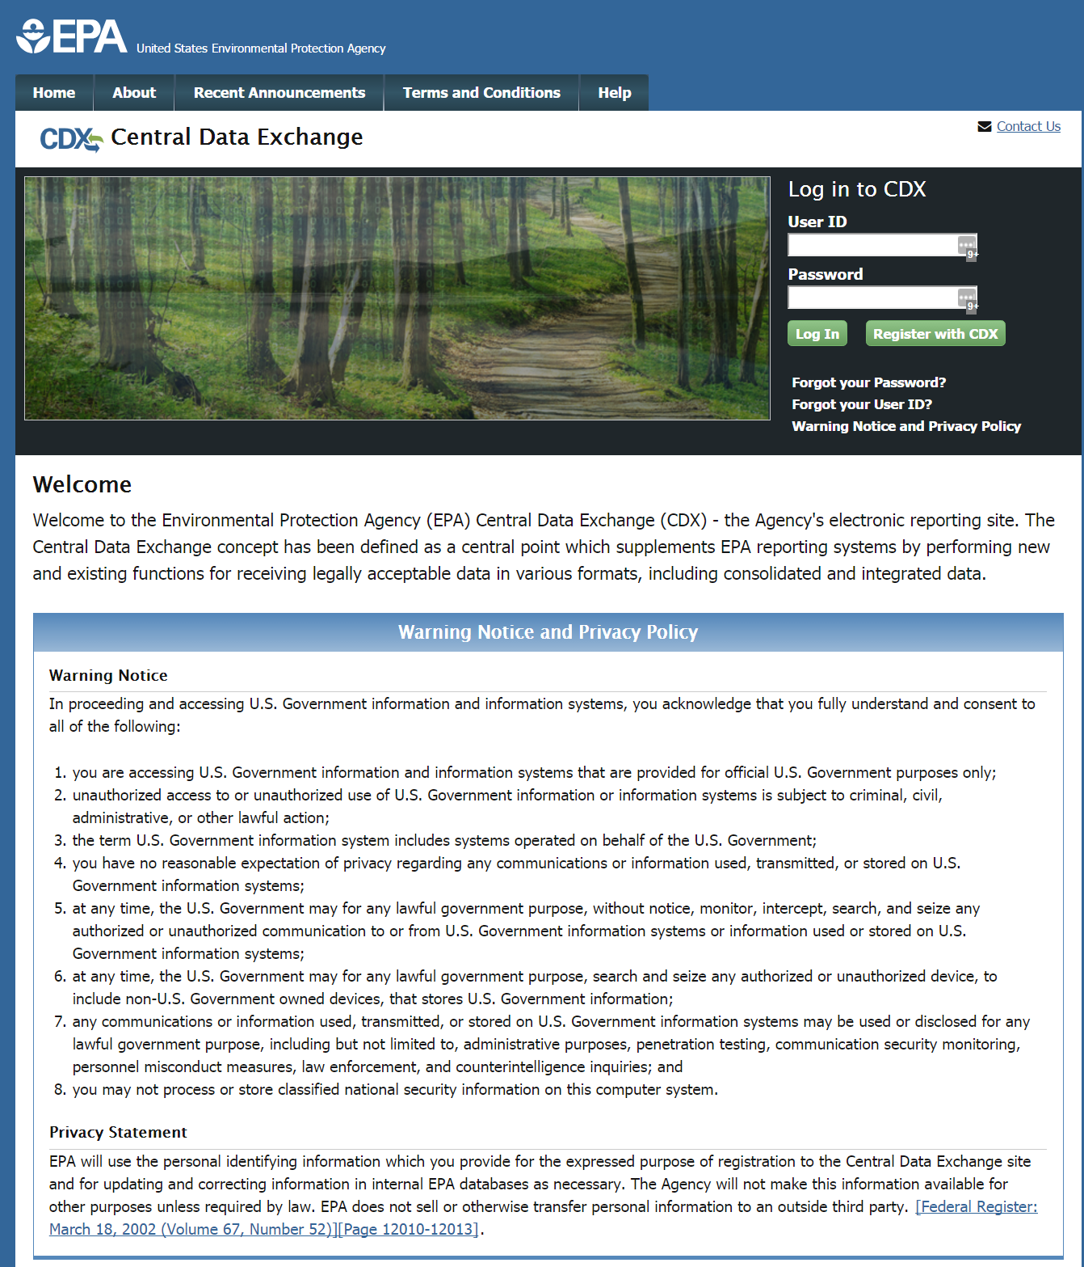

Adding the Electronic Permit System Program Service to an Existing CDX Account

1. On the MyCDX page, select the ‘Add Program Service’ button (see Figure 2).

Figure : MyCDX Page

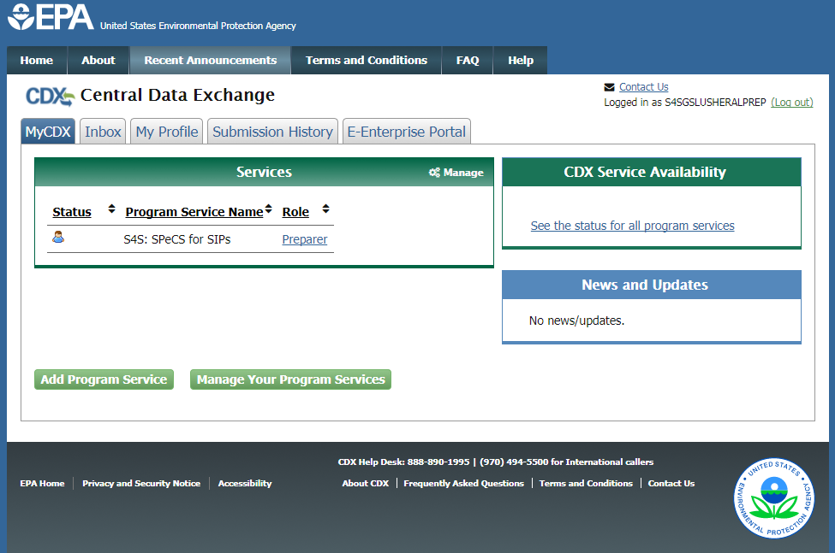

1. The Edit Account Profile screen will appear. Search for the Electronic Permit System program service in the Program Service page by entering the program service name in the ‘Active Program Services List’ text box (See Figure 3).

Figure : Selecting a Program Service

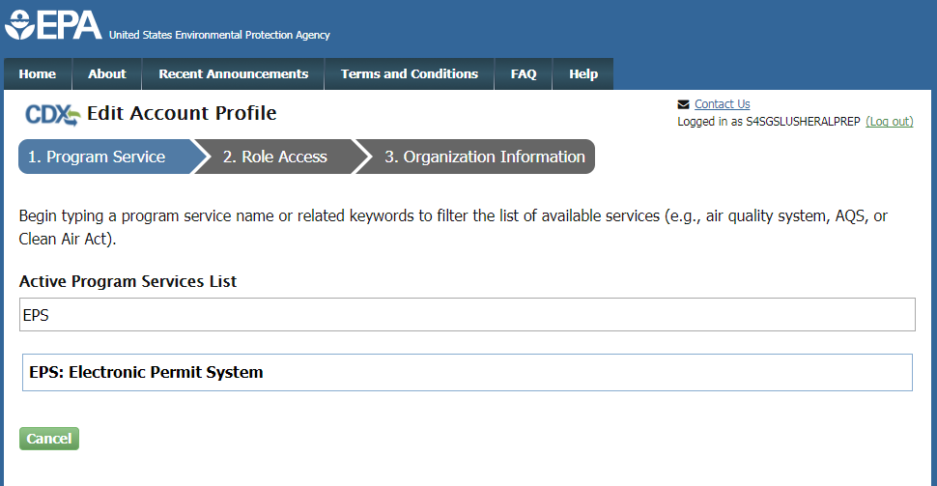

Enter ‘EPS’ or ‘Electronic Permit System’ in this text box

1. Select the ‘Electronic Permit System’ program service once it appears on the list.
2. You will be automatically redirected to the Role Access page (see Figure 4). Select the ‘Preparer’ role from the dropdown list on the Role Access page.
3. The ‘Permitting Authority’ field will appear after selecting the ‘Preparer’ role. From the dropdown field, select the Permitting Authority you are affiliated with.
4. Select the ‘Request Role Access’ button to complete adding the role to your account.

Figure : Role Access Page

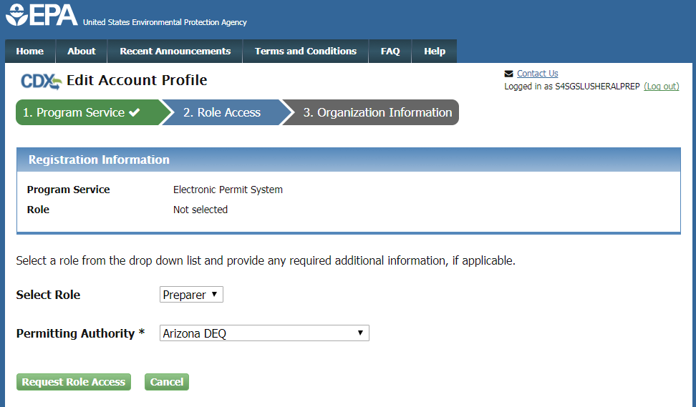

1. The Organization Information page will appear. On the Organization Information page (see Figure 5), choose one option from the following:
2. *Select a Current Organization*. If you already have other CDX Program Services associated with your account, this option will display the list of organizations that you associated with those program services. Select the appropriate organization from the dropdown list to associate with your Electronic Permit System role.
3. *Request to Add an Organization*. This option prompts you to enter keyword(s) to search for the name of the organization you wish to associate with your Electronic Permit System role.
   * 1. If you see your organization in the search results table, click on the appropriate organization ID to select your organization.
     2. If the simple search returns too many results, you may 1) click on the “Use advanced search” at the bottom of the page; or 2) enter new keywords in the search box.
     3. If you cannot locate your organization in the search results, you may click the ‘Request that we add your organization’ link at the bottom of the page. The form will expand and you can enter the name, address, and other information for the new organization.
4. Select the ‘Submit Request for Access’ button.
5. A notification will be sent to an EPA Registration Maintenance Account Manager (RMAM) to review and approve your request for access. You will be notified via email once your request has been approved. Once approved, please log into CDX with your CDX username and password and select the ‘Preparer’ role hyperlink on the MyCDX homepage to access the Electronic Permit System program service.

Figure : Organization Information Page

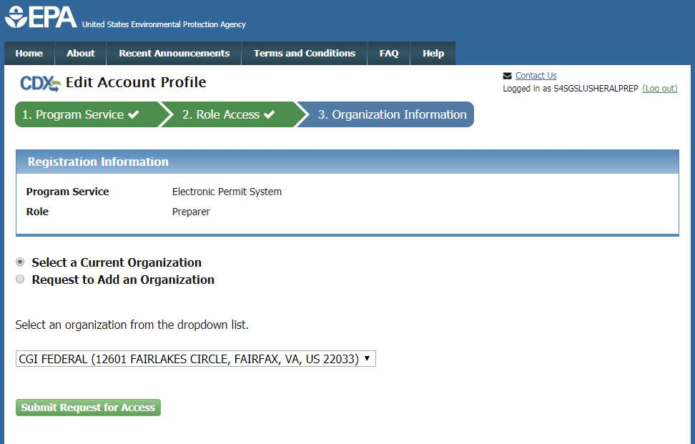

Creating a New CDX Account

1. Go to the CDX Home Page at <https://cdx.epa.gov/>. To create a new CDX account, click the ‘Register with CDX’ button (see Figure 1).
2. The CDX ‘Terms and Conditions’ screen will be displayed, documenting the terms and conditions. To continue, accept the terms and conditions by selecting the ‘I am this registrant. I will not share my account, and I accept the terms and conditions, above.’ checkbox and the ‘Proceed’ button (see Figure 6).
   1. You may cancel the registration process by selecting the ‘Cancel’ hyperlink. Note that if you decline the terms and conditions, you will not be able to proceed with the registration.
   2. Once you have accepted the registration agreement, you are redirected to proceed with the registration process.

Figure : CDX Terms and Conditions

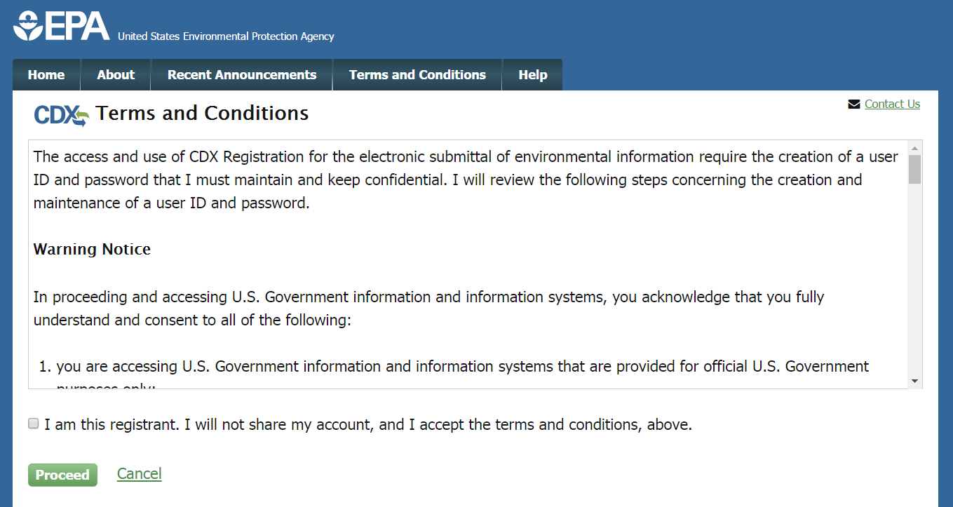

1. The ‘Request Program Service’ screen displays a list of active program services (see Figure 7). You may filter the active program service list by typing the program service name or related keywords in the text bar.
2. Select ‘EPS: Electronic Permit System’ from the Active Program Service List by clicking on the list item.

Figure : Program Service Selection

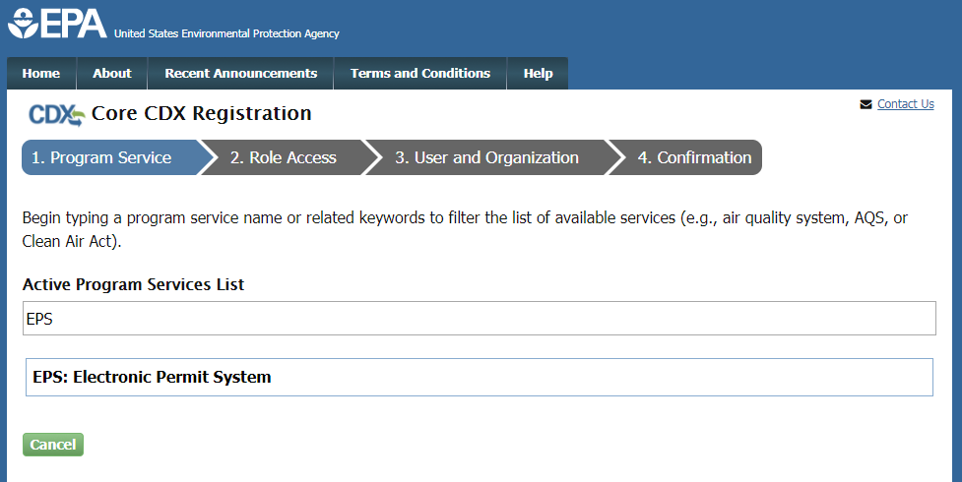

Enter ‘EPS’ or ‘Electronic Permit System’ in this text box

1. You will be automatically redirected to the Role Access page (see Figure 8). Select the ‘Preparer’ role from the dropdown list on the Role Access page.
2. The ‘Permitting Authority’ field will appear after selecting the ‘Preparer’ role. From the dropdown field, select the Permitting Authority you are affiliated with.
3. Select the ‘Request Role Access’ button to complete adding the role to your account.

Figure 8: Role Access Page

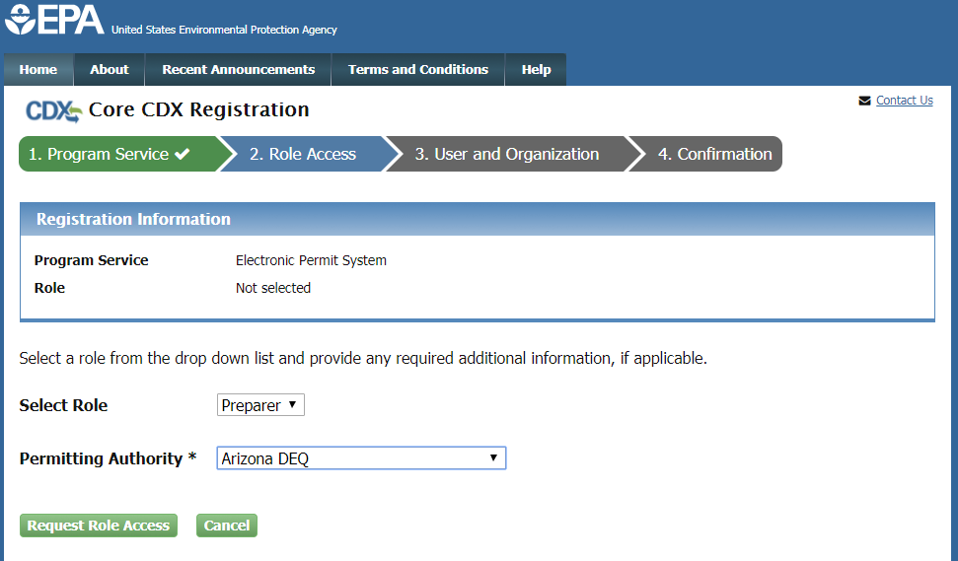

Organization Information

1. The User and Organization Information Page will appear. On the ‘Part 1: User Information’ section of the ‘User and Organization’ page, enter your user information in all of the required fields marked with an asterisk (see Figure 9).
   1. The ‘Security Question’ and ‘Security Answer’ selections are used for identity authentication in the event you forget your password and need to reset it. The answers you provide to the security questions are case insensitive.

**Note:** It is important that you carefully note your input for the ‘User ID’ and ‘Password’ fields, as you are prompted for this information during the Electronic Permit System submission process and will need to provide an exact match for authentication.

Figure : User and Organization Information Page

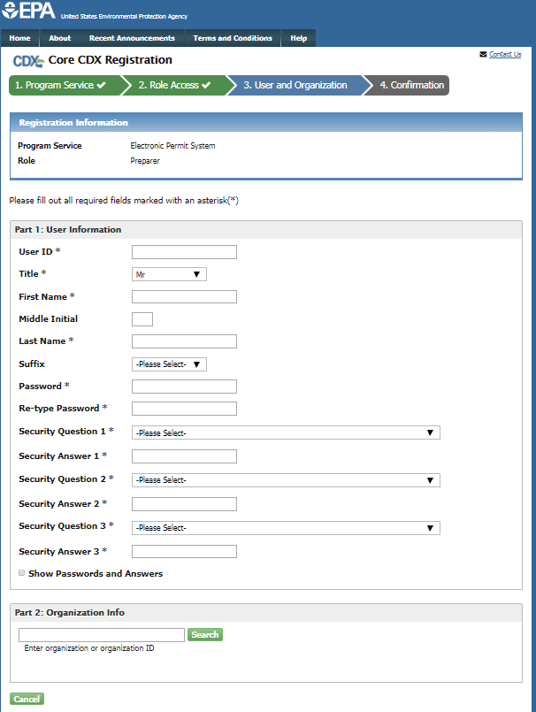

1. On the ‘Part 2: Organization Info’ section of the ‘User and Organization’ page, search for the name of your existing organization (see Figure 10).

Figure : Organization Search

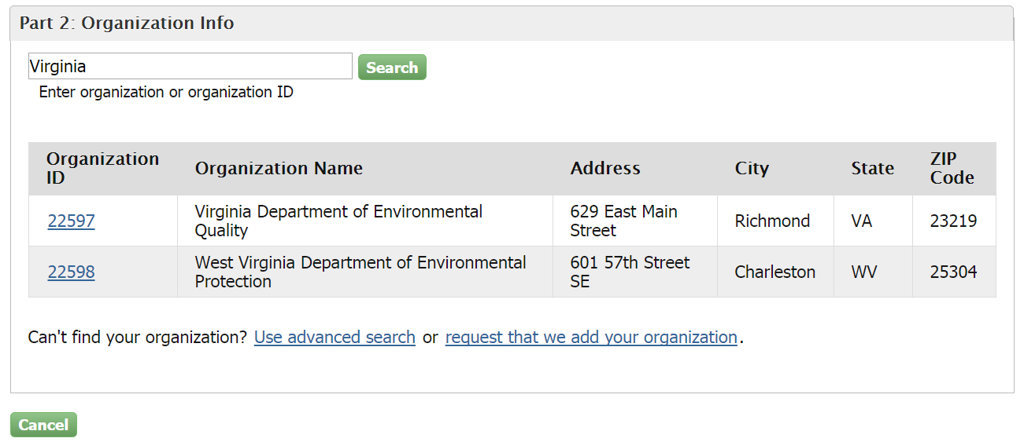

* 1. If you see your organization in the search results table, click on the appropriate organization ID to select your organization.
     1. If the simple search returns too many results, you may use the advanced search option or choose to search again with modified keyword(s).
     2. Once an existing organization has been selected, you are required to enter an email and phone number with the option of entering a phone number extension or fax number (see Figure 11).

**Warning:** Search results only include “verified” organizations (i.e. organizations that have been verified electronically or has an approved paper Electronic Signature Agreement) unless the search is specifically conducted using the ‘Organization Id’.

This means that organizations created by Certifiers with approved ESAs are returned in search results if the search is conducted by organization name. Organizations created by Preparers will not be returned in the identical search since Preparers are not required to have an ESA.

All users within your Permitting Authority do not need to be registered to the same organization in order to be able to view and/or submit Permit Actions within your Permitting Authority.

Figure 11: Organization Information

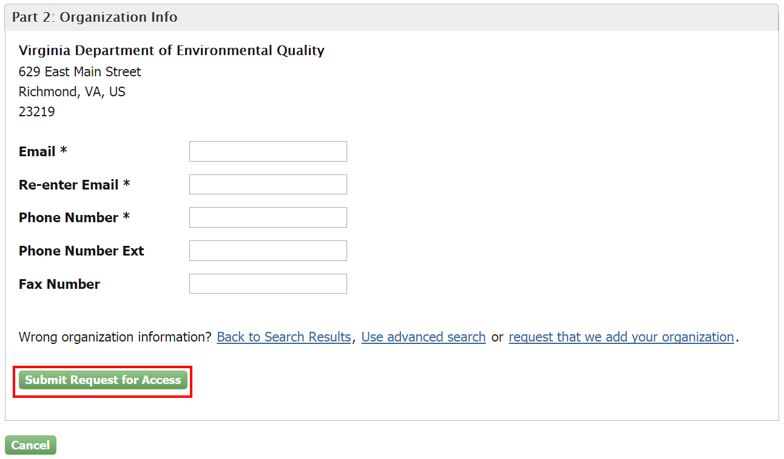

* 1. If you cannot locate your organization in the search results, you may create a new organization by clicking the ‘request that we add your organization’ link (see Figure 10). Clicking the link will take you to the Organization Information page where you can enter required organization details (See Figure 12).

Figure 12: Creating a New Organization

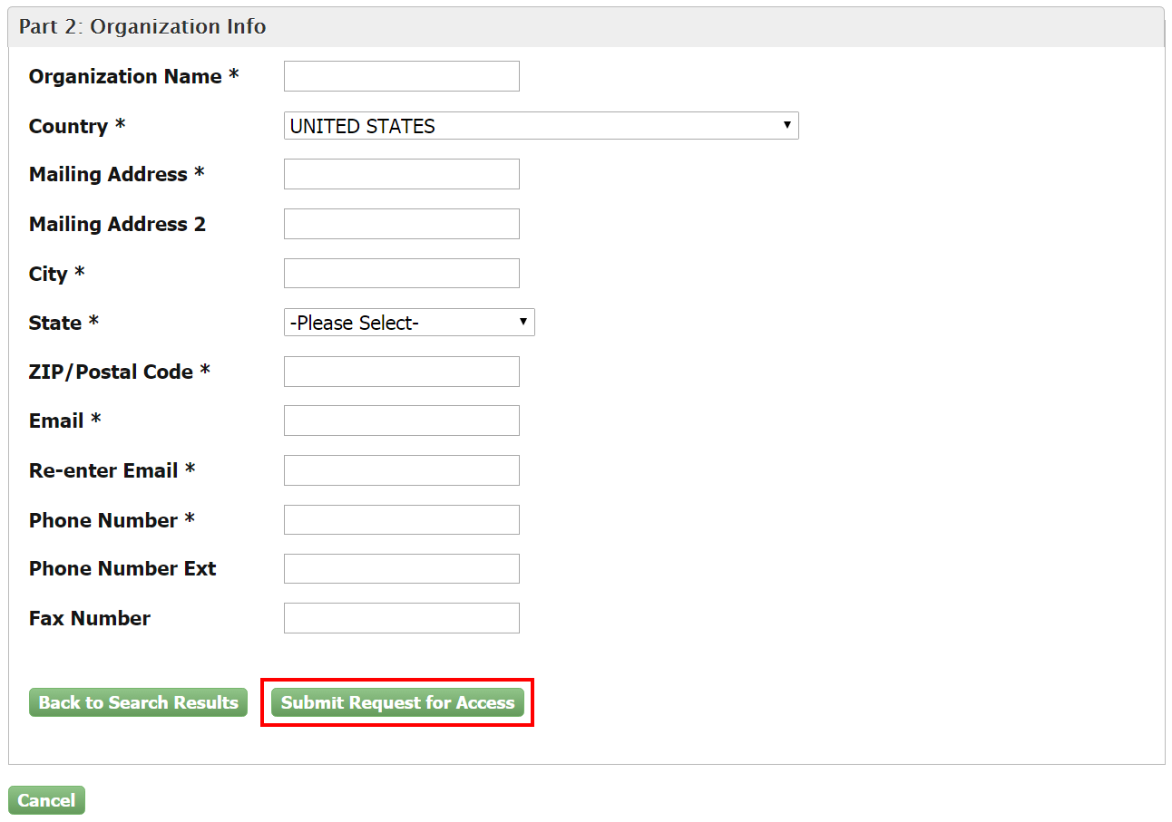

1. Select the ‘Submit Request for Access’ button to proceed with registration.
   1. A confirmation page will appear stating that you will receive an email from CDX to activate your account shortly (see Figure 11).

Figure 11: Registration Confirmation

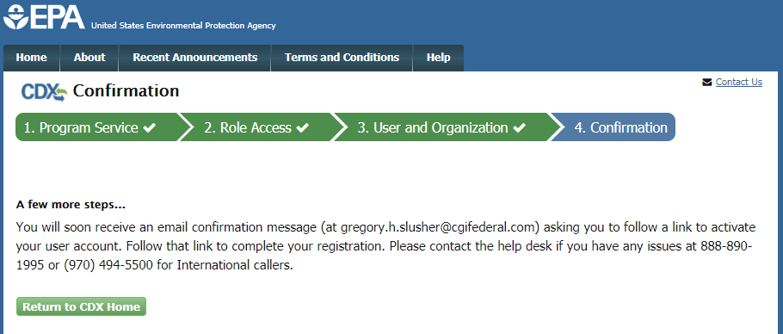

Confirming your Account Registration

1. Access your email account, and open the email sent from CDX with the subject of ‘Core Registration Email Verification Request’ (see Figure 12).
2. Select the hyperlink within the email, which will direct you to CDX. From the CDX homepage, log in to activate your account.

Figure : CDX Email Verification Request

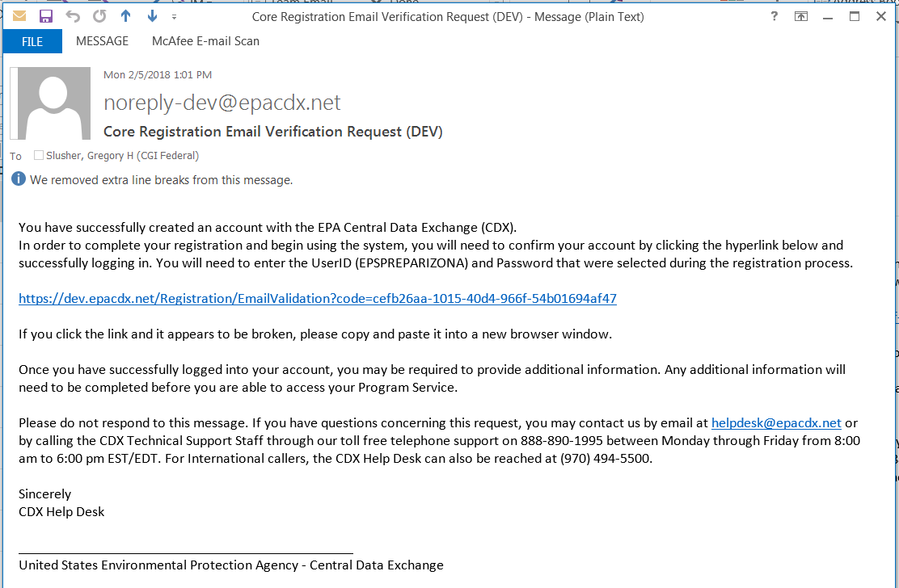

Registration Notifications

1. After completing the registration process, CDX will send you an email confirming your successful registration (see Figure 13).

Figure : CDX Registration Confirmation Email

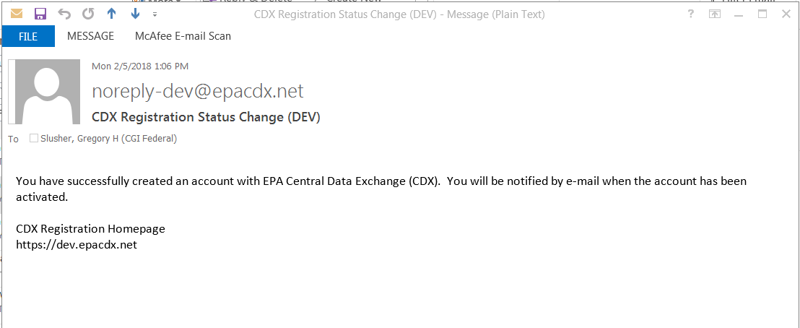

1. Upon logging in to CDX or navigating to the ‘MyCDX’ screen, the Preparer role is listed under the ‘Services’ section of the screen.
   1. You cannot access the Electronic Permit System until EPA has reviewed and approved your request for access.
   2. Until EPA has reviewed and approved your request, an hourglass  icon will be shown indicating that your account is awaiting approval.
2. A notification will be sent to an EPA Registration Maintenance Account Manager (RMAM) to review and approve your request for access. You will be notified via email once your request has been approved (see Figure 14). Once approved, please log into CDX with your CDX username and password and select the ‘Preparer’ role hyperlink on the MyCDX homepage to access the Electronic Permit System program service.
   1. Once your role has been approved by EPA, the EPS: Electronic Permit System’ Preparer role will have an active hyperlink and the Active icon, signifying that the role is active.

**Figure 14: Active Role Notification**

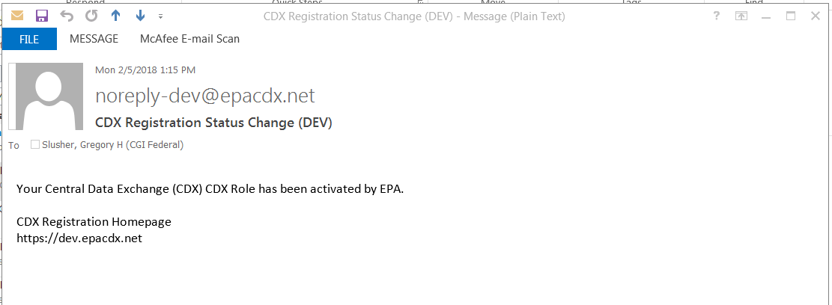

**Support**

If you have any questions related to whether or not you should register as a Preparer for Electronic Permit System, please contact your EPA Regional Office contact.

If you have any questions related to CDX, the Preparer registration process, or the Electronic Permit System program service, please contact the CDX Help Desk at [helpdesk@epacdx.net](mailto:helpdesk@epacdx.net) or by telephone at 888-890-1995.