SmartWay Technology Application Reporting System (STARS)

Submission User Guide

Environmental Protection Agency

Office of Air and Radiation (OAR)

Version 2.1

November 8, 2019

Table of Contents
1 Introduction 1
1.1 Purpose 1
1.2 Background 1
1.3 Technology Applications Supported by STARS 1
1.4 System Requirements 1
1.4.1 Supported Browsers 1
2 STARS Tasks 3
2.1 Access the STARS Program Service 3
2.2 Create a STARS application 5
2.3 Applicant Company Information 6
2.3.1 Add a New Company 8
2.4 Product Information 9
2.4.1 Low Rolling Resistance Tires (LRRT) Product Information 9
2.4.2 Idle Reduction Technology (IRT) Product Information 13
2.5 Laboratory and Testing Information 19
2.6 Manufacturer Information 20
2.6.1 Manufacturer Address 21
2.6.2 Factory Address 21
2.6.3 Applicant/Manufacturer Relationship 22
2.7 Laboratory Test Results 23
2.7.1 Low Rolling Resistance Tires (LRRT) Lab Test Results 23
2.7.2 Idle Reduction Technology (IRT) Lab Test Results 24
2.8 Additional Information 25
2.8.1 General Comments 26
2.8.2 Technology Application Review 27
2.9 Submit a STARS Application 27
2.10 Work on a ‘Draft’ Application 28
2.10.1 Save a ‘Draft’ Application 28
2.10.2 Continue a ‘Draft’ Application 28
2.10.3 Delete a ‘Draft’ Application 29
2.11 Review a Submitted STARS Application 29
2.12 Download ‘Approved’ Application Approval Letter 29
2.13 Resubmit a ‘Pushed Back’ Application 30
2.14 Amend an ‘Approved’ Application 31
2.15 Withdraw an ‘Approved’ Application 31

List of Figures
Figure 2-1 Accessing STARS from CDX 3
Figure 2-2 STARS Home Page 5
Figure 2-3 Create New Application – Select Technology 6
Figure 2-4 Applicant Company Information 7
Figure 2-5 Request to Add Applicant Company 8
Figure 2-6 Foreign Address File Upload 9
Figure 2-7 LRRT Brand Name and Model Information 10
Figure 2-8 Adding a Brand Name and Model 10
Figure 2-9 Product, Size, and Position Information (New Tire) 12
Figure 2-10 Product, Size, and Position Information (Retread Tire) 12
Figure 2-11 IRT Brand Name and Model Information (1 of 3) 13
Figure 2-12 IRT Brand Name and Model Information (2 of 3) 13
Figure 2-13 IRT Brand Name and Model Information (3 of 3) 14
Figure 2-14 IRT Brand / Model Information (1 of n) 15
Figure 2-15 IRT File Uploads (1 of 2) 16
Figure 2-16 IRT File Uploads (1 of 2) (6 of n) 17
Figure 2-17 IRT Additional Questions 18
Figure 2-18 IRT Laboratory Information (1 of 2) 18
Figure 2-19 IRT Laboratory Information (2 of 2) 19
Figure 2-20 Laboratory and Testing Information 20
Figure 2-21 Add a New Test Lab 20
Figure 2-22 Manufacturer Information 21
Figure 2-23 Factory Information 22
Figure 2-24 Applicant/Manufacturer Relationship 22
Figure 2-25 Tire Test Results 23
Figure 2-26 Test Method and Test Sheet Upload 24
Figure 2-27 Results of Laboratory Test – IRT (1 of 2) 25
Figure 2-28 Results of Laboratory Test – IRT (2 of 2) 25
Figure 2-29 General Comments and Attachments 26
Figure 2-30 Accuracy Statement 27
Figure 2-31 Electronic Signature Process 28
Figure 2-32 Continuing a Draft Application 29
Figure 2-33 Review Approved Application 30
Figure 2-34 Download Approval Letter 30
Figure 2-35 Review EPA Comments 30
Figure 2-36 Revise Pushed Back Application 31
Figure 2-37 Amend Approved Application 31
Figure 2-38 Withdraw Approved Application 32
Figure 2-39 Specify Reason for Withdrawal 32

Introduction
The SmartWay Technology Application Reporting System (STARS) is the electronic, web-based tool provided by the Environmental Protection Agency’s (EPA’s) Office of Air and Radiation (OAR) for the electronic submission of SmartWay technology verification applications to EPA. The STARS tool is available to users through EPA’s Central Data Exchange (CDX), a web-based system used for various electronic environmental data submissions to EPA. Under EPA’s “E-Reporting” rules, users wishing to submit SmartWay applications to EPA must register for access to the STARS program service through CDX. More information about CDX is available at https://cdx.epa.gov/.

Purpose
The purpose of this document is to help users submit Smartway technology applications using STARS. This user guide is intended for the ‘Primary Applicant’ and ‘Applicant’ users of the STARS program service. Users wishing to submit SmartWay technology applications first need to register for the STARS program service within CDX (see CDX STARS Registration User Guide for assistance).

Background
EPA’s SmartWay program helps companies advance supply chain sustainability by measuring, benchmarking, and improving freight transportation efficiency.
Through SmartWay technology verification and branding, EPA has accelerated availability, adoption and market penetration of fuel-saving technologies and operational practices while helping companies save fuel, lower costs and reduce adverse environmental impacts. Learn how to use the SmartWay brand.
For questions concerning CDX, please contact the CDX Help Desk at helpdesk@epacdx.net or call 1-888-890-1995 between the hours of 8a.m. – 6p.m. Eastern Standard Time (EST).

Technology Applications Supported by STARS
STARS can be used to submit applications for verification of two technology categories: Low Rolling Resistance Tires (LRRT) and Idle Reduction Technologies (IRT). Application forms for Aerodynamics technologies and Retrofit technologies will be added in the near future.

System Requirements
In order to use CDX and STARS, the following is required:
- An email account
- Java Script enabled web browser
- Internet access

Supported Browsers
- Internet Explorer 9 or above
- Go to the following link to download:
http://windows.microsoft.com/en-US/internet-explorer/downloads/ie
- Mozilla Firefox 3.5 or above
- Go to the following link to download:
http://www.mozilla.com/en-US/firefox/all-older.html
- Safari 4 or above
- Go to the following link to download:
http://support.apple.com/kb/dl877
- Google Chrome
- Go to the following link to download:
http://www.google.com/chrome
Note – Browsers not supported:
Microsoft Edge browser should not he used to access the STARS program service.

STARS Tasks
The following sections describe the tasks a user performs when submitting applications to EPA using the STARS program service:
- Access the STARS Program Service: (see Section 2.1)
- Create a STARS Application: (see Section 2.2)
- Submit a STARS Application: (see Section 2.9)
- Work on a ‘Draft’ Application: (see Section 2.10)
- Review a Submitted STARS Application: (see Section 2.11)
- Download ‘Approved’ Application Approval Letter: (see Section 2.6)
- Resubmit a ‘Pushed Back’ Application: (see Section 2.7)
- Amend an ‘Approved’ Application: (see Section 2.8)
- Withdraw an ‘Approved’ Application: (see Section 2.9)

Access the STARS Program Service
Once logged in to CDX, the ‘STARS: SmartWay Technology Application Reporting System’ is listed in the ‘Services’ section of the page. Select the ‘Primary Applicant’ or ‘Applicant’ Role hyperlink to access the STARS application (see Error! Reference source not found.).
Figure 2-1 Accessing STARS from CDX
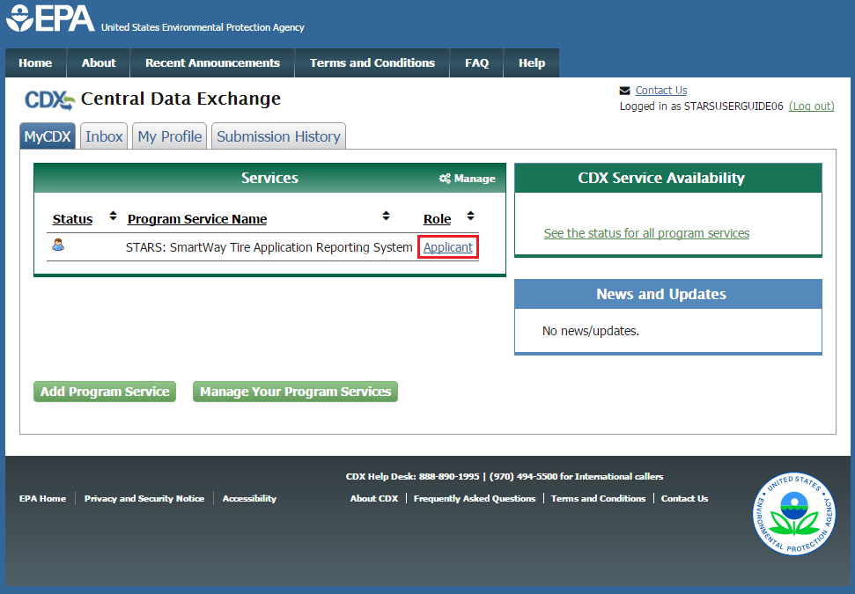
After clicking the Applicant hyperlink, you enter the STARS application where you see the STARS home page (See Error! Reference source not found.). All applications that have been created for the CDX Organization that you registered with will be displayed (see CDX STARS Registration User Guide).
From the STARS home page you can:
- Create a new STARS application (see Section 2.2)
- Continue a ‘Draft’ application (see Section 2.10.2)
- Delete a ‘Draft’ application (see Section 2.10.3)
- Review a Submitted application (see Section 2.11)
- Download ‘Approved’ Application Approval Letter: (see Section 2.6)
- Resubmit a ‘Pushed Back’ Application: (see Section 2.7)
- Amend an ‘Approved’ Application: (see Section 2.8)
- Withdraw an ‘Approved’ Application: (see Section 2.9)
- Navigate back to MyCDX
- Log out of CDX
At any time, you can return to MyCDX by selecting ‘MyCDX’ in the ‘Welcome to Smartway’ drop-down.
Warning: Application Forms are not Automatically Saved!
Remember to save any ‘Draft’ applications before leaving the STARS system (see Section 2.10.1).

Figure 2-2 STARS Home Page
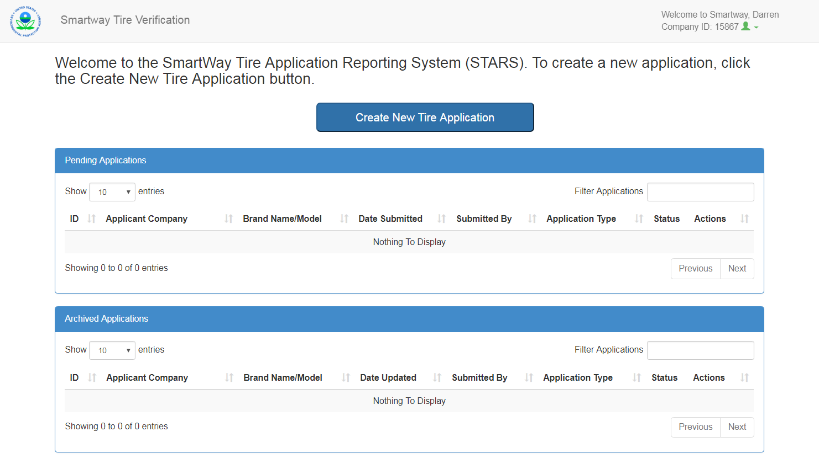

Create a STARS application
These sections take you through the steps to complete a STARS application. The STARS application consists of seven pages:
- Applicant Company Information (see Section 2.3).
- Product Information (see Section 2.4)
- Manufacturer Information (see Section 2.6)
- Lab Test Results (see Section 2.7)
- Additional Information (see Section 2.7.2)
- General Comments (see Section 2.8.1)
- Application Review (see Section 2.8.2)
The following pages are common across all technology applications:
- Applicant Company Information
- Manufacturer Information
- Additional Information
- General Comments
- Application Review (Preview of completed application. Product Information and Lab Test Results pages are Technology specific.)
From the STARS home page, select ‘Create New Technology Application’ (Figure 2-2). This opens the ‘Select Technology’ window where you may select the ‘Technology’ for which you are submitting an application (see Figure 2-3). Regardless of technology selected an application is created and the Applicant Company Information page displays (see Figure 2-4).
Figure 2-3 Create New Application – Select Technology

Applicant Company Information
The Applicant Company Information page allows you to associate two contacts with the application. The ‘Primary Contact’ should be the point of contact for the company submitting the application. The ‘Secondary Contact’ is included in the case that the Primary Contact cannot be reached.
Provide the following information for both the Primary and Secondary contact (see Figure 2-4):
- Title
- First Name
- Last Name
- Position at Company
- Email
- Telephone
- Company
Note: The Primary Contact Information is required. If you do not see your company in the ‘Company Selection’ drop-down, you will need to add your company (see Section 2.3.1).
The Secondary Contact Information is not required but is suggested if you would like someone else to be contacted when you are unavailable. Once you have entered all the required information, click the ‘Save and Continue’ button to continue to the ‘Product Information’ page.

Figure 2-4 Applicant Company Information
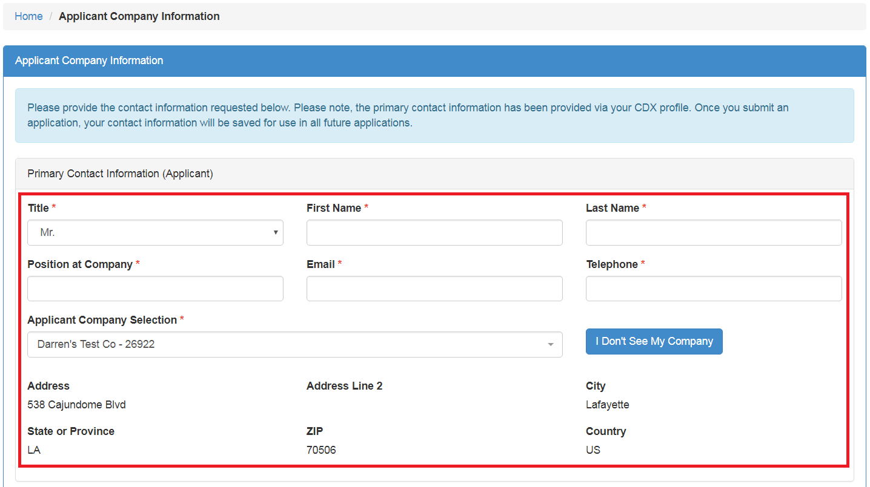
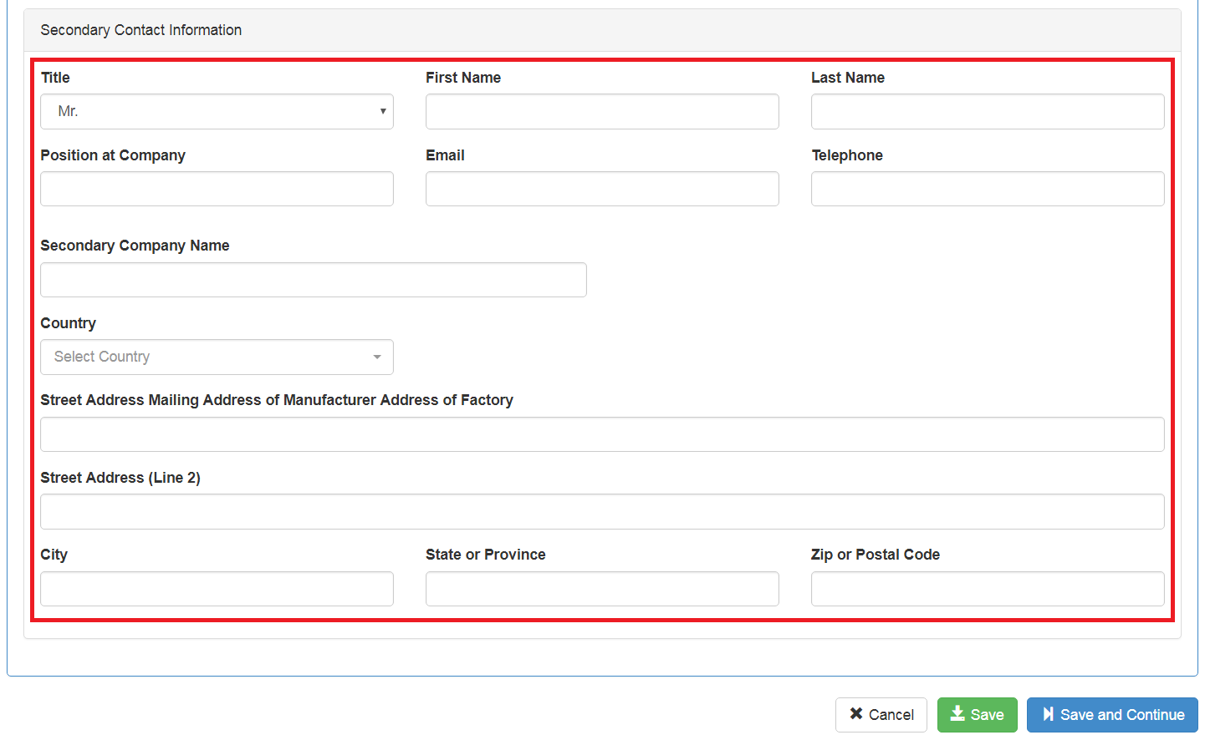

Add a New Company
If you do not see your company in the ‘Company Selection’ drop-down menu for the Primary Contact, you can add a new company by selecting ‘I Don’t See My Company’.
The STARS application uses your CDX Organization as your Applicant Company. If you would like to submit the application for another company, you will need to add that company to your CDX profile as an alternative CDX Organization.
Once you have selected ‘I Don’t See My Company’, select the ‘CDX’ link in the ‘Request to Add Applicant Company’ pop up (see Figure 2-5).
Figure 2-5 Request to Add Applicant Company
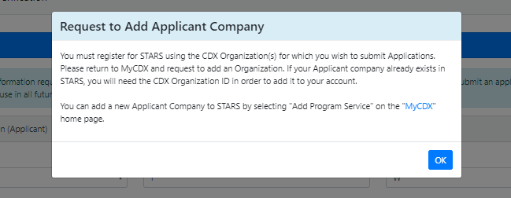

For more information on adding CDX Organizations to your CDX Profile, reference the CDX STARS Registration User Guide.
If your mailing address is outside of the United States (U.S.), the page will expand to display instructions encouraging you to upload an image or text file containing your mailing address in your native language and characters (see Figure 2-6). This will make it easier for EPA to mail certification letters to you through your country’s postal service. Select ‘Upload’ to add an image or text file containing your address to your application.
Figure 2-6 Foreign Address File Upload
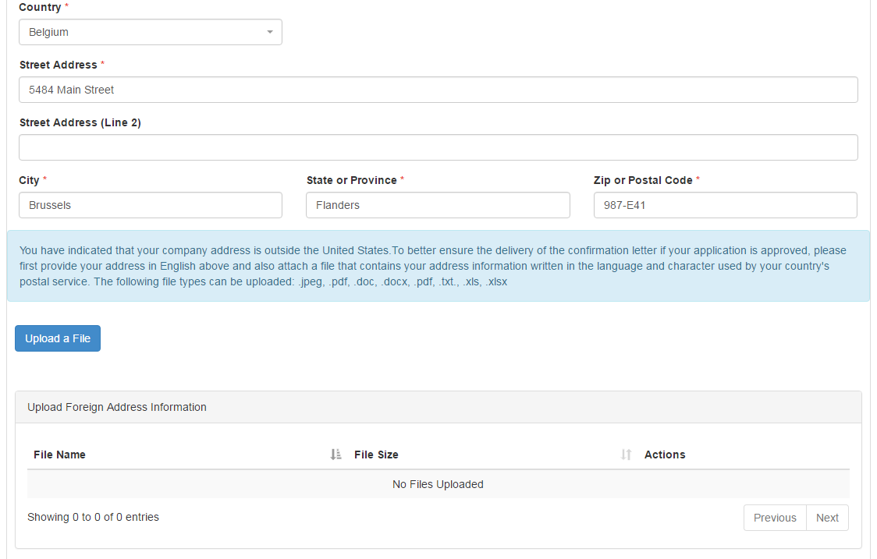

Product Information
After providing the Applicant Company Information, you will proceed to the ‘Product Information’ page where you will provide the following information about the technology you are applying to certify:
- Brand Name and Model (see Section 2.4.1)
- Technology Specific Product Information (see Section 2.4.1.2)
- Laboratory and Testing Information (see Section 2.5)

Low Rolling Resistance Tires (LRRT) Product Information

LRRT Brand Name and Model Information
You will need to provide the Brand Name and Model for the tire you wish to certify (see Figure 2-7). To add a Brand Name and Model, click the ‘Add Brand Name and Model’ button and fill out the displayed fields with the requested information (see Figure 2-8). If you intend to sell your tire under more than one Brand Name and Model, you must provide all alternate Brand Names and Models and specify the Brand Name and Model the tire will be primarily sold as by answering ‘Yes’ to the question “is this your primary brand name and model?”
The primary Brand Name and Model should be the Brand Name and Model that appears on the laboratory test report. If your tire will only be sold under one Brand Name and Model, specify that Brand Name and Model as ‘Primary.’
Figure 2-7 LRRT Brand Name and Model Information
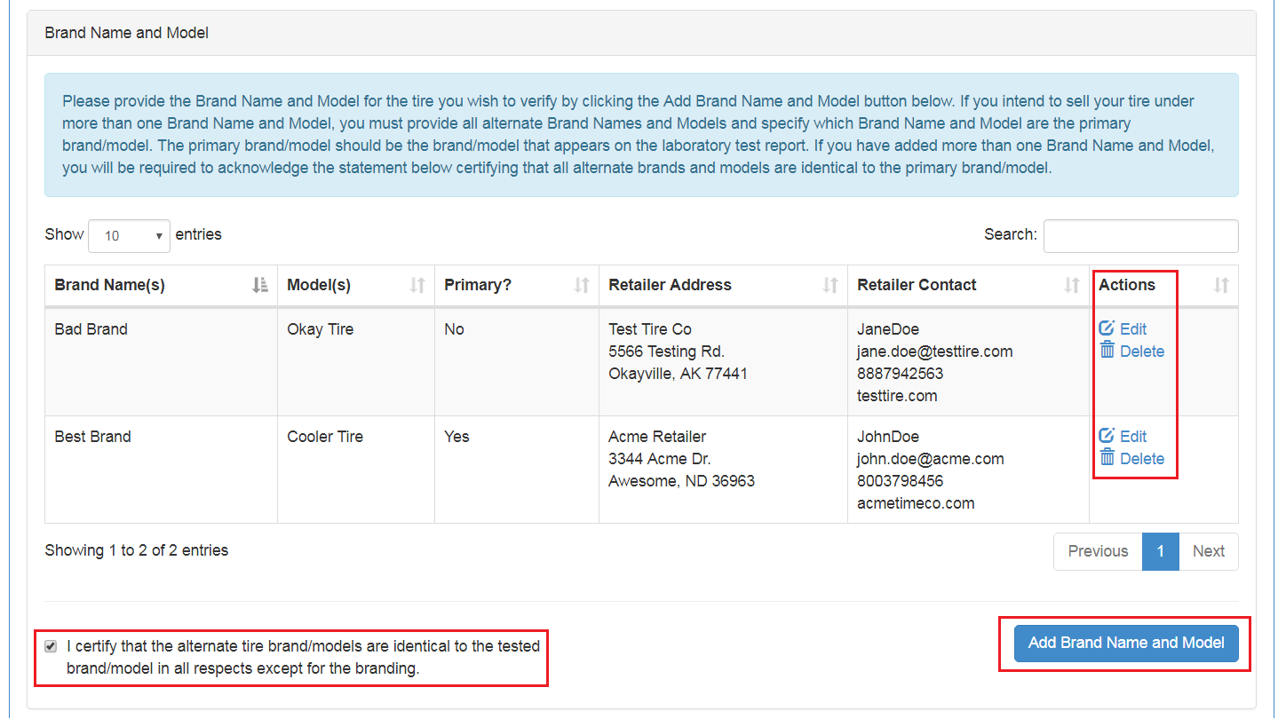
Figure 2-8 Adding a Brand Name and Model
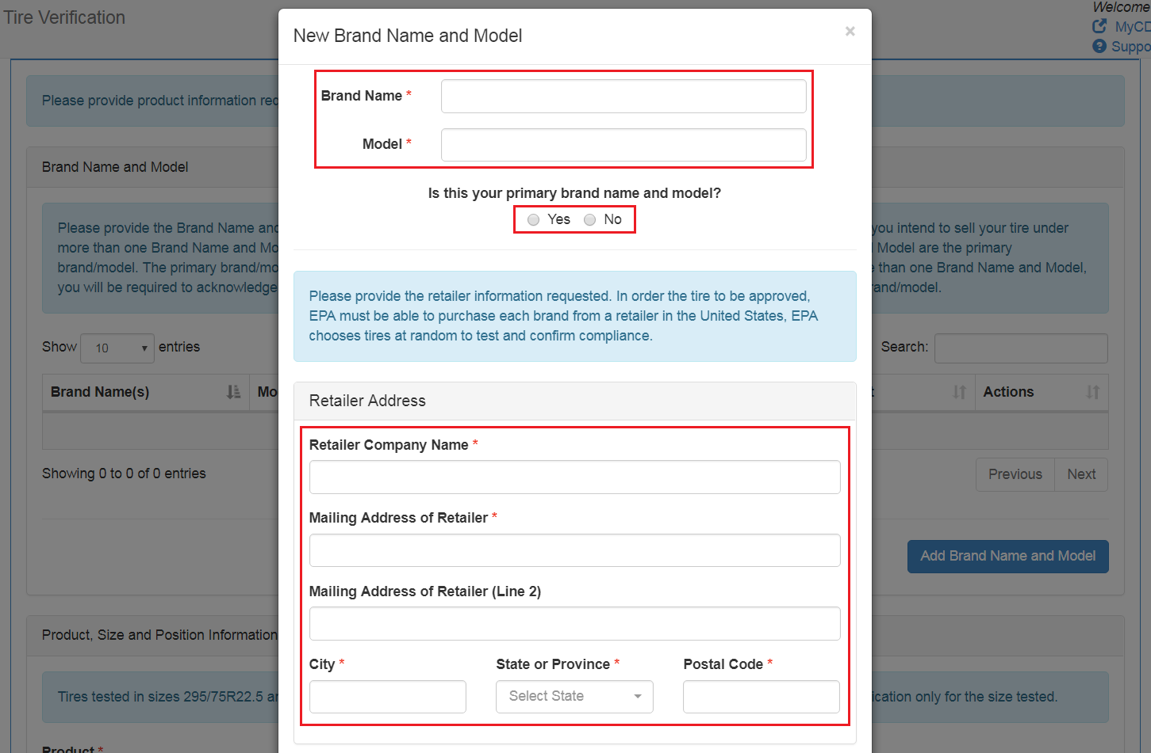
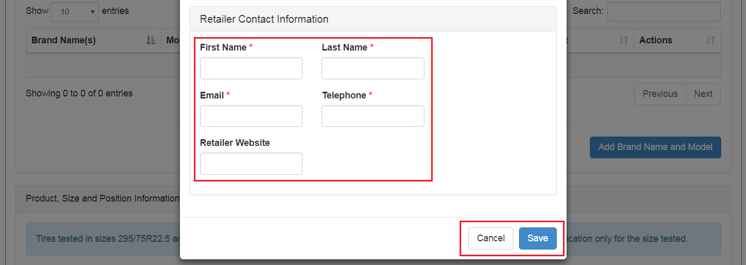
In addition to providing your Brand Name, Model, and Primary specification, you will be asked to provide the Retailer Information indicating where your tire can be purchased in the United States:
- Retailer Company Name
- Mailing Address of Retailer
- Mailing Address of Retailer (Line 2) – Not required
- City
- State or Province
- Postal Code
You will also be asked to provide information for a contact at the Retailer:
- First Name
- Last Name
- Email
- Telephone
- Retailer Website – Not required
EPA requests this information so the tire can easily be purchased for quality assurance testing.
Once you have finished providing the required information, click the save button to add the Brand Name and Model to your application. The entry will be added to the table where you can edit or delete it by selecting the ‘Edit’ or ‘Delete’ buttons in the ‘Actions’ column. If you have entered more than one Brand Name and Model, you will also be required to check the following statement before proceeding:
I certify that the alternate brands/models are identical to the tested brand/model in all respects except for the branding.

Product, Size, and Position Information
In this section, you will provide more details about the tire for which you are submitting the application. You will need to provide the following information about your tire (see Error! Reference source not found.8):
- Product
- Size Tested
- Requested Axle Positions
- Tread Depth*
- Tread Pattern Photo*
- Tread Model Designation Stamping Photo*
*only required if the selected product type is a retread (see Error! Reference source not found.9)
Figure 2-9 Product, Size, and Position Information (New Tire)
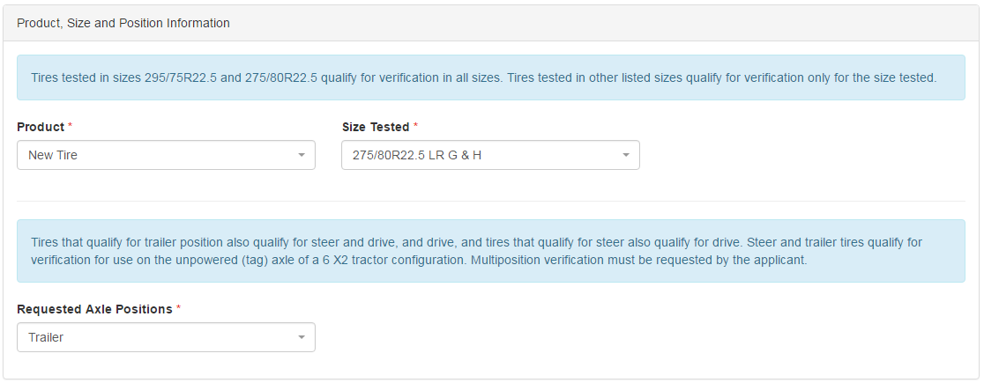
Figure 2-10 Product, Size, and Position Information (Retread Tire)
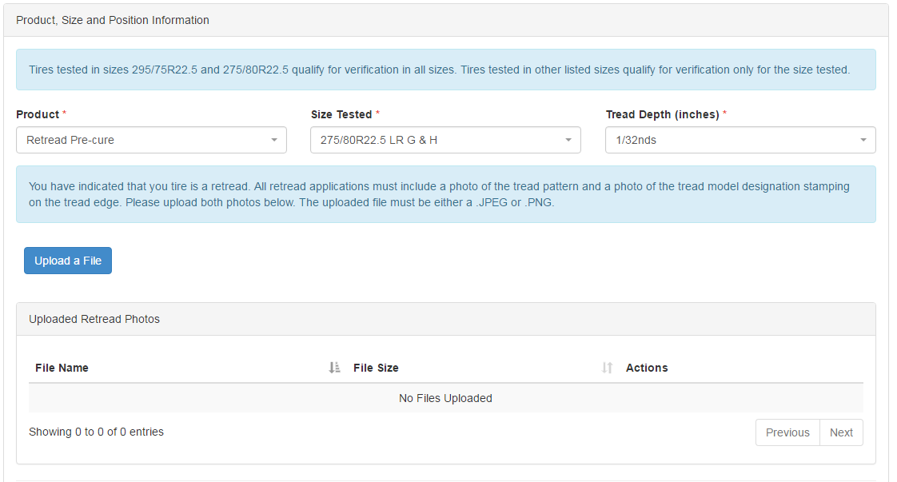

Idle Reduction Technology (IRT) Product Information

IRT Brand and Model Information
You may include one or more IRT application per submission by adding multiple Technology Types to you application (see Figure 2-11). For each technology:
- Select a ‘Technology Type’ from the dropdown list (see Figure 2-12)
- Enter the Brand Name and Model for the technology selected.
- Click the ‘Add Technology’ button.
- Indicate if the technology is designed for class 8 long haul heavy duty sleeper tractors (see Figure 2-13). Select ‘Yes’ or ‘No’ and then click ‘OK’.
Figure 2-11 IRT Brand Name and Model Information (1 of 3)
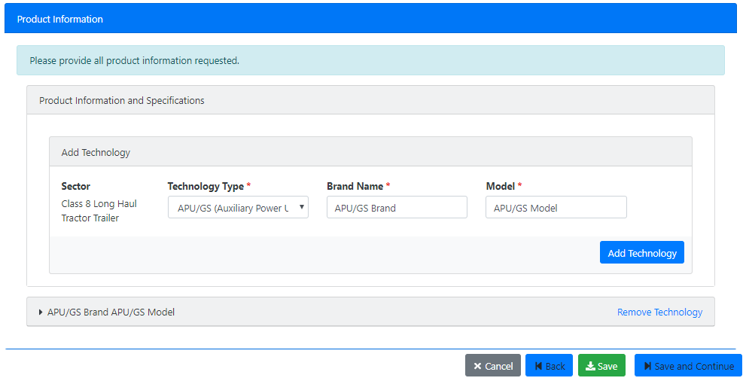
Figure 2-12 IRT Brand Name and Model Information (2 of 3)
Note: If you answer “No” that your technology is not designed for class 8 long haul heavy duty sleeper tractors and can provide (truck engine off) idle reduction services for at least 8 hours, you will not be permitted to submit an application to EPA using STARS.
.
Figure 2-13 IRT Brand Name and Model Information (3 of 3)
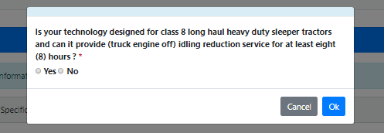
Each technology added appears in an expandable section below the ‘Product Information and Specification’ section labeled with the Brand Name and Model specified. To enter product information for each technology click the triangle to the left of the Brand Name/Model to open the ‘Product Information’ window.

IRT Product Information
The sector, technology type, brand name, and model of the technology displays at the top of the ‘Product Information section. You will need to provide the following information about your technology (see Figure 2-14). Fields marked with an asterisk are required:
- Engine Family Name
Specifications:
- Engine Off Duration (min 8 hrs)
- Length (in)*
- Height (in)*
- Width (in)*
- Weight (lbs)*
- Fuel Savings (gallons/hr)*
- Heat Output (Btu/hr)*
- Electrical Output (watts/hr)*
- Air Conditioning Output(Btu/hr)*
- Heats Truck Coolant or Engine Pre-heating*
- Diesel Engine or Alternative Source of Ignition and continuous operation of IRT*
  - Diesel Engine
  - Alternative Source of Ignition
Sales & Warranty
- Retail Cost*
- Length and Terms of Warranty
- Sales and Service Location*
- Return On Investment (Months)*
- You may use the ‘Browse’ button to attach a file containing Sales and Warranty information.
Figure 2-14 IRT Brand / Model Information (1 of n)
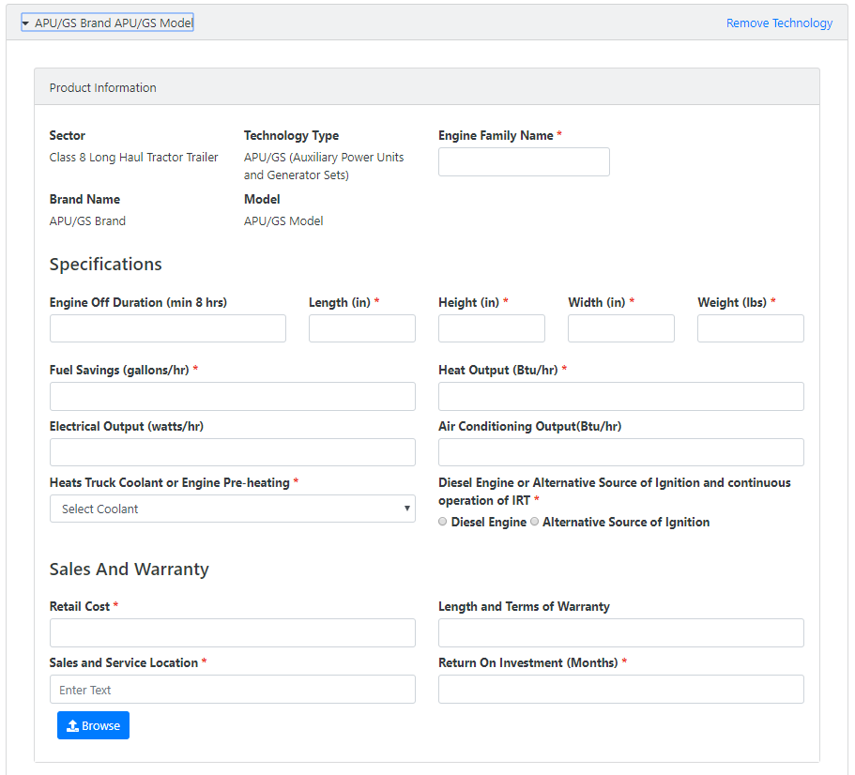

IRT File Uploads
Use the ‘File Uploads’ section of the application to attach a ZIP file containing product photos of all components in a pre- and post- installation configuration. Click the ‘Upload Files; button to open the ‘File Upload’ dialog box to attach your ZIP file (see Figure 2-15).

Figure 2-15 IRT File Uploads (1 of 2)
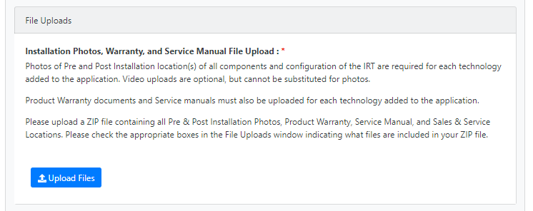

Documents to include in the ZIP file include the following. Required files are marked with an asterisk:
Installation Photos and Videos:
- Pre-Installation Photo*
- Pre-Installation Video
- Post-Installation Photo*
- Post-Installation Video
- Device Schematic
- Test Report
- Additional Documentation
Warranty and Service Manuals:
- Product Warranty*
- Service Manual*
Sales and Service Information:
- Sales Locations*
- Service Locations*
Note: You must include all required files in your ZIP file and check all required files before you can proceed to the next section
.
Click the ‘Upload Files’ button to browse your local file system. Click the ‘Done’ button to close the File Uploads window and proceed to the ‘Additional Questions’ section.
Figure 2-16 IRT File Uploads (1 of 2) (6 of n)
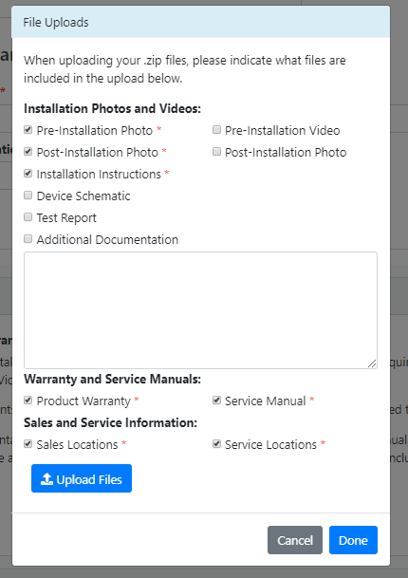

IRT Additional Questions
Additional questions, not previously captured in the ‘Product Information’ section are asked in this section (see Figure 2-17. All questions are ‘Yes’ / ‘No’ questions and all questions in this section are required to be answered.
Each question, depending on the response require further explanation in the comment box that displays when you answer the question. Further explanation are required the following responses
- Does your technology have federal regulatory requirements that supersede verification? Yes
- Does your company offer full warranty over the sale of this product? No
- Is this the first time you have submitted this technology for EPA verification? No
- Does your technology have any health or safety concerns? Yes
- Does your technology have any existing durability, emissions, or overall performance data? Yes
- Is your technology beyond the research and development stage and currently available commercially? No
Figure 2-17 IRT Additional Questions
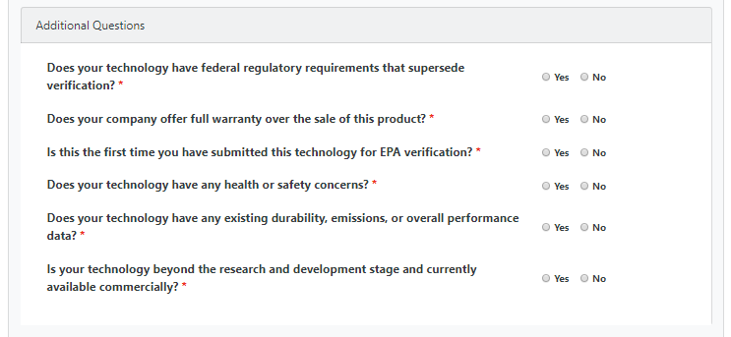

IRT Laboratory Information
Laboratory testing information is provided in this section for technologies that already have a Smartway certification. For technologies not yet certified testing requirements can be found at:
Testing for SmartWay Verification of Idling Reduction Technologies (IRTs) for Trucks
Figure 2-18 IRT Laboratory Information (1 of 2)
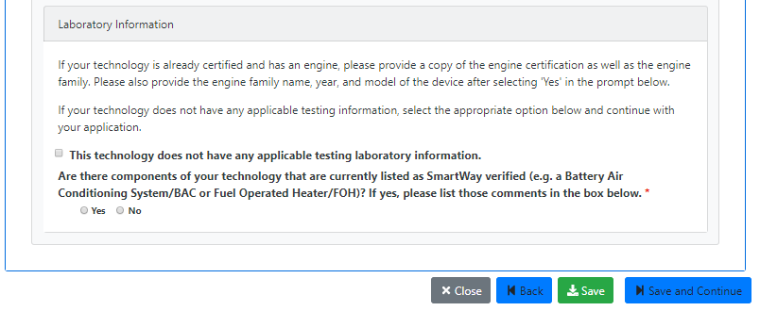
Checking the ‘This technology does not have any applicable testing laboratory information’ checkbox opens the EPA Testing SmartWay Verification of Idling Reduction Technologies (IRTs) for Truck web page for your reference.
If your technology is already certified select ‘Yes’, provides comments in the comment box, upload a copy of your Engine Certificate, and enter the Engine Family Name and Year from the certificate (see Figure 2-19).
Figure 2-19 IRT Laboratory Information (2 of 2)
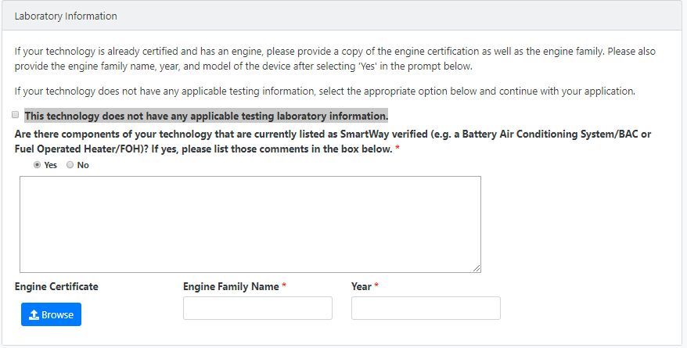

Laboratory and Testing Information
Select the Test Laboratory that tested the compliance of your product (see Figure 2-20). If you do not see the test lab you used in the ‘Test Laboratory selections’ drop-down menu, you can select ‘I Don’t See My Test Lab’ to add your test lab’s information (see Figure 2-21).
You will need to provide the following information:
- Test Laboratory Name
- Laboratory Accreditation
- Country
- State or Province
- City
- Laboratory Accreditation Certificate
You can add the laboratory accreditation certificate by selecting ‘Upload Files’. Once you have uploaded the certificate, it will be added to the Uploaded Files table where you can delete it if necessary by selecting delete in the action column.
Note: If you selected your test lab from the ‘Test Laboratory selections’ drop-down menu, no additional test lab information is required. All information pertaining to these test labs, including the Laboratory Accreditation Certificate, is already stored in EPA’s database.
Figure 2-20 Laboratory and Testing Information
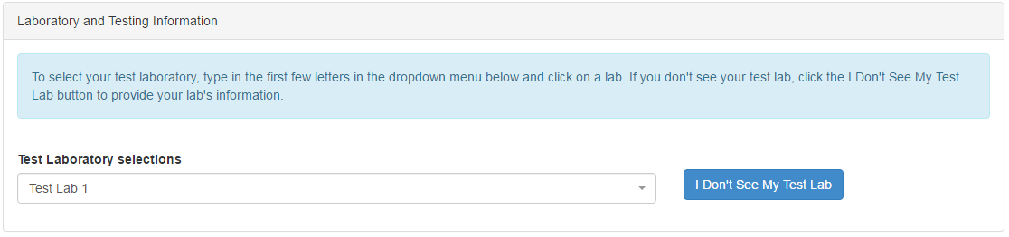
Figure 2-21 Add a New Test Lab
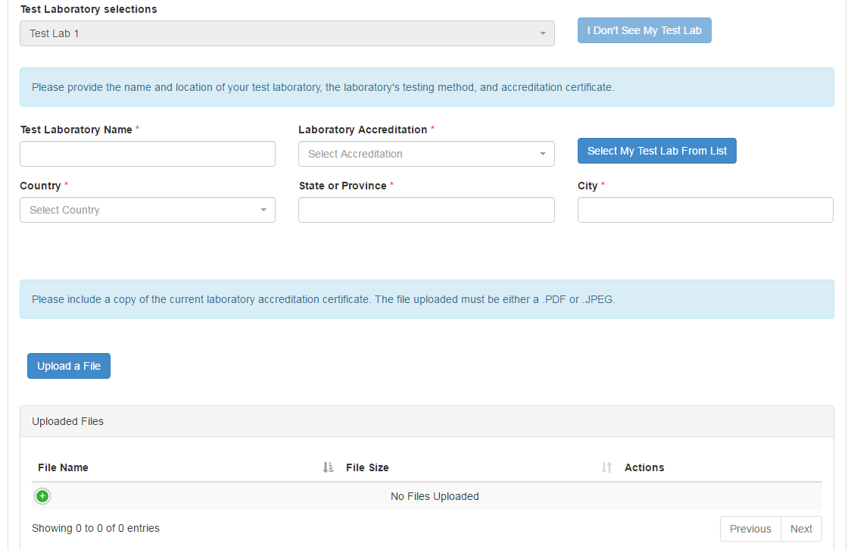
Once you have completed the Brand Name and Model Information, the Product, Size, and Position Information, and the Laboratory and Testing Information, select ‘Save and Continue’ to proceed to the Manufacturer Information page.

Manufacturer Information
This section will take you through the steps to provide Manufacturer Information. You will need to provide the Manufacturer and Factory used to produce your product. If your Manufacturer or Factory is not listed in the drop-down, you will need to provide additional information respectively. You will also need to describe your relationship with the manufacturer.

Manufacturer Address
Select your manufacturer from the ‘Manufacturer Selection’ drop-down and proceed to Factory Selection. If you do not see your manufacturer in the list, select ‘I Don’t See My Manufacturer’ and provide the following information (see Error! Reference source not found.2):
- Name of Manufacturer
- Country
- Mailing Address of Manufacturer
- Mailing Address of Manufacturer (Line 2) – not required
- City
- State or Province
- Zip or Postal Code
Figure 2-22 Manufacturer Information
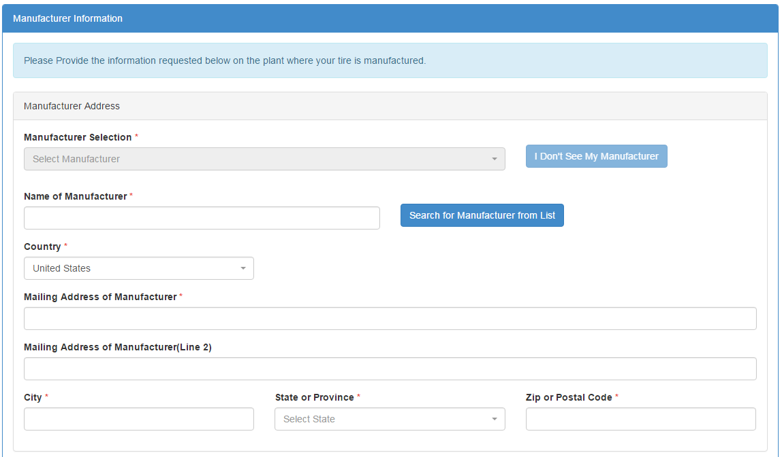
If you would like to return and search through the list of manufacturers in the ‘Manufacturer Selection’ drop-down menu, select ‘Search for Manufacturer from List’.

Factory Address
Select your factory from the ‘Factory Selection’ drop-down and proceed to Applicant/Manufacturer Relationship. If you do not see your factory in the list, select ‘I Don’t See My Factory’ and provide the following information (see Error! Reference source not found.3):
- Country
- Address of Factory
- Address of Manufacturer (Line 2) – not required
- City
- State or Province
- Zip or Postal Code
Figure 2-23 Factory Information
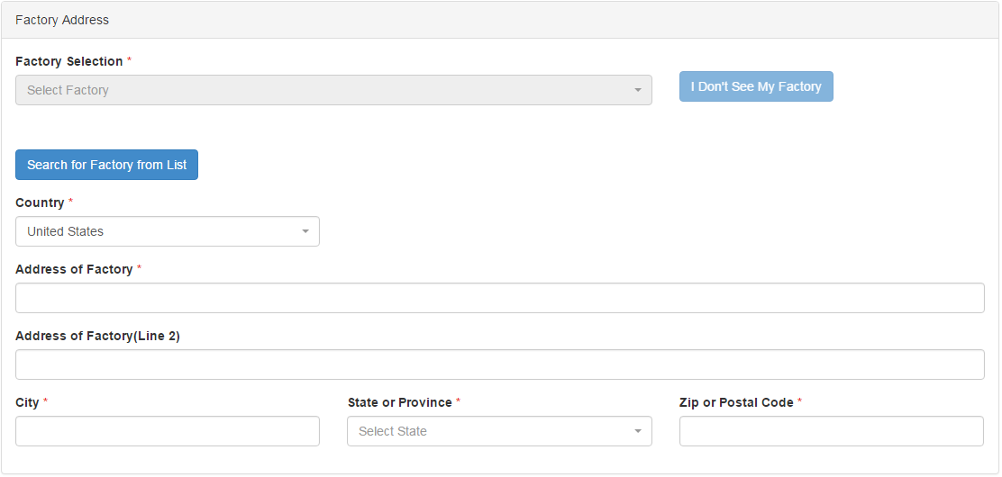
If you would like to return and search through the list of factories in the ‘Factory Selection’ drop-down menu, select ‘Search for Factory from List’.

Applicant/Manufacturer Relationship
Describe the relationship between you (the applicant) and the manufacturer in the ‘Please Describe the Relationship Between Applicant and Manufacturer’ field (see Figure 2-24). An example of a relationship would be “Applicant is the same as the Manufacturer.” Once you have provided the Manufacturer, Factory, and the Applicant/Manufacturer Relationship, select ‘Save and Continue’ to proceed to the Laboratory Test Results page.
Figure 2-24 Applicant/Manufacturer Relationship
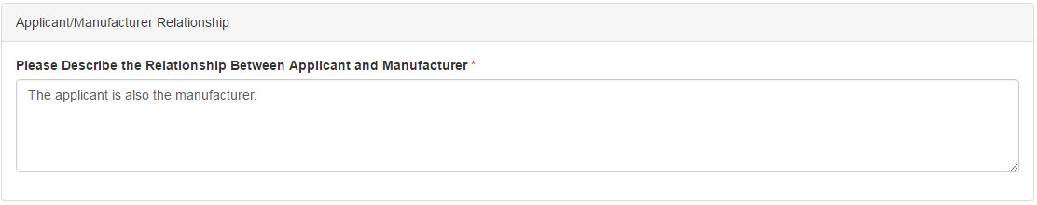

Laboratory Test Results

Low Rolling Resistance Tires (LRRT) Lab Test Results
In this section, you will provide the results from your product’s laboratory tests. To begin, you will need to provide the following for the three (3) tires the laboratory tested (see Figure 2-25):
- Date Tested (mm/dd/yyyy)
- Test Tire DOT Code
- Rolling Resistance Coefficient (kg/ton)
Figure 2-25 Tire Test Results
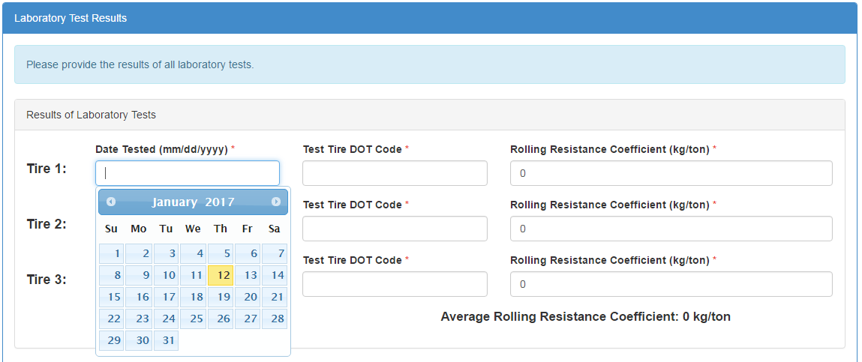
If applicable, you will next need to specify the ‘Test Method’ your test laboratory used. Note: If your product is a retread type, the ‘ISO28580’ test method is selected for you. The final laboratory test information you will need to provide are your original laboratory test sheets. Select ‘Upload’ to add the necessary attachments to the application (see Error! Reference source not found.6). Once completed, select ‘Save & Continue’ to proceed to the Additional Information page.
Figure 2-26 Test Method and Test Sheet Upload
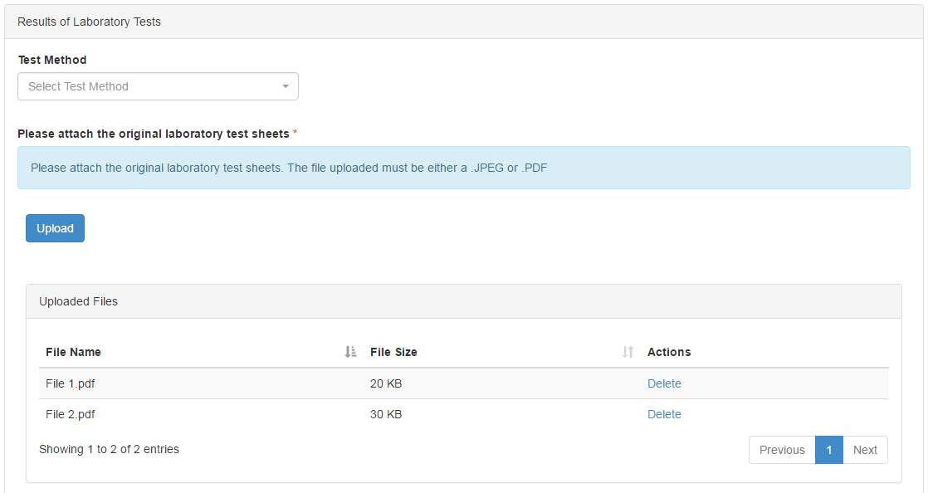

Idle Reduction Technology (IRT) Lab Test Results
Laboratory test results must be provided for each device (technology) specified (see Figure 2-27). For each device the following information is required:
- Date Tested (yyyy-mm-dd)*
- Device DOT Code*
- Fuel Savings Percentage*
Stars calculates Average Fuel Savings Percentage across all devices.
EPA laboratory testing procedures can be found at: Draft Test Protocol for Idling Reduction Technologies (IRTs) for Trucks. This page can be accessed by clicking the ‘here’ hyperlink in the Results of Laboratory Test section.
The following laboratory testing information and documentation is required to be provided:
- Test Method: select from dropdown list (see Figure 2-28).
  - ISO 28580
  - SAE J1269 5-point average
  - SAE J1269 Test point 2
  - SAE J1269 Application test point
- Copy of Engine Certification Information and Emissions Data
- Copy of original laboratory test sheets

Figure 2-27 Results of Laboratory Test – IRT (1 of 2)
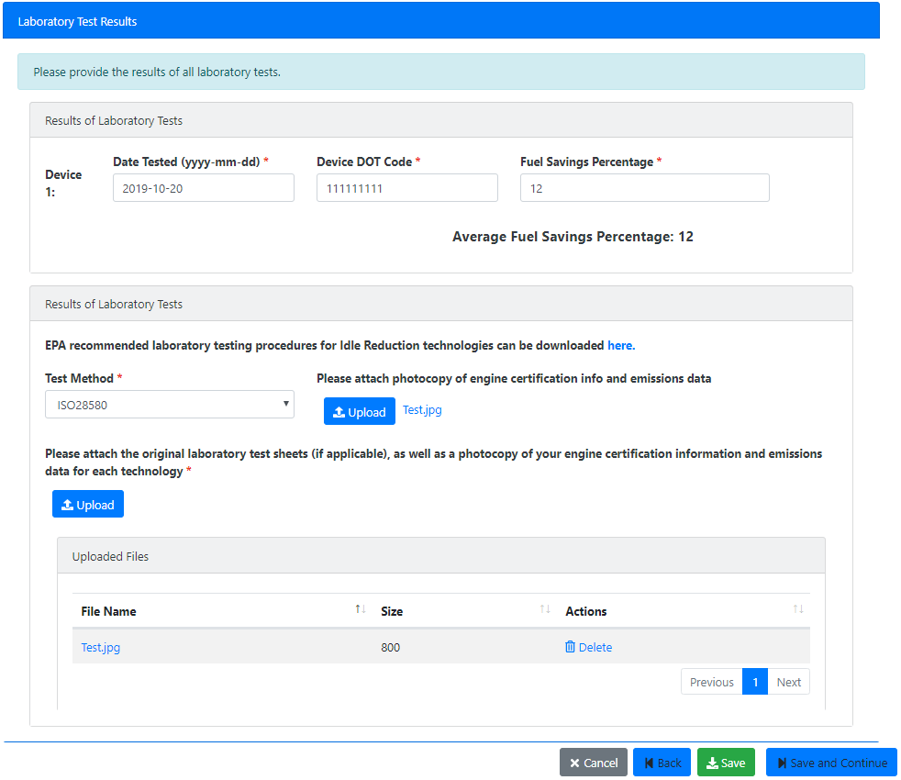
Figure 2-28 Results of Laboratory Test – IRT (2 of 2)

Additional Information
Once you have provided all of the details on your product, you will need to answer some additional questions. The following questions will require a ‘Yes’ or ‘No’ answer:
- Does your technology have U.S. Federal regulatory requirements that supersede verification?
- Is your technology currently available?
- Does your technology have any existing durability, emissions, or overall performance data?
- Does your technology have any health or safety concerns?
- Is this the first time you have submitted this technology for EPA verification?
- Does your company offer a full warranty over the sale of this product?
- Do you accept full responsibility in attesting to EPA that all submitted information is correct?
Note: If you answered ‘Yes’ to ‘Is your technology currently available?’ you will also be required to answer:
- Does the technology have in-use experience in the intended market?
Once you have answered all of the questions, select ‘Save and Continue’ to proceed to the General Comments page.

General Comments
This section allows you to provide EPA with any additional information, comments, statements, or files you would like to include in your application. The section is not required. To upload additional documents to your application, select ‘Upload a File’ (see Figure 2-29). Once completed, select ‘Save and Continue’ to proceed to the Review Page.
Figure 2-29 General Comments and Attachments
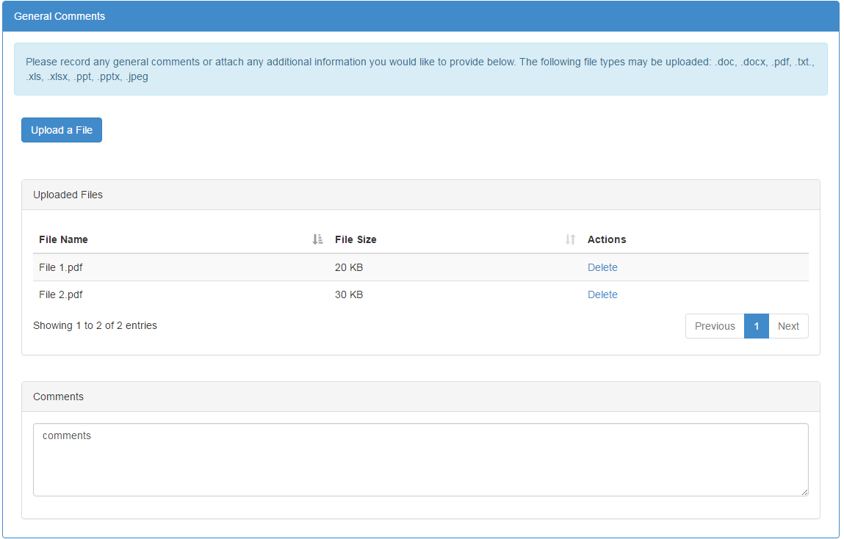

Technology Application Review
On this page, you have the chance to review all of the information you have provided in the application. If you need to make any changes, you can navigate back to any section of the application by clicking the ‘Back’ button at the bottom of the page.
Once you have verified that all of the information you provided is correct, select ‘Sign and Submit’ at the bottom of the page to electronically sign and submit your application.

Submit a STARS Application
Once you have completed and reviewed your STARS application and you are ready to submit your report, select ‘Sign and Submit’ to electronically sign and submit your application.
After clicking the ‘Sign and Submit’ button, you are required to certify the submission package. The first step in certification is to accept the certification statement. Click the ‘Accept’ button to proceed with certification (see Figure 2-30)
Figure 2-30 Accuracy Statement
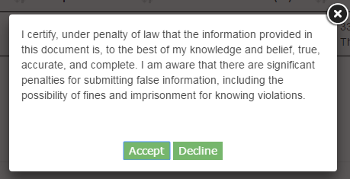
If the ‘Decline’ button is selected, you are returned to the ‘Tire Application Review’ screen. You may then update the application and attempt to submit again.
After clicking the ‘Accept’ button, the Cross-Media Electronic Reporting Regulation (CROMERR) eSignature Widget is launched. At any time, you may cancel the signature process by clicking the ‘X’ button on the eSignature Widget. Cancelling the process displays a message informing you that you have cancelled the signature dialog and returns you to the ‘Tire Application Review’ screen. To complete the electronic signature process, you must provide the password for the CDX account you are logged-in with and the answer to a randomly selected security question (see Figure 2-31). After clicking the ‘Sign’ button, the CROMERR eSignature Widget closes and you are navigated to the STARS Home screen where you can see your submitted application in the Tire Applications table. Contact the CDX Helpdesk if you do not.
Figure 2-31 Electronic Signature Process
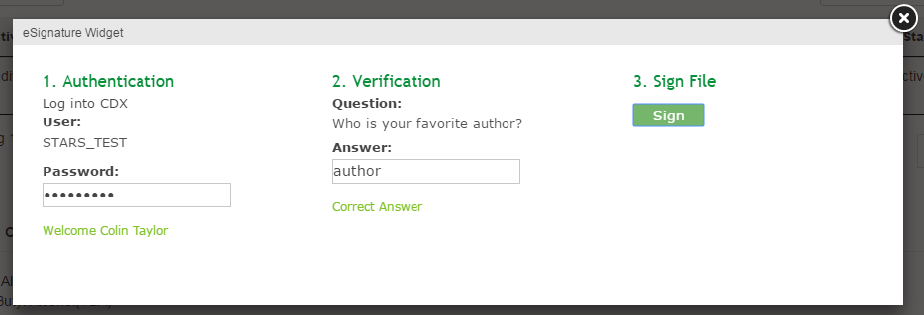
After submitting an application package, a confirmation message is emailed to the email address registered in your CDX account and is also placed in your CDX Inbox.

Work on a ‘Draft’ Application
If you have created a STARS application but have not submitted the application, it is considered ‘Draft.’ This section walks you through the 3 actions you can perform with a ‘Draft’ application:
- Save a ‘Draft’ Application (see Section 2.10.1)
- Continue a ‘Draft’ Application (see Section 2.10.2)
- Delete a ‘Draft’ Application (see Section 2.10.3)

Save a ‘Draft’ Application
If you have started a STARS application but are not ready to complete the application, you may consider saving your work and returning to it later.
At the bottom-right of every page in the application you will find a ‘Save’ button. This button allows you to save your work in progress without continuing to the next section of the application.
Select ‘Save’ and all the information you have entered will be saved in your ‘Draft’ application on the STARS Home page. However, you must identify the Applicant Company and Brand Name and Model in order for your ‘Draft’ application to be saved.

Continue a ‘Draft’ Application
If you have saved a ‘Draft’ application and you would like to continue working on the application, navigate to the STARS Home page. Find the ‘Draft’ application you would like to continue in the ‘Pending Applications’ table. Select ‘Continue’ in the ‘Actions’ column to proceed with your application (see Figure 2-32).
Figure 2-32 Continuing a Draft Application
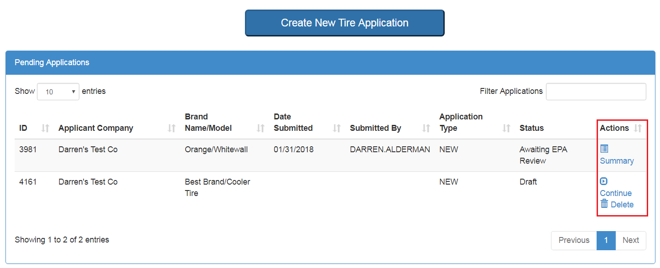

Delete a ‘Draft’ Application
If you have a ‘Draft’ application that you no longer wish to submit or you have created another application in its place, you may consider deleting the application. To delete a ‘Draft’ application, navigate to the STARS Home page. Find the ‘Draft’ application you would like to delete in the ‘Pending Applications’ table. Select ‘Delete’ in the ‘Actions’ column to permanently delete your ‘Draft’ application (see Figure 2-32).

Review a Submitted STARS Application
If you would like to review a STARS application that you have already submitted to EPA, navigate to the STARS Home page. Find the application in the ‘Pending Applications’ table that is in the status ‘Awaiting EPA Review’ or ‘Resubmitted Awaiting EPA Review’ and select ‘Summary’ in the ‘Actions’ column of the table (See Figure 2-32).
The review page from your application will be shown. Note: The application will not be editable since you have already submitted it.

Download ‘Approved’ Application Approval Letter
Once your application has been approved by EPA, you will receive an email notifying you of the approval with a link to the approved application. Once an application is approved, it will be moved to the ‘Archived Applications’ section.
To download the approval letter, you can follow the link provided in the notification email or go the STARS Home page, locate the ‘Approved’ application in the ‘Archived Applications’ section, and select ‘Summary’ (see Figure 2-33).
Figure 2-33 Review Approved Application
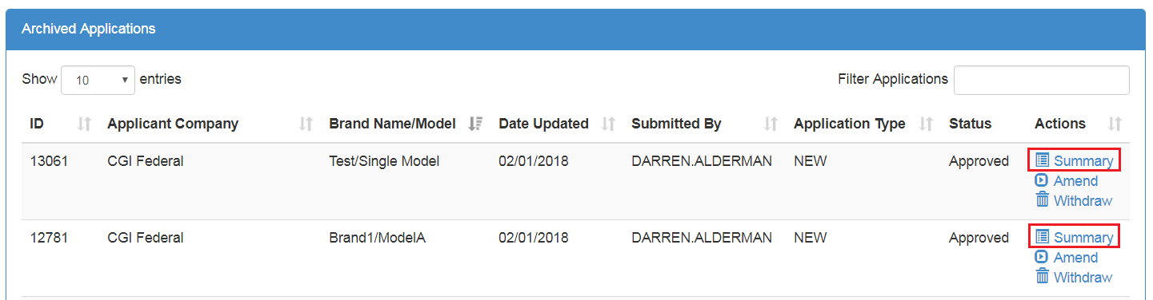
On the application review page if the application is approved you will have the option to ‘Download Approval Letter’ (see Figure 2-34). Select ‘Download Approval Letter’ to download the approval letter PDF verifying that your technology has been approved by the SmartWay program office.
Figure 2-34 Download Approval Letter

Resubmit a ‘Pushed Back’ Application
In the event that EPA would like you to make changes to your application before they approve the application, EPA returns the application to you for resubmission. When this occurs you receive an email notification that includes EPA’s comments. You can also review these comments on the STARS Home page by clicking the linked ‘Pushed Back for Resubmission’ text in the Status column (see Figure 2-35).
Figure 2-35 Review EPA Comments
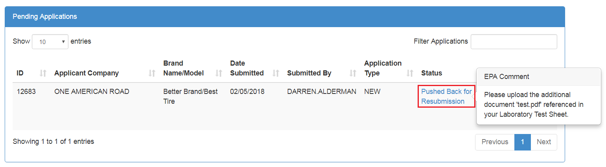
To update the application, select ‘Revise & Resubmit’ in the ‘Actions’ column (see Figure 2-36). This takes you through the pages you completed when you originally filled out the application. Once you have made all required changes, you can resubmit the application (see section 2.9 Submit a STARS Application).
Figure 2-36 Revise Pushed Back Application
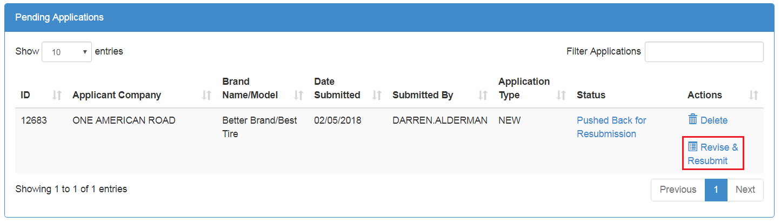

Amend an ‘Approved’ Application
In the event that you need to update an application for a tire that has already been approved by EPA, you can choose to ‘Amend’ the application. On the STARS Home page, locate the ‘Approved’ application in the ‘Archived Applications’ section. Select ‘Amend’ in the ‘Actions’ column (see Figure 2-37).
Figure 2-37 Amend Approved Application
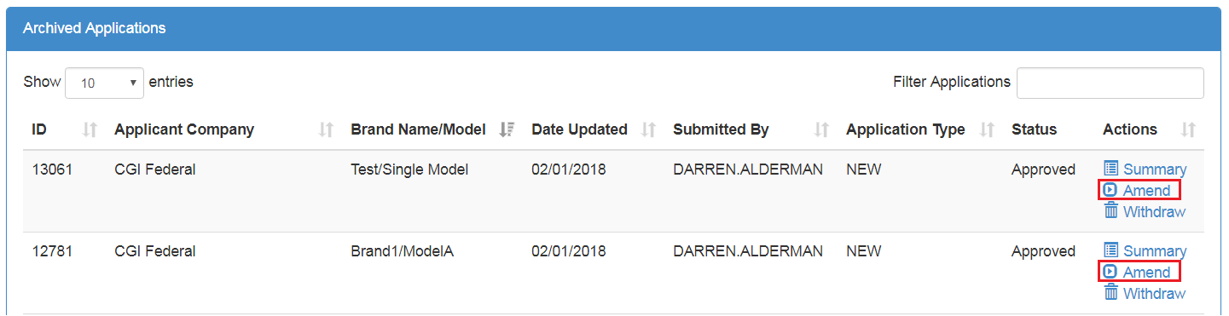

This creates a copy of the original application. The ‘Application Type’ is set to ‘Amendment’ and the ‘Status’ to ‘Draft’. The original ‘Approved’ application is not retracted until EPA has approved the new amendment.
Once you have made all required changes to the amendment application, you can submit the application to EPA application (see section 2.9 Submit a STARS Application).

Withdraw an ‘Approved’ Application
In the event you would like to remove your technology from the list of SmartWay approved technologies, you can choose to ‘Withdraw’ the approved application and technology. This action must be approved by EPA and is not reversible.
To withdraw your application, go to the STARS Home page, locate your approved technology in the ‘Archived Applications’ section, and select ‘Withdraw’ (see Figure 2-38).
Figure 2-38 Withdraw Approved Application
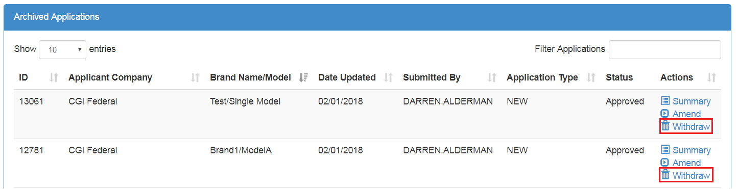
Upon selecting ‘Withdraw’, you are asked to specify why you would like to withdraw the approved technology. Once you have provided this information, select ‘Continue’ to proceed to the review page (See Figure 2-39).
Figure 2-39 Specify Reason for Withdrawal
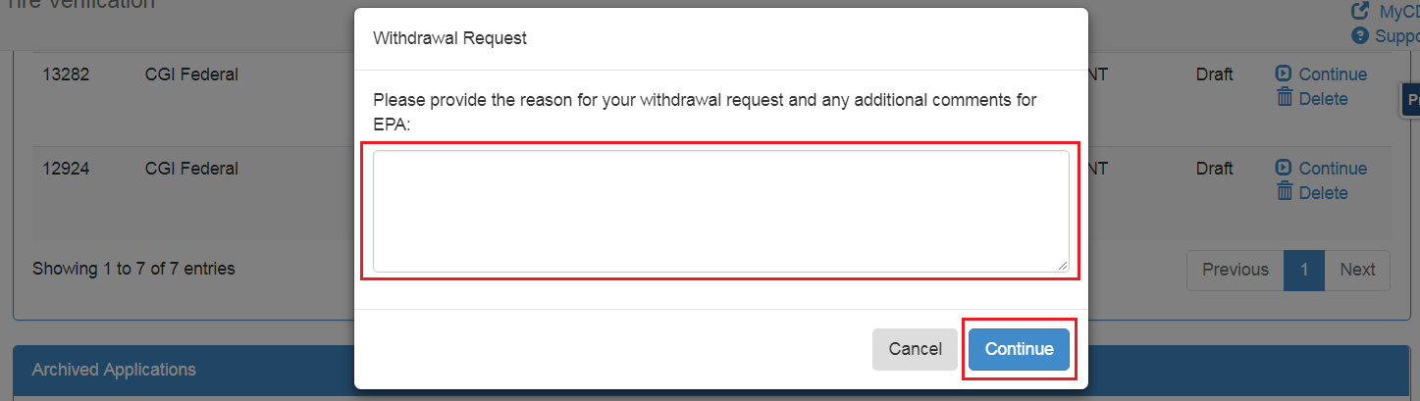
You are brought to a review page that summarizes your original approved application and your reason for requesting the withdrawal. If you would like to continue, select ‘Sign and Submit’ to submit the request to EPA (see section 2.9 Submit a STARS Application).
Note: Your original approved application will not be retracted until EPA has approved the withdraw request. The ‘Application Type’ of the request is set to ‘Withdrawal’ and appears in your ‘Pending Applications’ section.
EPA may determine that an application needs to be marked as withdrawn, and has the ability to withdraw any approved application if the users are not able to submit the request themselves. In the event that EPA marks your application as withdrawn, you will receive an email notification explaining the withdrawal action.

