
CDX SmartWay Technology Application Reporting System (STARS)
Registration User Guide
Environmental Protection Agency Office of Air and Radiation (OAR)

Version 3.0

November 8, 2019

Table of Contents
Version 3.0 1-1
November 8, 2019 1-1
1 Introduction 1
1.1 Purpose 1
1.2 Background 1
1.3 Types of STARS Accounts for Manufacturers 1
2 System Requirements 1
2.1 Supported Browsers 1
3 CDX Tasks 3
3.1 Overview 3
3.2 Access CDX 3
3.2.1 CDX Core Registration 6
3.3 Request STARS Program Service 7
3.4 Role Access 8
3.5 Provide User and Organization Information 8
3.5.1 Provide User Information 9
3.5.2 Provide Organization Information 11
3.5.3 Confirm Registration 17
3.6 Verify Identity 18
3.6.1 CDX Electronic Signature Agreement 21
3.6.2 Complete Electronic ESA 22
3.6.3 Complete Paper ESA 27
3.7 Access the STARS Program Service 30
3.8 Sponsor Applicants for Registration 30
3.8.1 Primary Applicant Sponsors Applicant 30
3.8.2 Applicant Creates CDX Account 30
3.8.3 Primary Applicant Approves Applicant Registration 30
3.8.4 Applicant Completes Identity Verification 30

Table of Figures
Figure 3-1 CDX Home Page 4
Figure 3-2 CDX Terms and Conditions Page 5
Figure 3-3 CDX Core Registration for New CDX Users 6
Figure 3-4 CDX Edit Account Profile for Existing CDX Users 6
Figure 3-5 Add a Program Service to Existing CDX Account 7
Figure 3-6 CDX Edit Account Profile - Program Service Page 8
Figure 3-7 CDX Registration - Role Access 8
Figure 3-8 Part 1: User Information 10
Figure 3-9 Select a Current Organization 12
Figure 3-10 Organization Search (New CDX User) 12
Figure 3-11 Organization Search (Existing CDX User) 13
Figure 3-12 Organization Search Results 13
Figure 3-13 Organization Information - Selected Organization 14
Figure 3-14 Organization Information - Add Organization 15
Figure 3-15 Access My Profile from MyCDX Home Page 16
Figure 3-16 Locate the Organization ID on the My Profile Page 17
Figure 3-17 Confirmation for CDX Registration and Organization Association 17
Figure 3-18 Account Confirmation Email 18
Figure 3-19 Identify Verification Page 19
Figure 3-20 LexisNexis Verification for EPA 20
Figure 3-21 CDX Registration – Additional Information 22
Figure 3-22 Review Electronic ESA 23
Figure 3-23 CDX Registration – CROMERR eSignature Widget page 1 24
Figure 3-24 CDX Registration – CROMERR eSignature Widget page 2 24
Figure 3-25 ESA Confirmation Email 25
Figure 3-26 STARS Account Awaiting Activation 25
Figure 3-27 Account Activation Email 27
Figure 3-28 Paper CDX Electronic Signature Agreement 28
Figure 3-29 Print Paper CDX Electronic Signature Agreement 29
Figure 3-30 CDX Registration - Status Change Confirmation 30
Figure 3-31 Accessing STARS from CDX 30
Figure 3-32 CDX Role Sponsorship - Tools 30
Figure 3-33 CDX Role Sponsorship – Role Sponsorship/Invitation 30
Figure 3-34 CDX Role Sponsorship – Email Confirmation (1 of 2) 30
Figure 3-35 CDX Role Sponsorship – Email Confirmation (2 of 2) 30
Figure 3-36 CDX Role Sponsorship – Applicant Invitation 30
Figure 3-37 CDX Role Sponsorship – Approve Invitation Request 30
Figure 3-38 CDX Role Sponsorship – CDX Account Creation (Part 1) 30
Figure 3-39 CDX Account Creation – Organization Selection (1 of 3) 30
Figure 3-40 CDX Account Creation – Organization Selection (2 of 3) 30
Figure 3-41 My Profile – Finding Your Company CDX Organization ID 30
Figure 3-42 CDX Role Sponsorship – CDX Account Creation (Part 2) 30
Figure 3-43 CDX Role Sponsorship – Applicant Account Awaiting Approval 30
Figure 3-44 CDX Role Sponsorship – Applicant Registration Request Email 30
Figure 3-45 CDX Role Sponsorship – Primary Applicant Approval Log in 30
Figure 3-46 CDX Role Sponsorship – Primary Applicant Organization & Role Selection 30
Figure 3-47 CDX Role Sponsorship – Primary Applicant Signs Approval (1 of 3) 30
Figure 3-48 CDX Role Sponsorship – Primary Applicant Signs Approval (2 of 3) 30
Figure 3-49 CDX Role Sponsorship – Primary Applicant Signs Approval (3 of 3) 30
Figure 3-50 CDX Role Sponsorship – Approval Notification 30
Figure 3-51 CDX Role Sponsorship – Account Confirmation 30
Figure 3-52 CDX Role Sponsorship – Confirmation Code Email 30
Figure 3-53 STARS Account Registration - CDX Identity Verification 30
Figure 3-54 STARS Account Registration – 2nd Factor Authentication Questions 30
Figure 3-55 STARS Account Registration – Signature Question Confirmation Email 30
Figure 3-56 STARS Account Registration – Electronic Signature Agreement (ESA) 30
Figure 3-57 STARS Account Registration – ESA Disclaimer 30
Figure 3-58 STARS Account Registration – ESA Signing 30
Figure 3-59 STARS Account Registration – ESA Confirmation Email 30
Figure 3-60 STARS Account Registration – Account Activation Email 30
Figure 3-61 STARS Account Registration – Applicant Account Activated 30

Introduction
The SmartWay Technology Application Reporting System (STARS) is the web-based tool provided by the Environmental Protection Agency’s (EPA’s) Office of Air and Radiation (OAR) for the electronic submission of SmartWay technology applications to EPA. The STARS tool is available to users through EPA’s Central Data Exchange (CDX), a web-based system used for various electronic data submissions to EPA. Under EPA’s “E-Reporting” rules, users wishing to submit tire applications to EPA must register for access to the STARS program service through CDX. More information about CDX is available at https://cdx.epa.gov/.

Purpose
The purpose of this document is to help users register for CDX and the STARS program service. Users wishing to submit SmartWay technology applications must register for the STARS program service within CDX. This document assists new users registering in the CDX system for the first time.

Background
EPA’s SmartWay program helps companies advance supply chain sustainability by measuring, benchmarking, and improving freight transportation efficiency.
Through SmartWay technology verification and branding, EPA has accelerated availability, adoption and market penetration of fuel-saving technologies and operational practices while helping companies save fuel, lower costs and reduce adverse environmental impacts. Learn how to use the SmartWay brand.
For questions concerning CDX, please contact the CDX Help Desk at helpdesk@epacdx.net or call 1-888-890-1995 between the hours of 8a.m. – 6p.m. Eastern Standard Time (EST).

Types of STARS Accounts for Manufacturers
STARS provides two types of account for manufacturers:
Primary Applicant: This account is available to manufactures to self-register in CDX. Once registered, the account requires EPA approval before it is activated. Once activated a Primary Applicant may log into STARS and submit applications. The Primary Applicant for an organization may also invite other employees in their organization to register an Applicant account. The Primary Applicant approves Applicant accounts before the accounts become active.
Applicant: This is available to manufacturers by invitation from a Primary Applicant in their organization. Once registered the account requires Primary Applicant approval before it is activated. Once activated the Applicant may log into STARS and submit applications.
The procedures for registering as a Primary Applicant and Applicant, and inviting and approving Applicants are described in the guide.

System Requirements
In order to use CDX and STARS, the following is required:
- An email account
- Java Script enabled web browser
- Internet access

Supported Browsers
- Internet Explorer 9 or above
- Go to the following link to download:
http://windows.microsoft.com/en-US/internet-explorer/downloads/ie
- Mozilla Firefox 3.5 or above
- Go to the following link to download:
http://www.mozilla.com/en-US/firefox/all-older.html
- Safari 4 or above
- Go to the following link to download:
http://support.apple.com/kb/dl877
- Google Chrome
- Go to the following link to download:
http://www.google.com/chrome
Note – Browsers not supported:
Microsoft Edge browser should not he used to access the STARS program service.

CDX Tasks

Overview
CDX enables EPA and participating program offices to work with stakeholders including state, tribal, and local governments and regulated industries to facilitate streamlined, electronic submission of data via the Internet. As part of the CDX system, the user registration component is used to facilitate user access to data collection program services such as STARS. The following sections describe how to register for the STARS program service and other related CDX functions:
- Accessing CDX: Section 3.2
- Requesting STARS Program Service: Section 3.3 through Section 3.6
- Access the STARS Program Service: Section 3.7
- Sponsoring and Approving Applicant Accounts: Section 3.8

Access CDX
The CDX homepage is the landing screen from which you have the ability to access and interact with CDX and the STARS program service hosted by CDX (see Figure 3-1). The CDX home screen can be accessed by the following link: https://cdx.epa.gov/. This screen provides you with the following features:
- Log in: If you already have an existing CDX account, you may log into the system by entering your user identification (ID) and password information and clicking the ‘Log In’ button located on the right side of the screen. You will still need to add the STARS program service to your account (see Section 3.3).
- Registration: If you do not have an account with CDX, click the ‘Register with CDX’ button to begin the registration process outlined later in this section (see Section 3.3).
- Welcome Announcement: This text area provides welcome text that is visible to all users who visit CDX.
- Important Alerts: The alerts appearing in the ‘Notices’ box provide you with system or program-specific information.
- Warning Notice/Privacy Policy: The ‘Warning Notice and Privacy Policy’ statements are displayed to ensure that you are aware of the terms of use for the CDX system whether you decide to log into, or register in, the system.
- FAQ (Frequently Asked Questions): Answers to common questions for various program services hosted by CDX. FAQs are updated regularly to address questions frequently asked of the CDX Help Desk.
Note: If you access CDX through the link provided on the SmartWay website, you will bypass part of the CDX registration process, and you can skip to Section 3.5. However, you will still be required to accept the CDX Terms and Conditions (see Figure 3-2).
Figure 3-1 CDX Home Page
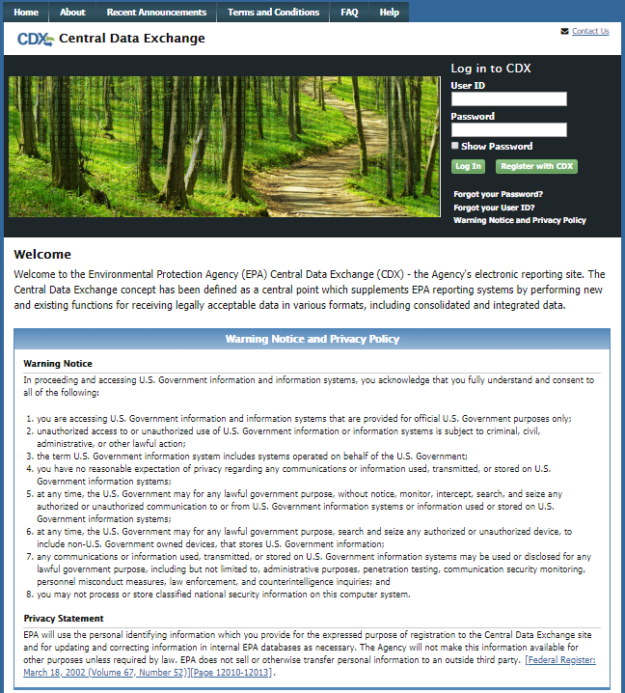
To log into CDX with an existing CDX account:
- Enter your CDX user ID in the ‘User ID field’
- Enter your CDX password in the ‘Password’ field.
- Click on the ‘Login’ button. You will be taken to the ‘MyCDX’ page where you may add the STARS data flow to your CDX program services (see Section 3.3)
To register for a CDX account:
- Click the ‘Register with CDX’ button. You will be taken to the CDX ‘Terms and Conditions’ page which displays the following minimum terms and conditions:
- Acceptance of warning and privacy policies
- Choosing a complex password
- Protecting your password
- Notifying CDX of possible misuse of account
- Limiting distribution of CDX software
- Agreement to notify CDX of changes in duties
Figure 3-2 CDX Terms and Conditions Page
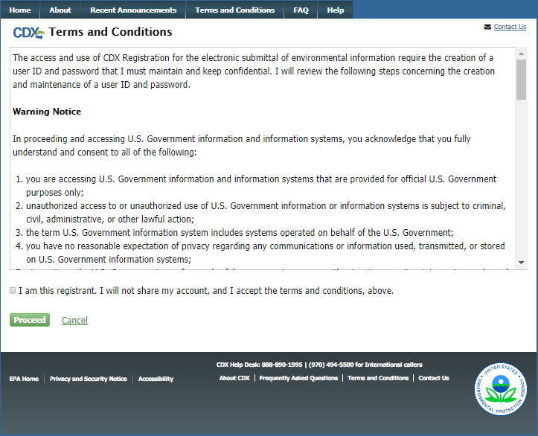
- Accept the terms and conditions by selecting the ‘I Accept’ radio button or cancel the registration by selecting the ‘I Decline’ radio button. Note that if you decline the terms and conditions, you will not be able to proceed with the registration.
- Click the ‘Proceed’ button. If you accepted the registration agreement, the system will navigate you to the ‘Core CDX Registration’ page to proceed with the registration process. You may add the STARS data flow to your CDX program services during the first step of the registration process.
Note – Important information about the registration process:
Submittal of files through CDX requires a CROMERR compliant signature. Authorized signature authorities for the facility should use the LexisNexis electronic identity validation service in lieu of a paper based validation. If the signature authority chooses to use the paper based validation process, the CDX Reporting Center will request the phone number of the signature authority’s employer/authorizing official to verify employment.

Facility contractors (consultants) will no longer be able to submit files to STARS on behalf of the source, and therefore do not need to proceed through the paper based validation process prior to submitting files to CDX.

CDX Core Registration
The CDX registration process for new users consists of five steps (see Figure 3-3)
- Program Service: search for and select the ‘STARS’ program service
- Role Access: select the STARS ‘Primary Applicant’ role
- User and Organization: provide user and organization information
- Confirmation: confirm your registration
Figure 3-3 CDX Core Registration for New CDX Users
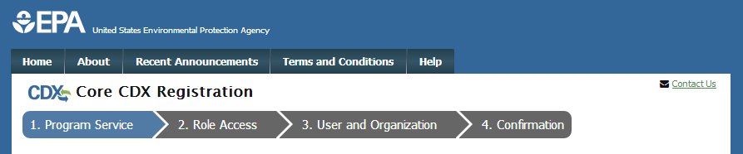
Existing CDX users will go through similar steps when editing their CDX accounts by requesting new program services and/or programs service roles, but will not be required to undergo the same level of account validation to establish proof of identify. There are three steps to the ‘Edit Account Profile’ process (see Figure 3-4):
- Program Service: search for and select the ‘STARS’ program service
- Role Access: select the STARS ‘Primary Applicant’ role
- Organization Information: provide your personal organization information
Figure 3-4 CDX Edit Account Profile for Existing CDX Users
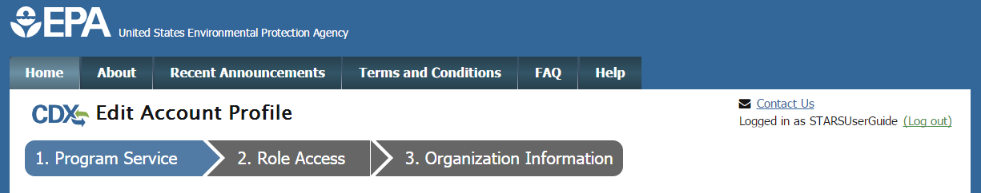

Request STARS Program Service
Requesting the STARS program service is the next step of the CDX registration process. After you accept the CDX terms and conditions, the system navigates you to the ‘Program Service’ page. The ‘Program Service’ page displays a list of program services with open registration from which you can choose to register (see Figure 3-6).
If you are an existing CDX user, you can request to add the STARS program service to your existing CDX account:
- Log into your CDX account. The system will navigate you to the ‘MyCDX’ page (see Figure 3-5).
Figure 3-5 Add a Program Service to Existing CDX Account
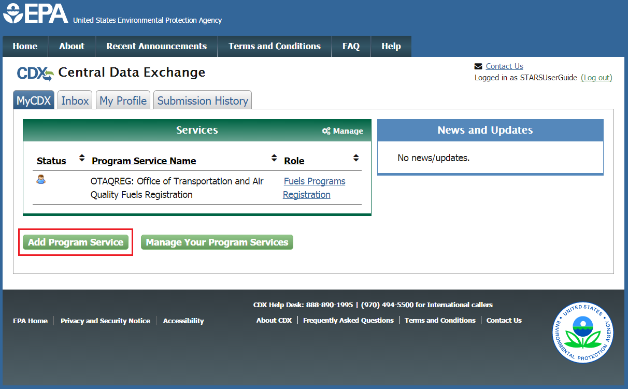
- Click the ‘Add Program Service’ button on the ‘MyCDX’ page. The system navigates you to the ‘Program Service’ page.
The ‘Program Service’ page displays a list of active program services with open registration from which you can choose to register.
Figure 3-6 CDX Edit Account Profile - Program Service Page
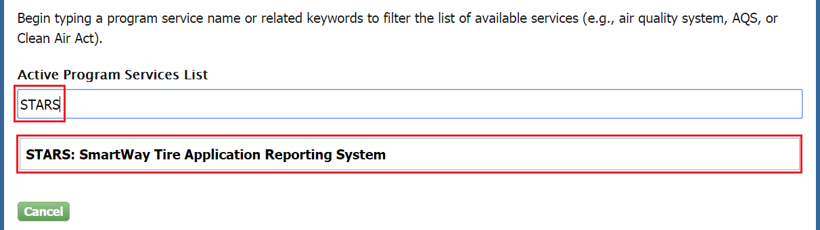
- Click in the ‘Active Program Services List’ field and enter ‘STARS’ to filter the active program service list.
- Click on ‘STARS: SmartWay Tire Application Reporting System’ to select it from the active program service list. The system will navigate you to the ‘User and Organization’ page.
- Click the ‘Cancel’ button to stop the process for requesting the STARS program service.

Role Access
After selecting the STARS program service, the system navigates you to the ‘User and Organization’ page (see Figure 3-7). Select the STARS Primary Applicant.
Figure 3-7 CDX Registration - Role Access
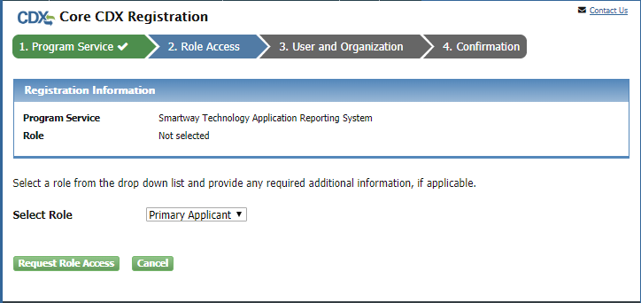

Provide User and Organization Information
If you are registering for a CDX account, the system will navigate you to the ‘Core CDX Registration – User and Organization’ page after selecting the ‘STARS’ program service (see section 3.5.2 3.5.2, Figure 3-9). User and organization information is captured on the same screen when registering for a CDX account. You enter account information in the ‘Part 1: User Information’ section of the page, and select your organization in the ‘Part 2: Organization Info’ section. All new CDX users are required to activate their account after these registration steps by following the instructions sent to the email address for the listed organization.
If you are an existing CDX user, the system navigates you to the ‘Edit Account Profile – Organization Information’ page after selecting the ‘STARS’ program service (see Figure 3-9). You have the option to either select an existing organization associated with your CDX account or request to add an organization.

Provide User Information
The ‘Part 1: User Information’ section of the ‘User and Organization’ page allows you to establish your CDX user ID and password as well as enter the personal information required for your CDX account. The information entered in the ‘Part 1: User Information’ section is used to perform account validation and establish levels of identity assurance.
Figure 3-8 Part 1: User Information
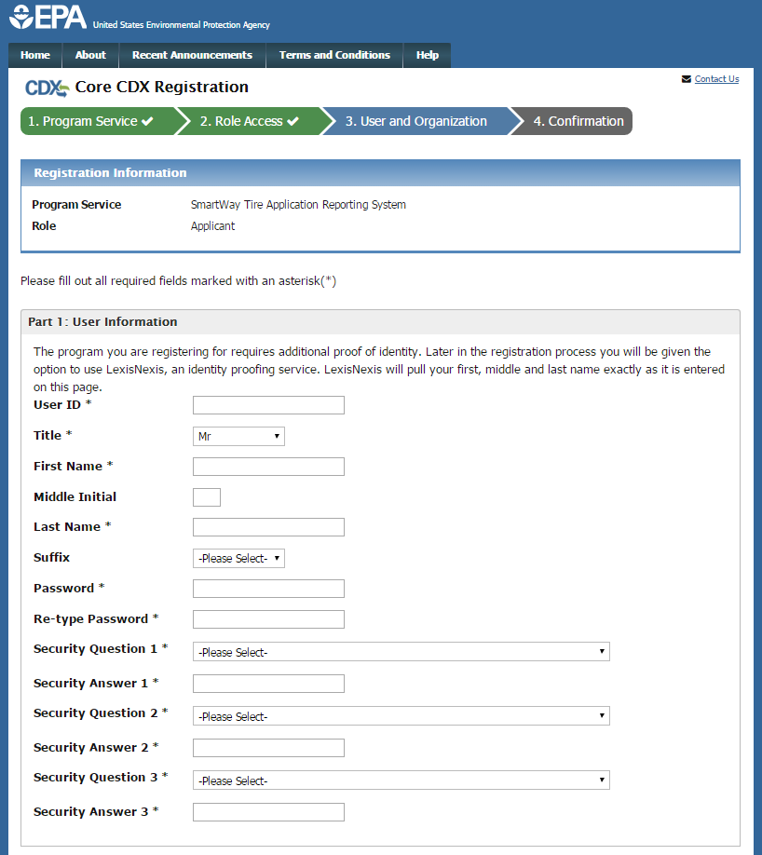
Enter the following information into the ‘Part 1: User Information’ section of the page (see Figure 3-8):
- User ID (required. Select a User ID you would like to use for CDX that meets the user name requirements)
- Title (required)
- First Name (required)
- Middle Initial
- Last Name (required)
- Suffix
- Password (required. Select a password that meets the minimum password requirements)
- Re-type Password (required)
- Security Question 1 (required)
- Security Answer 1 (required)
- Security Question 2 (required)
- Security Answer 2 (required)
- Security Question 3 (required)
- Security Answer 3 (required)
Note: It is important that you carefully note your input for the ‘User ID’ and ‘Password’ fields, as you are prompted for this information during the STARS submission process and will need to provide an exact match for authentication.
The ‘Security Question’ and ‘Security Answer’ are of your choosing and are for authentication in the event you forget your password and need to reset it. The answers you provide to the security questions are case insensitive.

Provide Organization Information
If you are registering for a CDX account, the ‘Part 2: Organization Information’ section of the ‘User and Organization’ page captures organization information for the selected STARS role. You are first required to perform a simple search to determine if information for your organization is already stored in CDX (see Figure 3-10). If you cannot find your organization, you can request that your organization be added to CDX.
If you are an existing CDX user, the system provides you with the option to either select an existing organization associated with your CDX account or request to add an organization (see Figure 3-9). When adding an organization, you can perform a simple search to select an organization already stored in CDX to your CDX account or request that the organization be added to CDX.
Warning: If you wish to share applications between multiple Applicants for the same Applicant Company, each Applicant must register for the same ‘Organization ID’.
Using the ‘Organization ID’ when searching for an organization ensures you are selecting the correct organization. The ‘Organization ID’, also known as ‘Company ID’ in some cases, can be found in the ‘Welcome to Smartway’ drop down in the top-right of the STARS application.
If you are creating the organization, please record the 'Organization ID' and provide this ID to other users wishing to be associated with the organization.
Please contact the CDX Helpdesk at 1-888-890-1995 or helpdesk@epacdx.net for assistance if you are unable to get the 'Organization ID' from the Applicant who created the organization with which you wish to be associated.
To select an existing organization associated with your CDX account:
Figure 3-9 Select a Current Organization
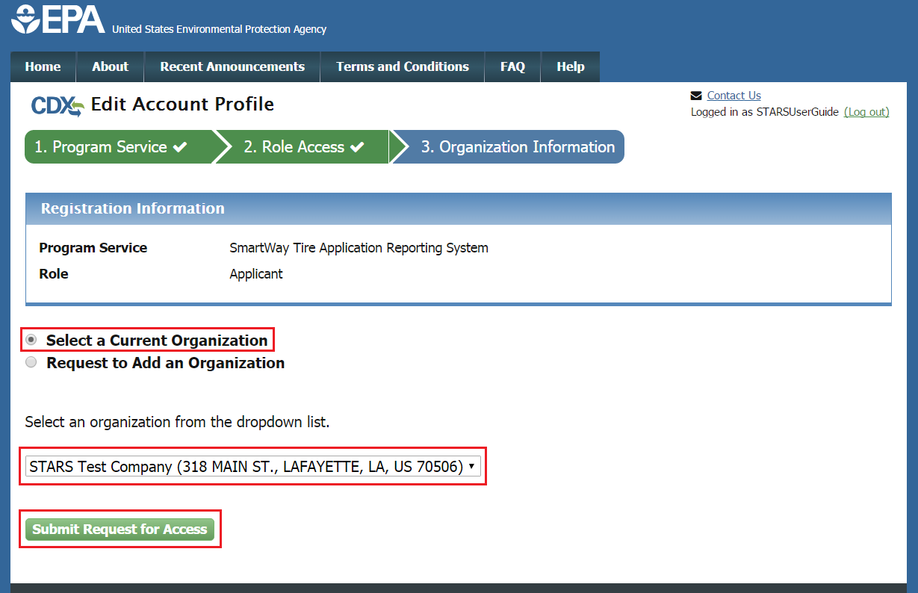
- Click the ‘Select a Current Organization’ option.
- Select an organization from the drop-down menu for your selected role.
- Select the ‘Submit Request for Access’ button to confirm your organization. You are taken to the ‘Identity Verification’ screen (see Section 3.6).

Search for Organization
If you are registering for a CDX account, the ‘Part 2: Organization Info’ section provides the capability to search for an existing organization (see Figure 3-10) to add to your CDX account.
Figure 3-10 Organization Search (New CDX User)
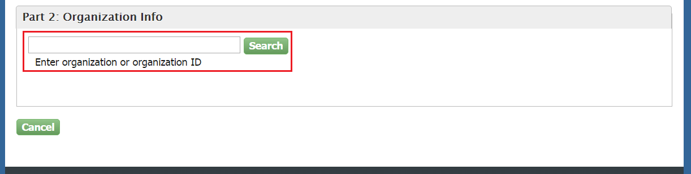
Existing CDX users can search for existing organizations to add to their account by selecting ‘Request to Add an Organization’ option on the ‘Organization Information’ page (see Figure 3-11).
Figure 3-11 Organization Search (Existing CDX User)
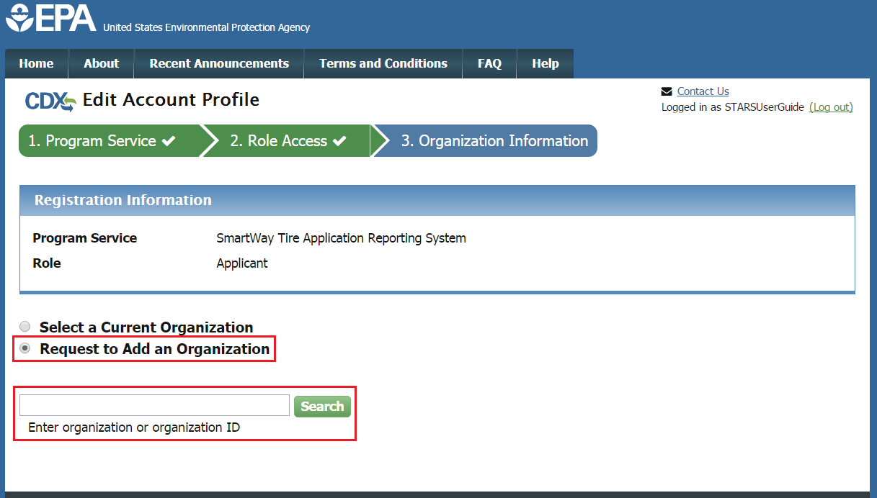
To search for an organization:
- Enter a full or partial name or Organization ID for your organization.
Note: If you wish to share applications between multiple Applicants for the same Applicant Company, each Applicant must register for the same ‘Organization ID’. The ‘Organization ID’, also known as ‘Company ID’ in some cases, can be found in the ‘Welcome to Smartway’ drop down in the top-right of the STARS application.
If another Applicant already exists for organization, request that they provide you their Organization ID by following Section 3.5.2.2.
- Click the ‘Search’ button. The system will display the search results under the search field (see Figure 3-12).
Figure 3-12 Organization Search Results
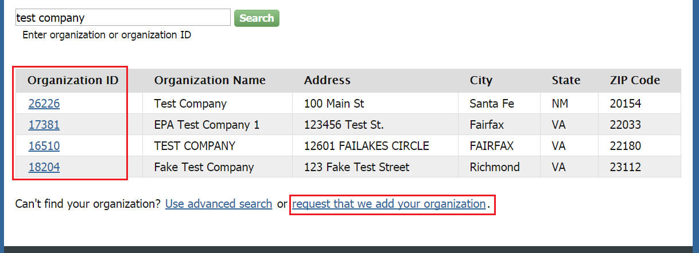
If you find your organization listed in the search results:
- Select the ‘Organization ID’ to select your organization. The system displays the organizational information. (See Figure 3-13).
Figure 3-13 Organization Information - Selected Organization
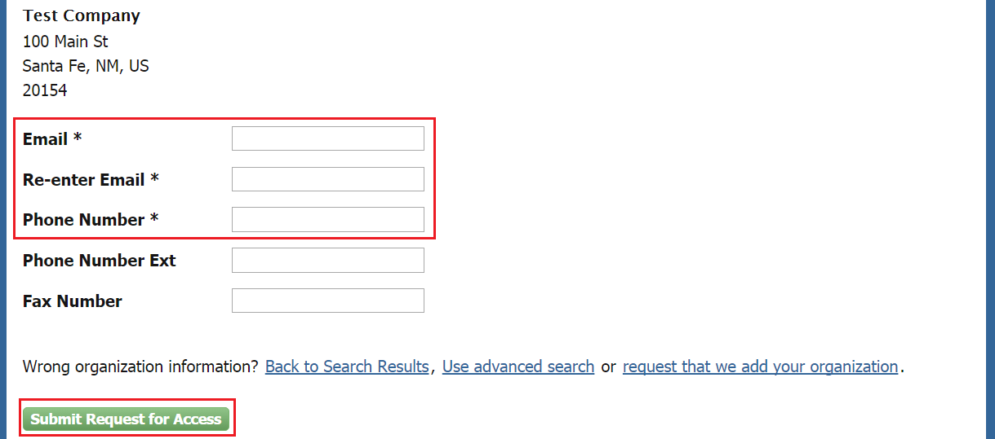
- Enter your organizational information (required fields are marked with an asterisk):
- Email: (required) CDX will use this email account for all CDX-related communications
- Re-enter Email: (required)
- Phone Number: (required)
- Phone Number Ext
- Fax Number
- Click the ‘Submit Request for Access’ button.

If you cannot find your organization in any search results:
- Select ‘request that we add your organization.’ The system will display data entry fields to capture your organizational information (see Figure 3-14)
Figure 3-14 Organization Information - Add Organization
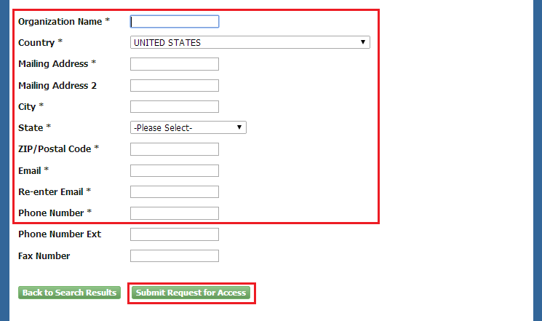
- Enter information about the organization (required fields are marked with an asterisk):
- Organization Name (required)
- Mailing Address (required)
- Mailing Address 2
- City (required)
- State/Province (required)
- Zip/Postal Code (required)
- Enter your organizational information (required fields are marked with an asterisk):
- Email: (required) CDX will use this email account for all CDX-related communications
- Re-enter Email: (required)
- Phone Number: (required)
- Phone Number Ext
- Fax Number
- Click the ‘Submit Request for Access’ button. The system navigates you to the ‘Confirmation’ page (see Figure 3-17) if you are registering for a CDX account.
Note: When creating a new organization, if the data entered is an exact match of an existing organization in CDX, you are directed to associate to the existing organization.
Note: Record the ‘Organization ID’ for future reference, so if additional users from your company register for the STARS program service, they can accurately identify the organization.

Locate Organization ID
If you wish to allow other Applicants to access and create STARS applications for your Applicant Company, they will need to register in CDX with your Applicant Company’s Organization ID.
To locate your Applicant Company’s Organization ID, you will first need to log into CDX. On the MyCDX Home Page, select ‘My Profile’ (see Figure 3-15).
Figure 3-15 Access My Profile from MyCDX Home Page
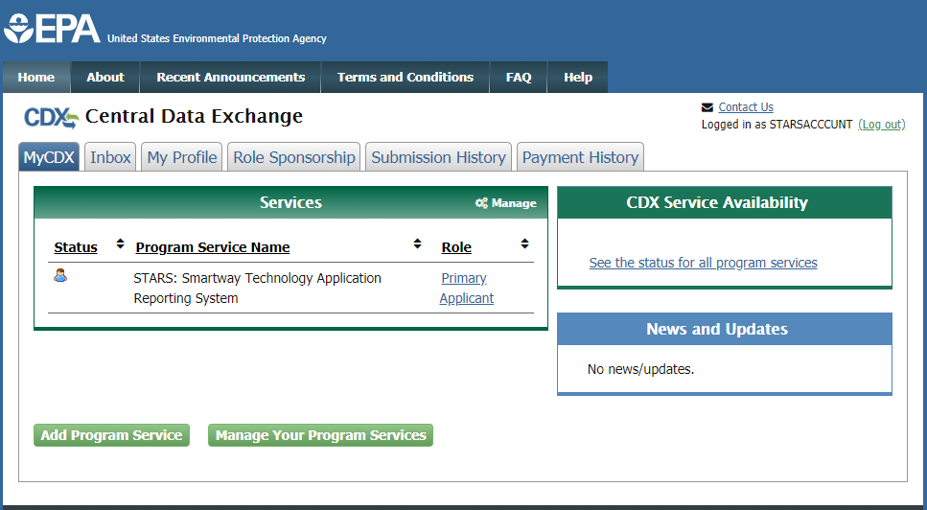
In the ‘Organization Information’ section on the ‘My Profile’ page is the Organization ID (see Figure 3-16). You may have multiple organizations for other CDX applications or STARS Applicant Companies. If this is the case, please confirm you are providing the correct Organization ID.
Figure 3-16 Locate the Organization ID on the My Profile Page
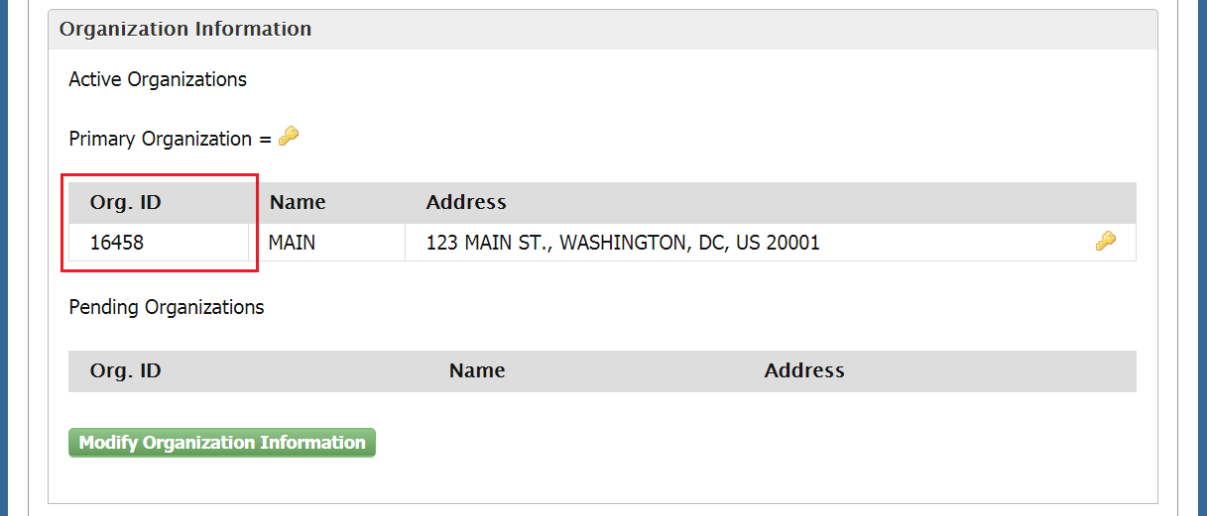

Confirm Registration
If you are registering for a CDX account, the system navigates you to the account ‘Confirmation’ page (see Figure 3-17). At this time, the CDX sends a confirmation email containing an access code to the email account you provided in the ‘Organization Information’ step (see Figure 3-18).
Figure 3-17 Confirmation for CDX Registration and Organization Association
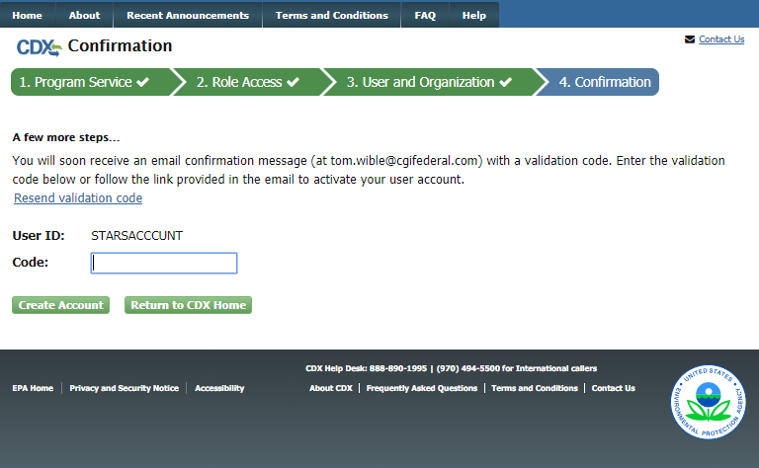
Upon receipt of the account confirmation email, copy the access code provided in the email and past into the code box in CDX.
Figure 3-18 Account Confirmation Email
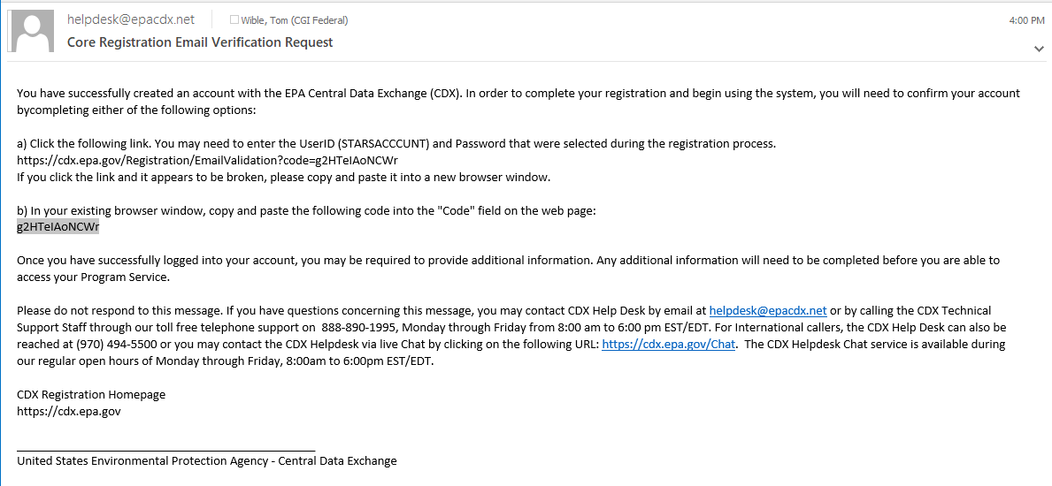

After entering the code provided and clicking ‘Create Account’, the system navigates you to the ‘Identity Verification’ screen (see Figure 3-19) to complete Identity Proofing and the Electronic Signature Agreement (ESA) process.

Verify Identity
In order to submit an application in STARS, additional identity proofing is required before the STARS program service becomes active in your CDX account. You are prompted to follow additional steps that support the LexisNexis identity validation and the ESA signing processes.
After following the hyperlink from the confirmation email and successfully logging in to CDX, the system navigates you to the ‘Identify Verification’ page (see Figure 3-19). You have the option to use either the electronic identity verification process or the paper-based identity verification process. CDX provides an identity verification service called LexisNexis, which is a third-party service that verifies the user's identity. At present, LexisNexis can only verify the identity of American citizens. If you are not an American citizen, you will need to verify your identity with the paper-based process.
Figure 3-19 Identify Verification Page
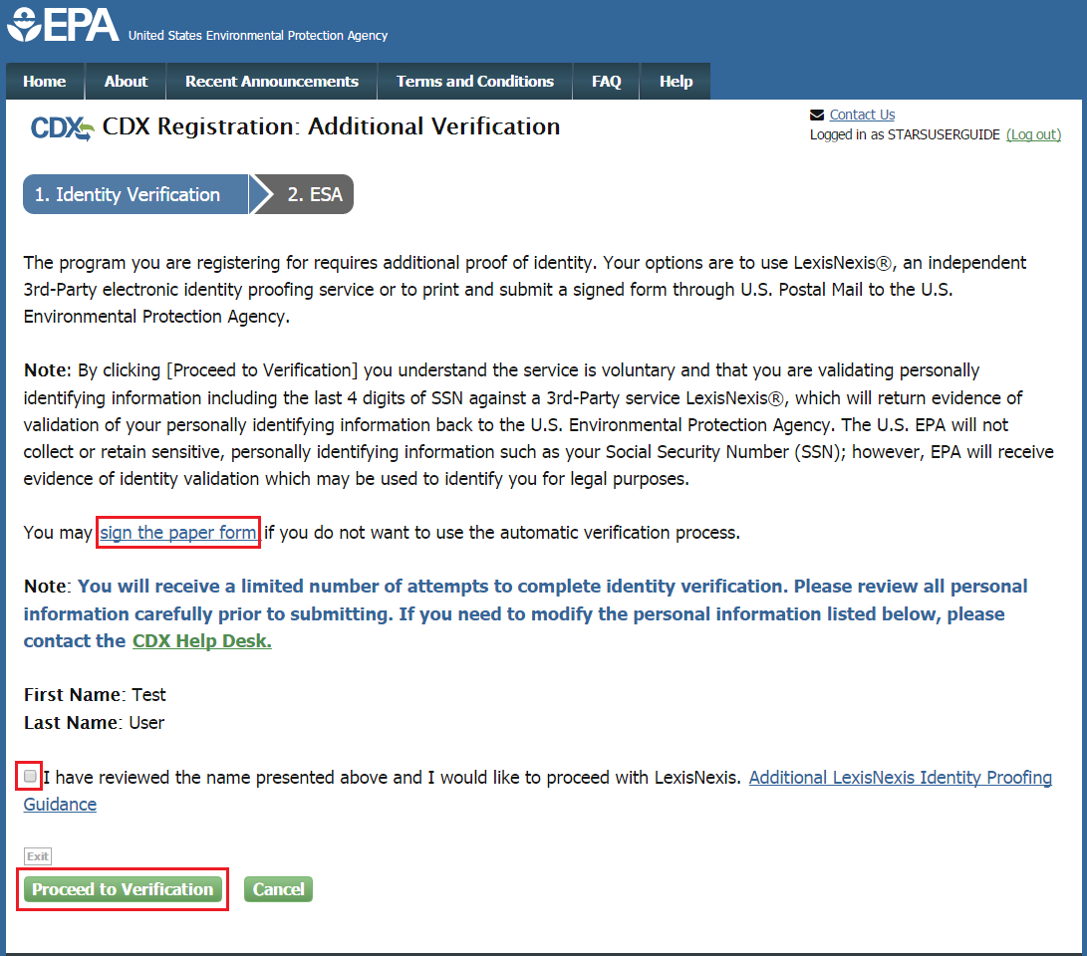
Click ‘sign the paper form’ link if you are not an American citizen or do not want to use the electronic verification process.
- The system navigates you to a screen where you are instructed to print, sign, and mail required identity proofing documentation (see Section 3.6.3 Complete Paper ESA).
- Note: Selecting paper verification will significantly increase processing time.
To proceed with the electronic verification process:
- Click the checkbox agreeing you have reviewed the first and last name presented and would like to proceed with LexisNexis.
- Click the ‘Proceed to Verification’ button. The system navigates you to the LexisNexis page to collect additional “Personally Identifiable Information (PII)” required for identity verification that CDX does not collect (see Figure 3-20).
- The LexisNexis Data Collection window displays the user and organization information collected by CDX and is not editable. The window also displays text fields in which you must provide the necessary PII for identity validation.
Figure 3-20 LexisNexis Verification for EPA
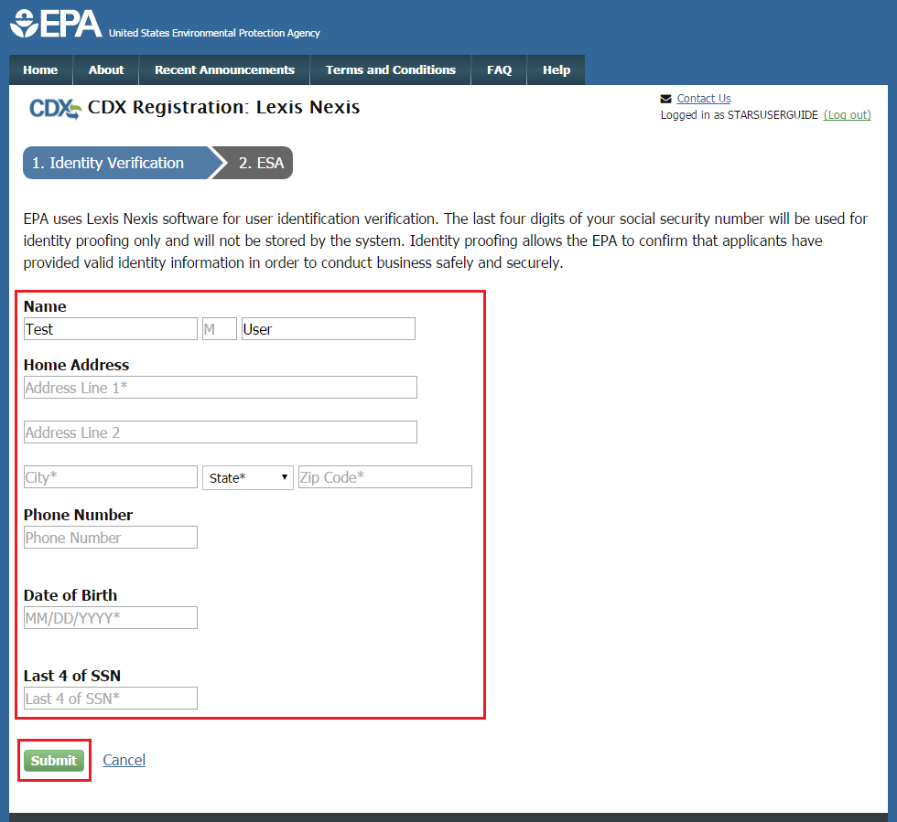

- Enter required PII:
- Home Address
- Home City
- Home State
- Home Zip
- Date of Birth
- Last 4 digits of SSN
- Confirm that all of the information provided is correct, and select the ‘Submit’ button to proceed with verification.
After completing LexisNexis data entry, one of the following may occur:
- You successfully completed LexisNexis identity verification.You can electronically sign the ESA at this point (see Section 3.6.1).
- You did not successfully complete LexisNexis identity verification and therefore need to print, sign, and mail the paper ESA (see Section 3.6.3 Complete Paper ESA).

CDX Electronic Signature Agreement
If you have not previously provided an ESA when registering with CDX, you will be prompted to sign an ESA, which can be signed electronically or manually. The following sections provide more detail about each option.
Warning: The paper ESA process may take up to 2 weeks to complete. Refer to Section 3.6.3 Complete Paper ESA for details.

Set-up CDX Security Challenge Questions
CDX provides twenty (20) questions to help validate your identity. From these 20 questions you are required to choose five (5) unique questions and provide unique answers for each. The questions that you select should be easy for you to remember, but difficult for someone else to guess. You are required to answer one (1) of these 5 questions upon submitting a STARS application. The question presented is randomly chosen by the system. If you pass LexisNexis validation and choose to sign the ESA electronically, the application verifies that the 20-5-1 security questions and answers have been set.
- If 20-5-1 security questions and answers have been set, the system will navigate you to the ESA.
- If not set, the system will navigate you to the page to provide 5 secret questions and answers before proceeding to the ‘ESA’ page (see Figure 3-21).
The 20-5-1 process must be completed before you can electronically sign the ESA.

Figure 3-21 CDX Registration – Additional Information
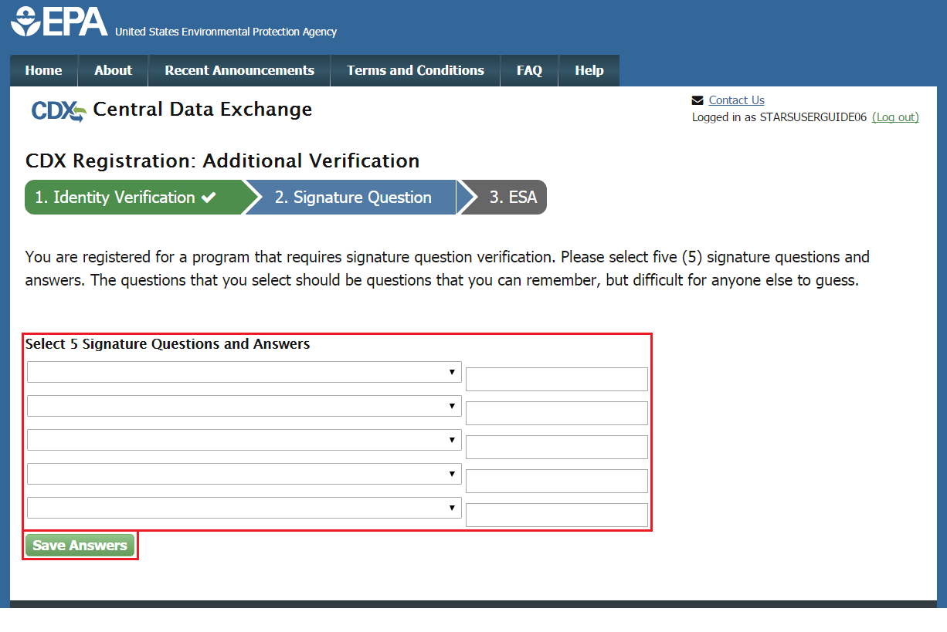
To select your five challenge questions:
- Click the question drop-down menu.
- Select the question.
- Enter the answer in the text box to the right of the question.
- Continue steps 1-3 until all 5 questions are selected and answered.
- Select the ‘Save Answers’ button to save the information. The system will send a confirmation email to your organization email and to your CDX Inbox listing the questions which you answered.
If you choose the paper ESA application process, the CROMERR 20-5-1 questions will be displayed the first time you log into your CDX account after your Applicant role has been manually activated by the CDX Helpdesk. If you need to electronically sign an ESA later, you will be required to provide your CROMERR 20-5-1 questions and answers before signing electronically.
If in the future, you forget your CROMERR 20-5-1 question answers, contact the CDX Helpdesk for assistance in resetting them.

Complete Electronic ESA
After you complete the CROMERR 20-5-1 process, the system will navigate you to the ‘Electronic Signature Agreement’ page to review and sign the ESA (see Figure 3-22).
Figure 3-22 Review Electronic ESA
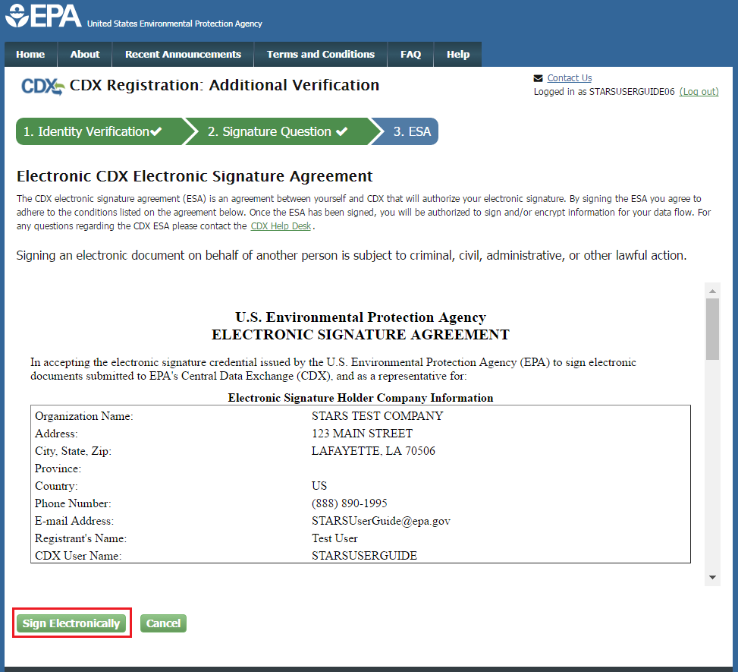
- Review the ESA.
- Click the ‘Sign Electronically’ button. The system will launch the CDX CROMERR widget for you to securely sign the ESA (see Figure 3-23).
Note: You may choose to discontinue the registration process by clicking the ‘Cancel’ button. If you do not complete either the electronic or paper ESA, you must contact your Registration Maintenance Account Manager (RMAM) to obtain access to the program role requested. If you do not know your RMAM contact information, contact the CDX Help Desk at 1-888-890-1995 or helpdesk@epacdx.net for assistance.
Figure 3-23 CDX Registration – CROMERR eSignature Widget page 1
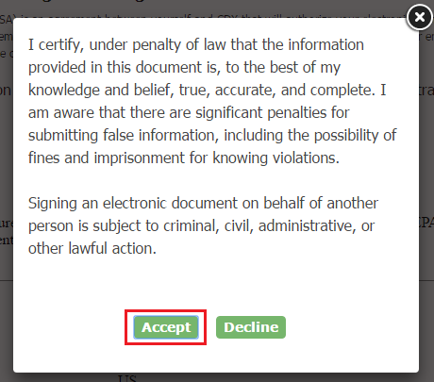
- Click the ‘Accept’ button. The system will display the next CROMERR eSignature pop-up window (see Figure 3-24).
Figure 3-24 CDX Registration – CROMERR eSignature Widget page 2
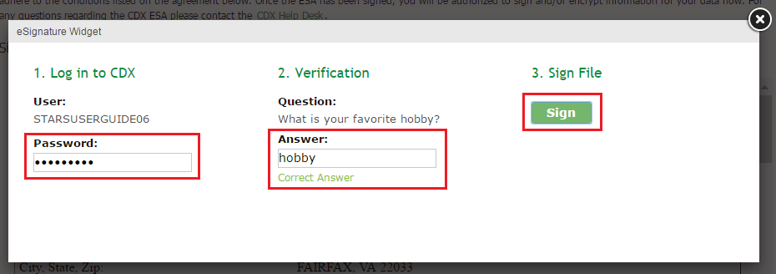
- Enter your CDX password, the answer to the security question displayed, and click the ‘Sign’ button.
When the ‘Sign’ button is clicked the system sends an email to the email provided for your CDX account confirming account creation and signing an ESA for STARS (see Figure 3-25). At this point your account is created, but not yet activated. The system also sends an email to EPA indicating an account is pending approval and activation. You are able to log into CDX at this time but you may not access the STARS program service until the role is activated (see Figure 3-26).
Note: You may not access STARS until your role is activated. If your role is not activated in a timely manner contact your Registration Maintenance Account Manager (RMAM) to obtain access to the program role requested. If you do not know your RMAM contact information, contact the CDX Help Desk at 1-888-890-1995 or helpdesk@epacdx.net for assistance.

Figure 3-25 ESA Confirmation Email
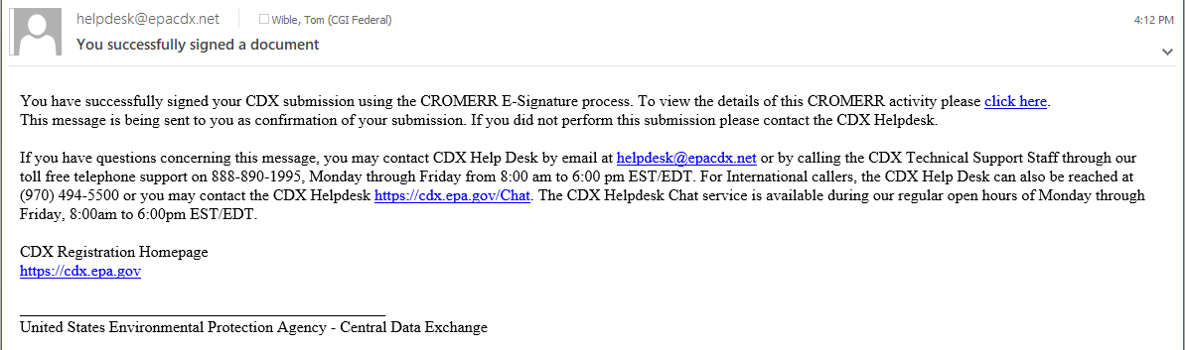
Note: You may not access STARS until your role is activated. If your role is not activated in a timely manner contact your Registration Maintenance Account Manager (RMAM) to obtain access to the program role requested. If you do not know your RMAM contact information, contact the CDX Help Desk at 1-888-890-1995 or helpdesk@epacdx.net for assistance.
Figure 3-26 STARS Account Awaiting Activation
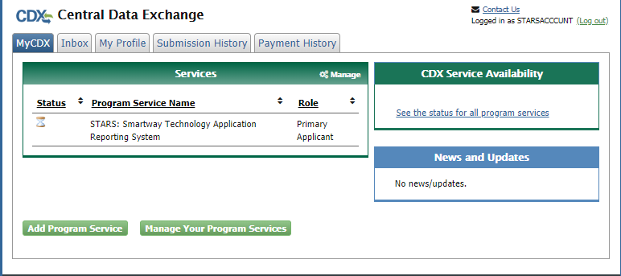
Once EPA approves the STARS role an email is sent to the email address provided during CDX account creation indicating the account was approved (or possibly rejected) (see Figure 3-27). If approved, STARS can now be accessed via CDX (see section 3.7 Access the STARS Program Service).
Figure 3-27 Account Activation Email
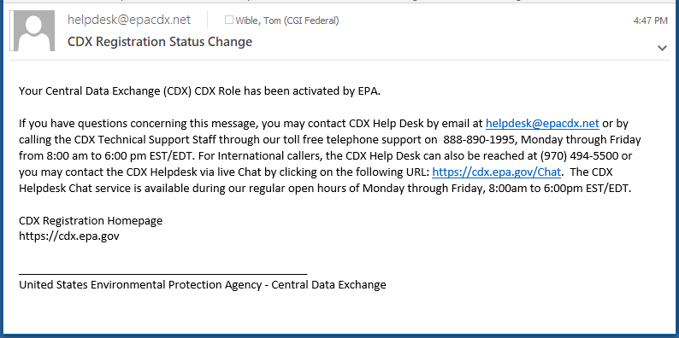

Complete Paper ESA
If you do not wish to leverage the LexisNexis process, or are unable to be properly validated to meet the minimum requirements for the program, you are required to follow the paper ESA process to activate the STARS program service. The paper process allows you to print the ESA, provide a wet ink signature, and mail the signed ESA to the CDX Help Desk (refer to the ESA for mailing instructions).
To perform the ESA paper process:
- Click ‘sign the paper form’ link on the ‘Identify Verification’ page (see Figure 3-19), or on the identify verification results page, to navigate to the ‘Paper CDX Electronic Signature Agreement’ page (see Figure 3-28).
Figure 3-28 Paper CDX Electronic Signature Agreement
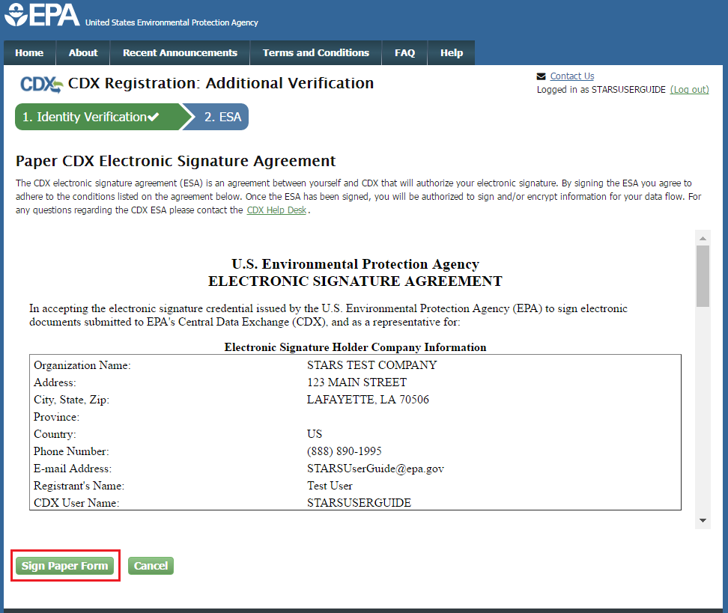
- Select the ‘Sign Paper Form’ button. The system displays the ESA in a pop-up window with an option to print the form (see Figure 3-29).
- Select the ‘Print to Mail’ button and print the form.
- Sign the ESA and mail it according to the ESA instructions.
Figure 3-29 Print Paper CDX Electronic Signature Agreement
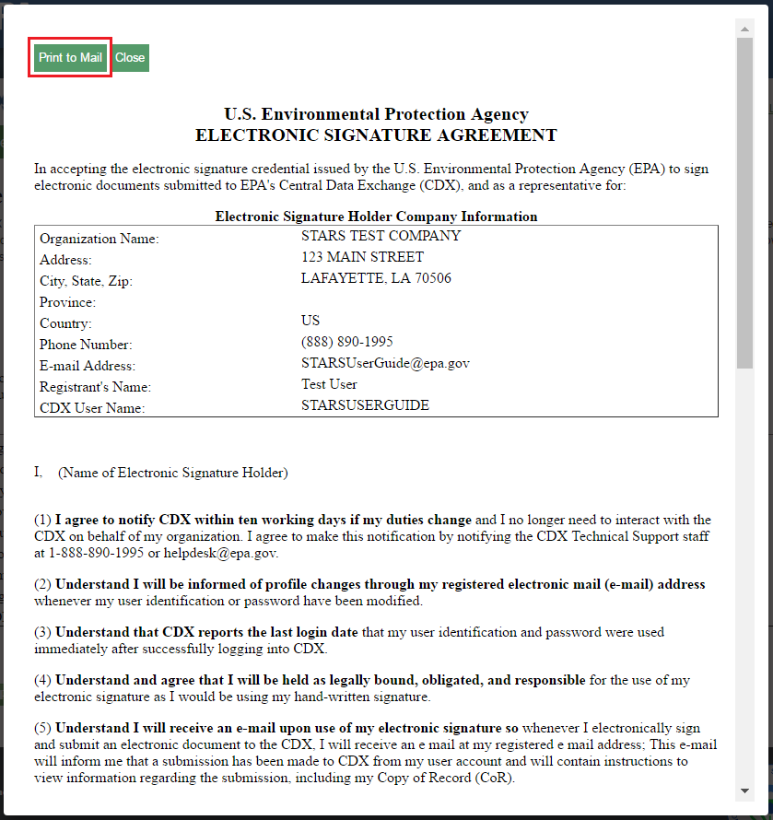
The ESA application process typically takes 5 to 10 business days to complete. Your Applicant role remains as ‘Awaiting Activation’ until the CDX Help Desk receives your form, verifies your identity, and approves your role. You may not access the STARS program service until your account is activated. You will receive an email notification once your role is approved (see Figure 3-30). A copy of the ESA form is automatically saved in your CDX Inbox for future reference and reprinting. To print, first download the .HTML file to your computer. You can then open the file in your browser for printing.
Figure 3-30 CDX Registration - Status Change Confirmation
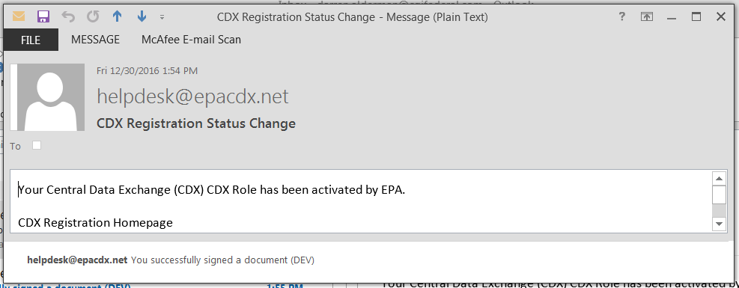
The CROMERR 20-5-1 questions will be displayed the first time you log into your CDX account following role approval. At that time, you will be required to provide CROMERR 20-5-1 questions and answers.

Access the STARS Program Service
Once logged in to CDX (see Section 3.2), the ‘STARS: SmartWay Technology Application Reporting System’ is listed in the ‘Services’ section of the page. Select the ‘Primary Applicant’ Role hyperlink to access the STARS application (see Figure 3-31).
Figure 3-31 Accessing STARS from CDX
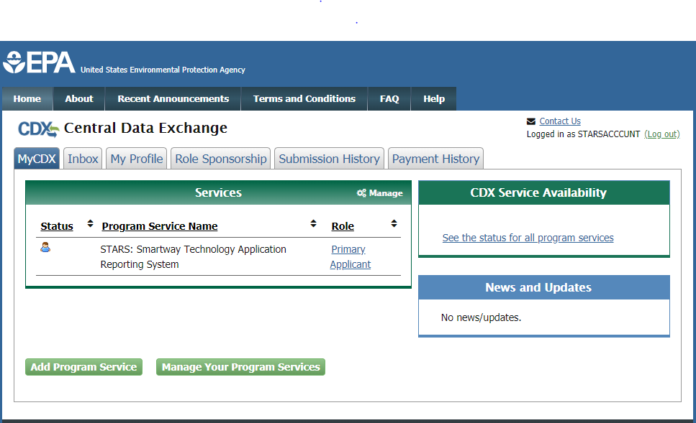
Refer to the STARS Submission Users Guide for instruction to complete applications for technology verification.

Sponsor Applicants for Registration
Companies applying for Smartway technology verification may manage user access to STARS once at least one company representative is registered in STARS as a Primary Applicant. The Primary Applicant(s) may invite other company representatives to register Applicant accounts and may deactivate accounts no longer needed.
The process of inviting company representatives to register and approving these requests for registration is referred to as Role Sponsorship. Role Sponsorship is initiated by your company’s Primary Applicant(s) with an invitation to request a STARS Applicant role.
Role Sponsorship consists of the following steps:
- Primary Applicant Sponsors Applicant
- Applicant Creates CDX Account (…and Requests STARS Registration)
- Primary Applicant Approves Applicant Registration
- Applicant Completes Identity Verification

Primary Applicant Sponsors Applicant
Primary Applicant logging into CDX see a ‘Role Sponsorship’ tab. Applicants do not see this tab as the Applicant role does not include this privilege (see Figure 3-32).
Tabs that both the Primary Applicant ad Applicant see are:
- MyCDX – Landing page listing program services and announcements
- Inbox – List of notification emails sent by CDX
- My Profile – Provides user account details and registration information
- Submission History – Lists submission made to EPA through CDX
- Payment History – List of payments made through CDX program services
Two tabs shown in Figure 3-32 will not appear for STARS Primary Applicants or Applicants:
- Reg Maint – Reserved for EPA personnel registered in CDX as Registration Maintenance Account Managers
- Help Desk – Reserved for EPA end user support Help Desk personnel.
Figure 3-32 CDX Role Sponsorship - Tools
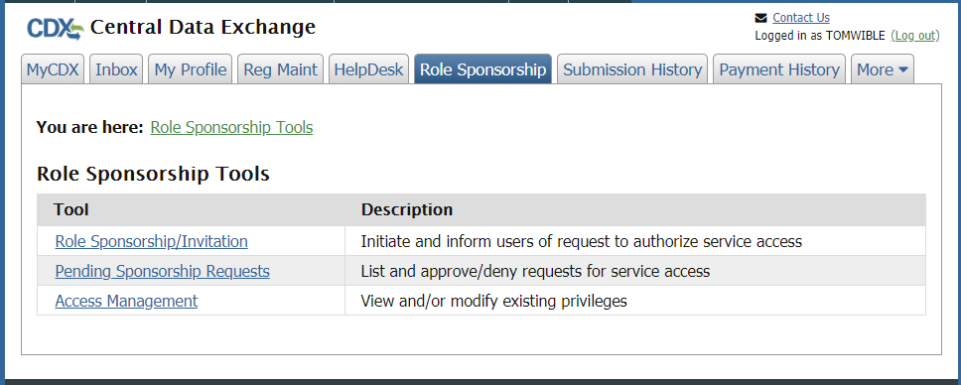

To initiate the Role Sponsorship process the Primary Applicant clicks the ‘Role Sponsorship/Invitation’ hyperlink to create an invitation to request an Applicant role in STARS.
On the ‘Role Sponsorship/Invitation’ page (see Figure 3-33):
Step 1: Recipient Information: enter the email address of the person being invited to register.
Step 2: Select STARS: Smartway Technology Application Reporting System’ for the ‘Program Service’ ad Applicant for the ‘Role’
Figure 3-33 CDX Role Sponsorship – Role Sponsorship/Invitation
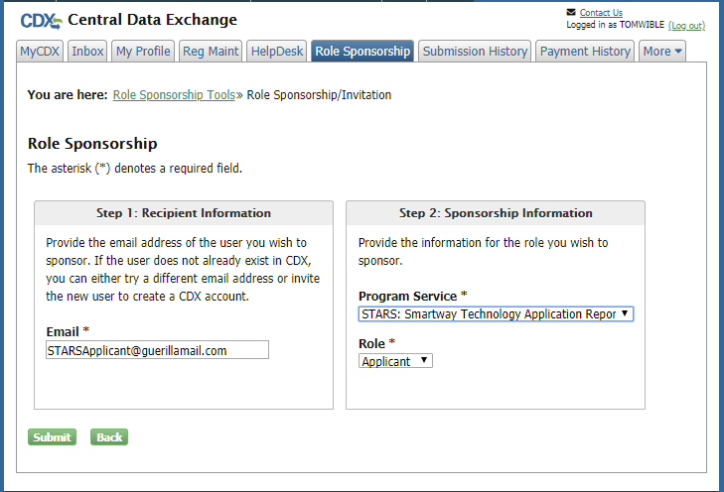

Clicking ‘Submit’ advances you to the ‘Role Sponsorship Review’ page (see Figure 3-34) where you review and confirm the email address specified for the Applicant is accurate.
Clicking ‘Submit’ on this page advances you to the ‘Email Confirmation’ page (see Figure 3-35) for a final confirmation of the Applicants email. Clicking ‘Confirm’ sends the Role Sponsorship invitation email to the Applicant email address specified.
Figure 3-34 CDX Role Sponsorship – Email Confirmation (1 of 2)
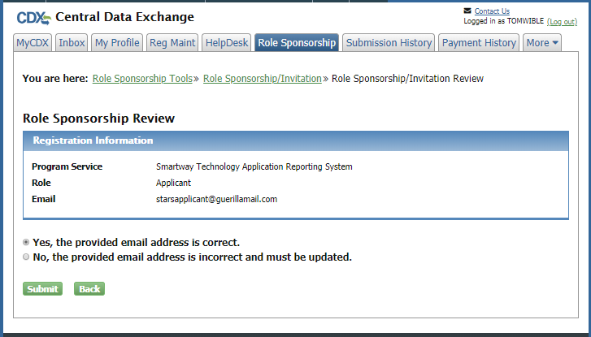

Figure 3-35 CDX Role Sponsorship – Email Confirmation (2 of 2)
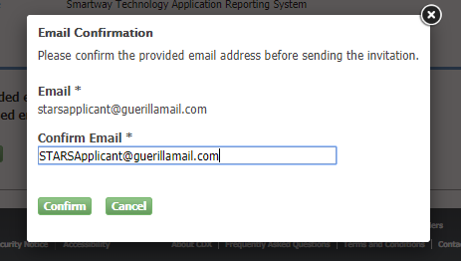

Applicant Creates CDX Account
The company representative invited to request STARS registration receives an email with instructions to either ‘review the sponsorship’ (i.e. proceed with registration) or ‘cancel the sponsorship request’ (see Figure 3-36).
To proceed with STARS registration click the ‘review this sponsorship’ link.
Figure 3-36 CDX Role Sponsorship – Applicant Invitation
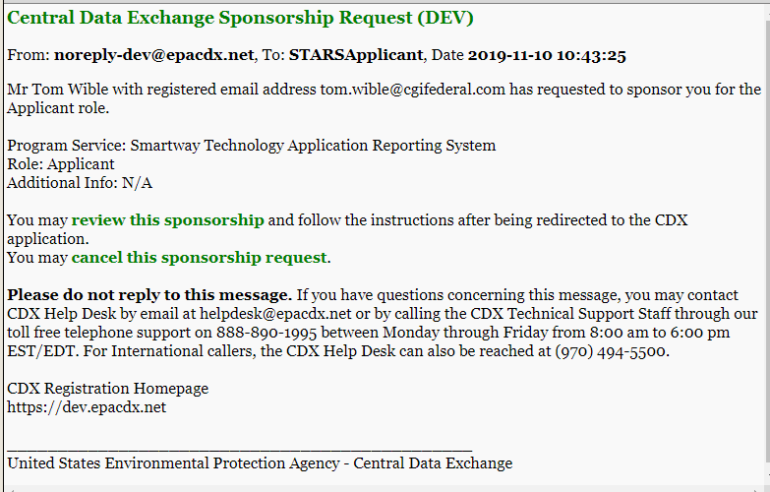

You are taken to CDX and presented with the role sponsorship details: your email address, STARS program service, Applicant role (see Figure 3-37). Click the ‘Approve’ button to proceed with creating a CDX account and registering for the STARS program service in the Applicant role.
Figure 3-37 CDX Role Sponsorship – Approve Invitation Request
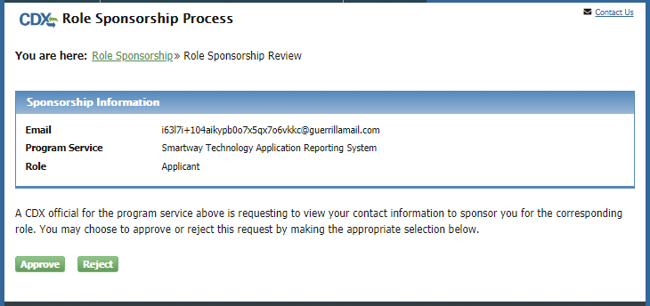

Provide User Information
The ‘Part 1: User Information’ section of the ‘User and Organization’ page allows you to establish your CDX user ID and password as well as enter the personal information required for your CDX account. The information entered in the ‘Part 1: User Information’ section is used to perform account validation and verify identity (see section 3.8.4 Applicant Completes Identity Verification).
Enter the following information into the ‘Part 1: User Information’ section of the page (see Figure 3-38):
- User ID (required. Select a User ID you would like to use for CDX that meets the user name requirements)
- Title (required)
- First Name (required)
- Middle Initial
- Last Name (required)
- Suffix
- Password (required. Select a password that meets the minimum password requirements)
- Re-type Password (required)
- Security Question 1 (required)
- Security Answer 1 (required)
- Security Question 2 (required)
- Security Answer 2 (required)
- Security Question 3 (required)
- Security Answer 3 (required)

Figure 3-38 CDX Role Sponsorship – CDX Account Creation (Part 1)
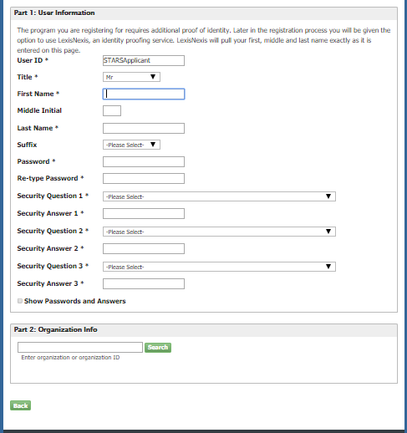

Note: It is important that you carefully note your input for the ‘User ID’ and ‘Password’ fields, as you are prompted for this information during the STARS submission process and will need to provide an exact match for authentication.
The ‘Security Question’ and ‘Security Answer’ are of your choosing and are for authentication in the event you forget your password and need to have it reset. The answers you provide to the security questions are case insensitive.

Provide Organization Information Using Organization ID
You are first required to perform a simple search to determine if information for your organization is already stored in CDX (see Figure 3-39). If you cannot find your organization, you can perform an “Advanced Search” to locate your company CDX organization.
Warning: If you wish to share applications between multiple Applicants for the same Applicant Company, each Applicant must register for the same ‘Organization ID’.
Using the ‘Organization ID’ when searching for an organization ensures you are selecting the correct organization. The ‘Organization ID’, also known as ‘Company ID’ in some cases, can be found in the ‘Welcome to Smartway’ drop down in the top-right of the STARS application.
If you are creating the organization, please record the 'Organization ID' and provide this ID to other users wishing to be associated with the organization.
Please contact the CDX Helpdesk at 1-888-890-1995 or helpdesk@epacdx.net for assistance if you are unable to get the 'Organization ID' from the Applicant who created the organization with which you wish to be associated.
To select the same organization as the Primary Applicant that invited you to register, obtain the CDX Organization ID for you company from the Primary Applicant and use this ID to search for your organization. See section 3.8.2.3 Locate Organization ID for instructions to locate your company Organization ID.
To search by Organization ID, click the ‘Use Advanced Search’ hyperlink (see Figure 3-39). On the search page enter the ‘Organization ID’ provided by the Primary Applicant into the ‘Organization ID’ field and click ‘Search’ (see Figure 3-40). From the search results, click the ‘Organization ID’ hyperlink to select the organization and proceed with registration.
Proceed to section 3.5.3 Confirm Registration to continue CDX account setup and STARS Applicant registration.
Figure 3-39 CDX Account Creation – Organization Selection (1 of 3)
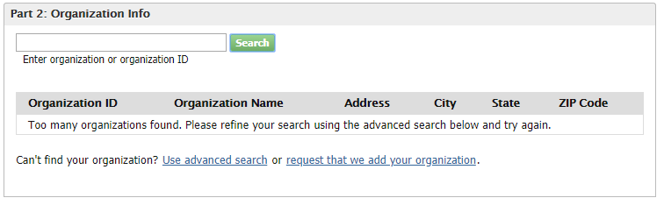

Figure 3-40 CDX Account Creation – Organization Selection (2 of 3)
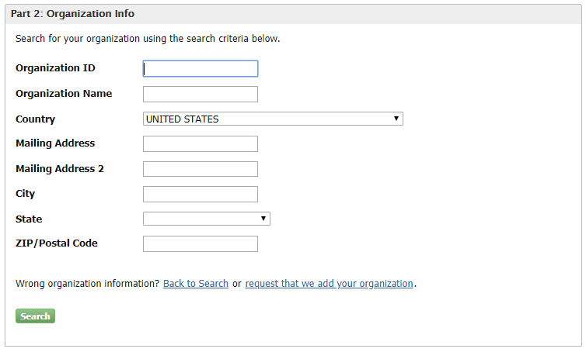

Locate Organization ID
If you wish to allow other Applicants to access and create STARS applications for your Applicant Company, they will need to set up their CDX account with the CDX Organization ID associated with the company of the Primary Applicant.
To locate your company’s CDX Organization ID, ask the Primary Applicant for your company to provide the CDX Organization ID. To do this:
- the Primary Applicant logs into CDX
- then, on the MyCDX Home Page, selects ‘My Profile’ (see Figure 3-41),
- then scrolls down to the Organization Information section, and records the ‘Org. ID’ from the table
This ‘Org. ID’ should then be entered in the ‘Organization ID’ to search for the organization in ‘Part 2 – Organization Info’ (see Figure 3-40).

Figure 3-41 My Profile – Finding Your Company CDX Organization ID
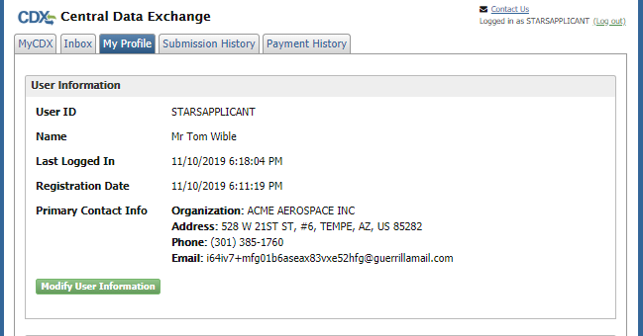
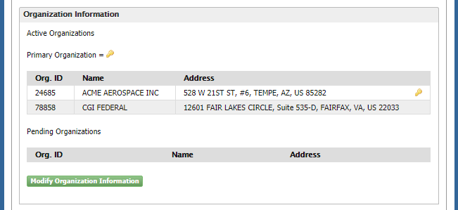

Completing Organization Information
After selecting the organization (section 3.8.2.2 Provide Organization Information Using Organization ID) enter your organization information (see Figure 3-42). Required fields are marked with an asterisk:
- Email: (required) CDX will use this email account for all CDX-related communications
- Re-enter Email: (required)
- Phone Number: (required)
- Phone Number Ext
- Fax Number
Click the ‘Submit Request for Access’ button.
Figure 3-42 CDX Role Sponsorship – CDX Account Creation (Part 2)
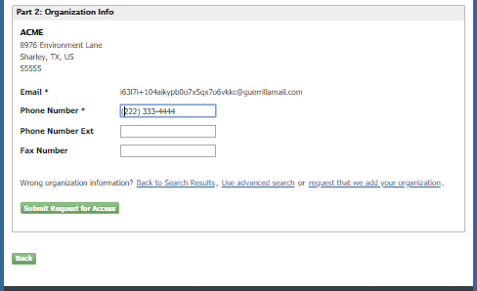

The system navigates you back to the MyCDX home page where you see the STARS program service in the ‘Services’ table. Your STARS registration is not yet activated so you will not be able to access the STARS program service until your registration request is approved by the Primary Applicant and your registration is activated.
Figure 3-43 CDX Role Sponsorship – Applicant Account Awaiting Approval
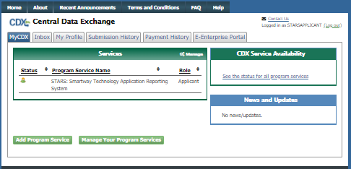

Primary Applicant Approves Applicant Registration
When the sponsored Applicant complete CDX account set up the system sends and email to the Primary Applicant indicating that a registration request is pending approval (see Figure 3-44).
The email includes the following information:
- Email address of the Applicant,
- Registration details:
  - Organization: Applicant Company
  - Program Service: Smartway Technology Application Reporting System
  - Role: Applicant
  - Additional Info: N/A
- Hyperlinks to:
  - ‘review (… and approve) this sponsorship request
  - ‘cancel (…and disapprove) this sponsorship request’
Figure 3-44 CDX Role Sponsorship – Applicant Registration Request Email
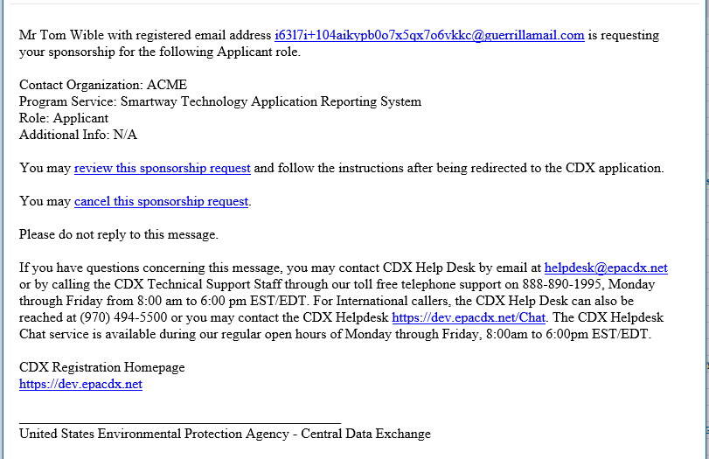

Click the ‘review this sponsorship request’ hyperlink to proceed with role sponsorship review and approval. On the ‘Role Sponsorship Process’ page review the Organization, Program Service, and Role for accuracy and then enter your CDX password and click the ‘Log In’ button to proceed with registration approval.

Figure 3-45 CDX Role Sponsorship – Primary Applicant Approval Log in
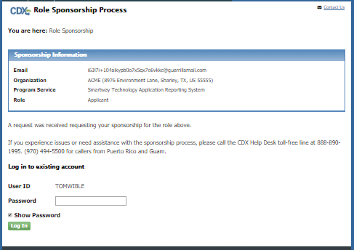
On the Role Sponsorship Process page, Role Sponsorship Review step select ‘Select an Existing Role’ to specify the Organization and Role to use to perform the registration approval (see Figure 3-46).
Note: CDX users may have Role Sponsorship privileges for multiple organizations and multiple roles. Therefore the Primary Applicant is given the opportunity to select the Organization and program service Role for which they are sponsoring the Applicant.
To approve the Applicants registration:
- Select the Organization for which the Applicant will be preparing and submitting applications from the ‘Organization’ dropdown. In most cases only one organization will be listed and will correspond to the CDX organization associated with your account.
- Select the Role being used for sponsorship from the Role dropdown. For STARS this role is “Primary Applicant”.
- Click the Approve button to accept the Applicants registration request and proceed to the approval signing process (see Figure 3-47).
As the sponsor the Primary Applicant must electronically sign the approval of the registration request.
- Before signing review the Electronic Sponsor Agreement (use the scroll bar to view the agreement).
- Click the ‘Approve’ button to proceed to the signing process (see Figure 3-47).
Figure 3-46 CDX Role Sponsorship – Primary Applicant Organization & Role Selection
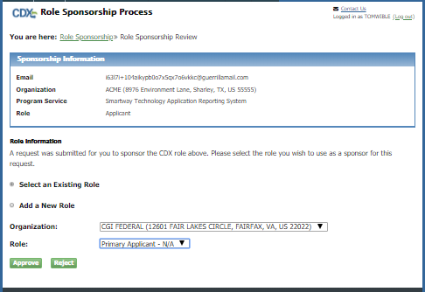
Figure 3-47 CDX Role Sponsorship – Primary Applicant Signs Approval (1 of 3)
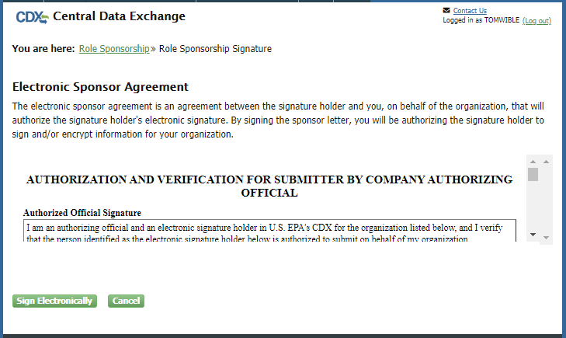

Review the disclaimer and click the ‘Accept” button to authenticate and sign the sponsorship agreement (see Figure 3-49). Upon clicking the ‘Sign’ button the system sends and email to the Applicant email address indicating the STARS Applicant role request is approved and Applicant may complete the registration process (i.e. Identity Verification).
Figure 3-48 CDX Role Sponsorship – Primary Applicant Signs Approval (2 of 3)
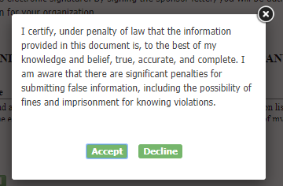
Figure 3-49 CDX Role Sponsorship – Primary Applicant Signs Approval (3 of 3)
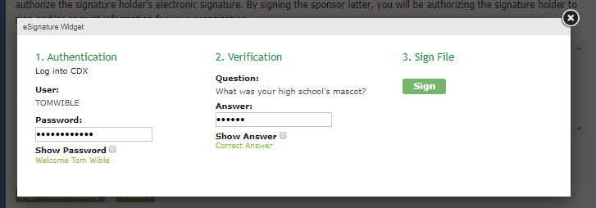

Applicant Completes Identity Verification
Approval of the registration request is provided in a system generated email (see Figure 3-50). Click the ‘log in to complete your account registration’ hyperlink to log back into CDX and complete the identity verification portion of registration.
Figure 3-50 CDX Role Sponsorship – Approval Notification
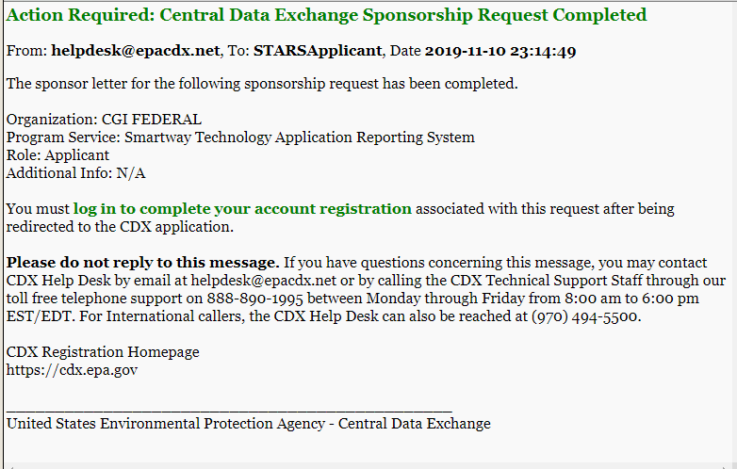

For added security the email address of the Applicant is confirmed by requiring an access code to proceed with the verification process (see Figure 3-51).
The access code is provided in a separate email (see Figure 3-52). Delivery of the email to the address specified in the Applicants CDX account profile is triggered when the ‘log in to complete your account registration’ link in the approval email is clicked.
Figure 3-51 CDX Role Sponsorship – Account Confirmation
Figure 3-52 CDX Role Sponsorship – Confirmation Code Email

After entering the “Code” from the ‘Core Registration Email Verification Request’ email (see Figure 3-52) into the ‘Code’ box on the ‘Confirmation’ page (see Figure 3-51) you are taken to the ‘CDX Registration: LexisNexis’ page to begin the Identity Verification process (see Figure 3-53.
The LexisNexis Data Collection window displays the user and organization information collected by CDX and is not editable. The window also displays text fields in which you must provide the necessary Personally Identifiable Information (PII) for identity validation.
Figure 3-53 STARS Account Registration - CDX Identity Verification
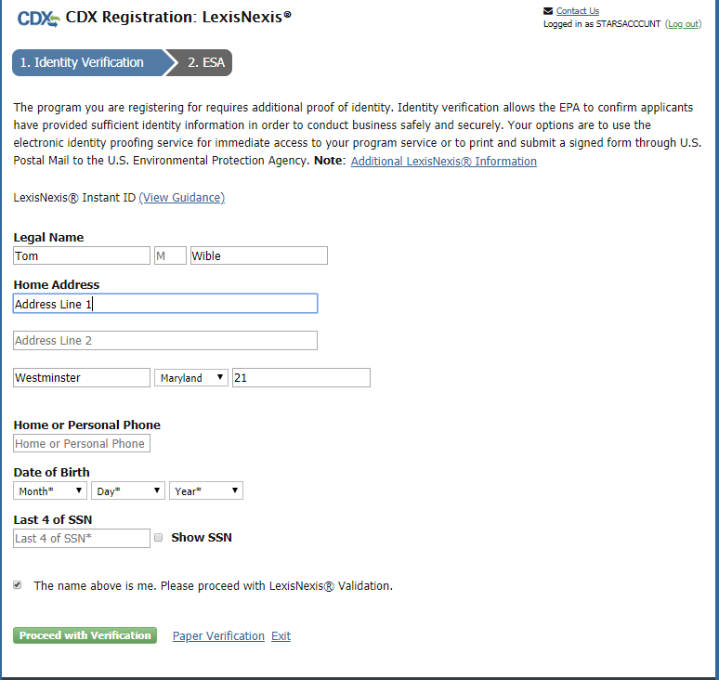
Note: LexisNexis Identity Verification is verify the identity of the individual registering for the CDX account. Therefore the address information must be the registrant’s personal home address and not the address of the company (organization) for which they are submitting Smartway applications.
- Enter required PII:
- Home Address
- Home City
- Home State
- Home Zip
- Date of Birth
- Last 4 digits of SSN
- Confirm that all of the information provided is correct, and click the ‘Proceed with Verification’ button to proceed with verification.
After completing LexisNexis data entry, one of the following may occur:
- You successfully completed LexisNexis identity verification.You can electronically sign the ESA at this point (see Figure 3-54 and Section 3.6.1).
- You did not successfully complete LexisNexis identity verification and therefore need to print, sign, and mail the paper ESA (see Section 3.6.3 Complete Paper ESA).
CDX provides twenty (20) questions to help validate your identity. From these 20 questions you are required to choose five (5) unique questions and provide unique answers for each. The questions that you select should be easy for you to remember, but difficult for someone else to guess. You are required to answer one (1) of these 5 questions upon submitting a STARS application. The question presented is randomly chosen by the system. If you pass LexisNexis validation and choose to sign the ESA electronically, the application verifies that the 20-5-1 security questions and answers have been set.
Figure 3-54 STARS Account Registration – 2nd Factor Authentication Questions
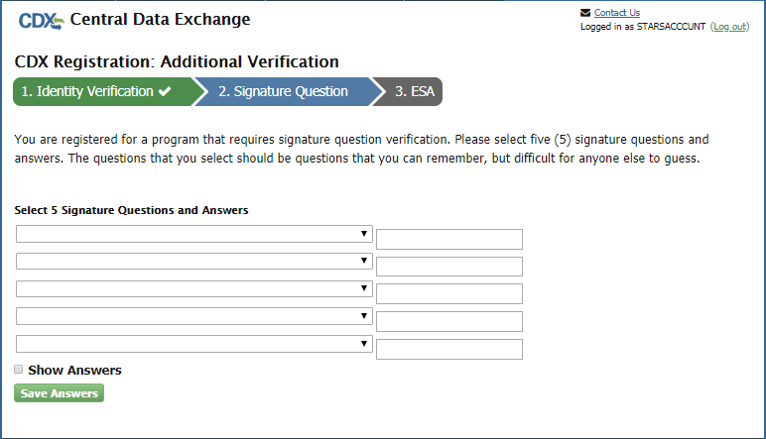
- If 20-5-1 security questions and answers have been set, the system will navigate you to the ESA.
- If not set, the system will navigate you to the page to provide 5 secret questions and answers before proceeding to the ‘ESA’ page (see Figure 3-21).
The 20-5-1 process must be completed before you can electronically sign the ESA.
Select the ‘Save Answers’ button to save the information. The system will send a confirmation email to your organization email (see Figure 3-55) and to your CDX Inbox listing the questions which you answered.
Figure 3-55 STARS Account Registration – Signature Question Confirmation Email
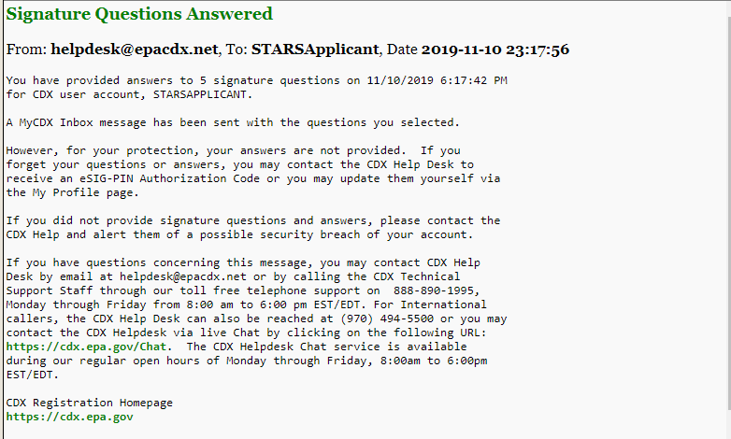
After you complete the CROMERR 20-5-1 process, the system will navigate you to the ‘Electronic Signature Agreement’ page to review and sign the ESA (see Figure 3-56).
- Review the ESA.
- Click the ‘Sign Electronically’ button. The system will launch the CDX CROMERR widget for you to securely sign the ESA (see Figure 3-23).
Note: You may choose to discontinue the registration process by clicking the ‘Cancel’ button. If you do not complete either the electronic or paper ESA, you must contact your Registration Maintenance Account Manager (RMAM) to obtain access to the program role requested. If you do not know your RMAM contact information, contact the CDX Help Desk at 1-888-890-1995 or helpdesk@epacdx.net for assistance.

Figure 3-56 STARS Account Registration – Electronic Signature Agreement (ESA)
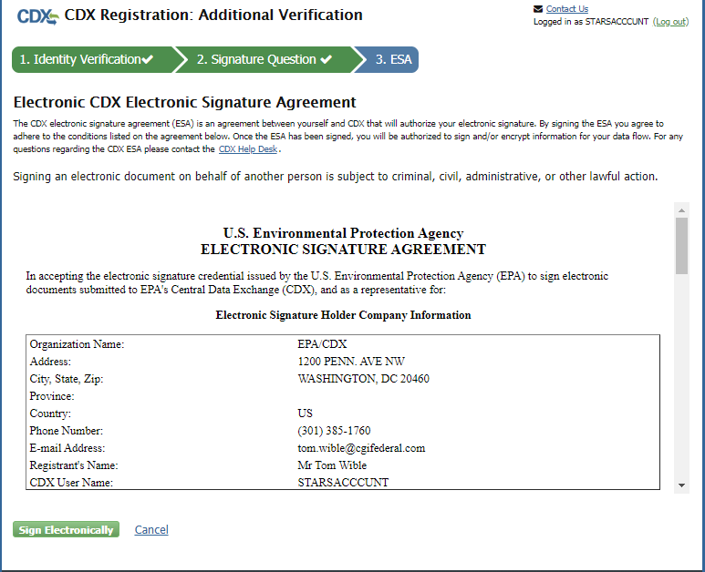
- Click the ‘Accept’ button. The system will display the next CROMERR eSignature pop-up window (see Figure 3-58).
- Enter your CDX password, the answer to the security question displayed, and click the ‘Sign’ button.
When the ‘Sign’ button is clicked the system sends an email to the email provided for your CDX account confirming account creation and signing an ESA for STARS (see Figure 3-59). You may view the ESA in CDX by clicking the ‘click here’ hyperlink in the email.
You will receive a second email from CDX indicating your STARS registration is activated (see Figure 3-60). Log into CDX using the clicking the link provided in the email. Once logged in you will in the Program Services table that the ‘STARS: Smartway Technology Application Reporting System’ has changed indicating the account is active (see Figure 3-61). Click the ‘Applicant’ hyperlink to access STARS.
Refer to the STARS Submission Users Guide for instruction to complete applications for technology verification.

Figure 3-57 STARS Account Registration – ESA Disclaimer
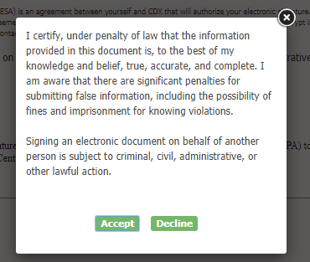
Figure 3-58 STARS Account Registration – ESA Signing
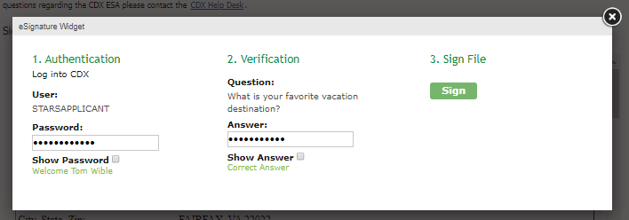

Figure 3-59 STARS Account Registration – ESA Confirmation Email
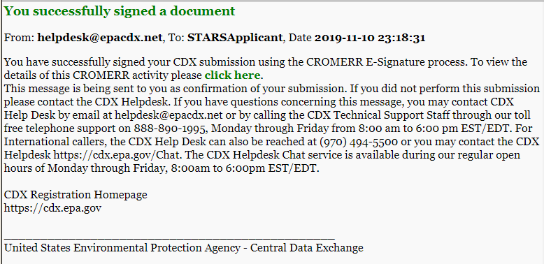
Figure 3-60 STARS Account Registration – Account Activation Email
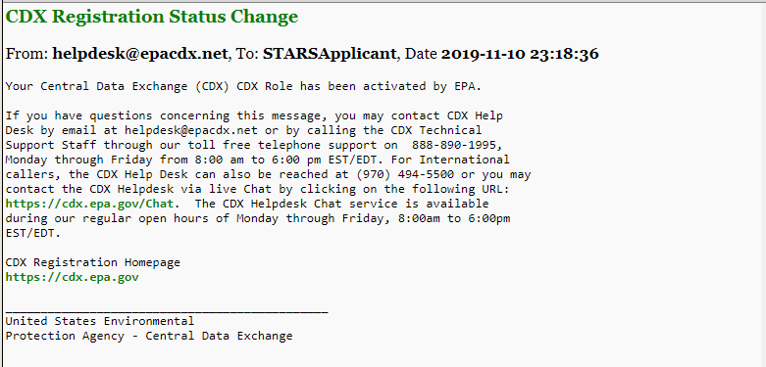

Figure 3-61 STARS Account Registration – Applicant Account Activated
